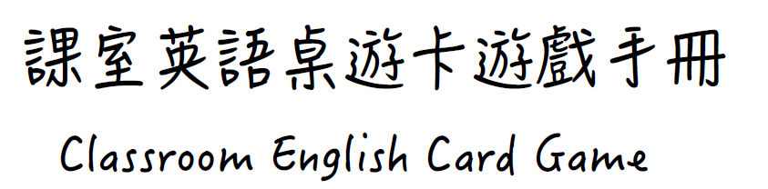

課室英語桌遊卡遊戲手冊
Classroom English Card Game

目錄

一、課室英語桌遊卡遊戲手冊介紹..................................... 1

二、課室英語桌遊卡遊戲方式說明..................................... 2

三、課室英語一覽表..……………….......…........................ 8

四、自製課室英語桌遊卡方法..………............................. 14

五、課室英語桌遊卡教學運用方法................................... 25

一、課室英語桌遊卡遊戲手冊介紹

課室英語桌遊卡為國立臺灣師範大學英語學系計畫團隊研發之教學資源，藉由趣味化的小組遊戲，幫助師生透過聽、說、讀的練習，熟悉不同課室英語表達方式。本手冊旨在說明遊戲方式，並彙整卡牌內容、自製桌遊卡說明以及桌遊卡教學應用方法，提供給老師運用及參考。在遊戲開始前或結束後，老師亦可運用手冊中課室英語一覽表進行教學，幫助學生認識不同的表達方式與回應方法。兩套桌遊卡適合於國中以上班級或教師研習中運用，每次遊戲時間約20-30分鐘。
每套桌遊卡牌包含12句學生表達，每句皆有4種不同的回答方法。兩套卡牌主要差異在於學生表達內容和教師回應方法有所不同，非依照難易度區分。此外，語言使用涵括不同的溝通功能，表達方式十分多元，兩套桌遊卡僅列舉師生部分可用到的課室英語及回應方式，供師生參考，回答方式並非絕對。老師亦可至計畫團隊網站下載可編輯的桌遊卡檔案，就班上學生特質和學習內容，自行調整或增減課室英語一覽表及卡牌文字。
兩套桌遊卡及本手冊的研發過程，感謝許多老師協助校對或提供桌遊卡試玩心得，以及宜蘭縣立凱旋國中陳育萱主任分享桌遊卡在教學上的應用方法。期望桌遊卡的研發有助於師生透過有趣的課堂活動，熟練課室英語。若有任何建議納入卡牌中的課室英語表達方式，亦歡迎提供您的想法給計畫團隊作為日後桌遊卡研發之參考。
二、課室英語桌遊卡遊戲方式說明

- 目標 Objective:
課室英語桌遊卡旨在幫助使用者練習課室英語，桌遊卡共有兩個版本，包括Classroom English (1) 和 Classroom English (2)。遊戲方式請見下方說明。若老師希望能幫助學生熟悉這些常用的課室英語表達方式，可以準備問答表紙本給學生，並於學期初先教學生這些問答句，後續在學期中，學生便可不斷應用課室英語。
The Classroom English card game aims to help users practice classroom English, and it has two versions: Classroom English (1) and Classroom English (2). Details about how to play this game are explained below. For teachers who intend to help their students become familiar with all these common expressions, they can prepare photocopies for students and pre-teach the expressions at the beginning of a semester. After that, students can play this game and practice classroom English frequently throughout the semester.

- 遊戲說明 How to Play This Card Game:
- 每套卡牌共有48張牌，包含12組卡牌，每組有同樣的學生問句，但有4種不同的老師回答，故一共48張，請見以下範例。
This game consists of 48 cards (12 ranks x 4 different teacher responses = 48 cards). Each rank shares the same student sentence, which has four corresponding teacher responses. Below is an example:
S: May I go to the restroom? T: Of course, go ahead.
S: May I go to the restroom? T: Yes, you may go to the restroom.
S: May I go to the restroom? T: Okay, you can go now, but don’t take too
long.
S: May I go to the restroom? T: Yes, you may go. Come back as soon as you are done!

- 遊戲開始前Pre-game setup:
- 遊戲玩家3到6人一組，每一組使用一套卡牌。
All players form a group of 3 to 6 players. Each group should get a deck of 48 cards.
- 每一組選一位玩家協助發牌，發牌者發給每位玩家（包括自己）一人五張卡牌，字面朝下。
Each group selects 1 player to be the dealer. The dealer then deals 5 cards face-down to each player including himself/herself.

- 發牌者將剩下未發完的卡牌放在桌子中間，字面朝下。
The dealer puts the rest of the deck in the center of the table.
- 遊戲規則 Game rules:
- 由發牌者左手邊的玩家開始遊戲。
The player to the left of the dealer starts the game.
- 當輪到你時，你得跟任何一位玩家要牌，這時你須唸卡牌上的問句，例如：「(玩家名), may I go to the restroom?」（請注意 你跟對方要的卡牌必須是你手中其中一張卡牌的問句）。
When it is your turn, ask any player for a specific card rank that you want, such as: “(other player’s name), may I go to the restroom?” (Note: The card rank you ask for must be one that you already have.)
- 如果你問的玩家剛好有你要的卡牌，她必須唸出該卡牌上教師的回答，爾後將該張卡片交給你，請見以下對話範例：
If the player you asked has the requested card, he/she must read the teacher response on the card and give the card to you. The following is an example dialogue:
- Tom (The player asking the question): Ms. Chang, may I go to the restroom?
- Ms. Chang (The player being asked): Yes, you may go. Come back as soon as you are done! (Okay, you can go now, but don’t take too long. / Of course, go ahead. / Yes, you may go to the restroom.)

請注意 假如你問的玩家有超過一張卡牌是你所唸的問題，她必須唸出這些卡牌上所有的答句，並將這些卡片都交給你。
Note: If the player you asked has multiple cards with the same rank that you requested, he/she must read all the responses out and give all those cards to you.
- 接著你可以跟另一位玩家要同一組或不同組的卡片，也可以選擇問同一位玩家，並跟她要另一張卡片。
Then you can ask another player for the same card rank or a different card rank. You can also ask the same player for a different card rank.
- 倘若你問的玩家剛好沒有你要的卡片，她必須要回答：“I don’t have that card. Pick a new card.” 接下來你必須要從桌子中間未發出去的卡牌中，抽一張卡給自己。然後你這一輪就正式結束。
If the player you ask doesn't have the requested card, he/she will say "I don’t have that card. Pick a new card." and you must draw a card from the deck. Then your turn ends.
- 前一位玩家左手邊的玩家開始新的一輪遊戲。
The person to the left of the previous player starts the next turn.
- 新的一輪遊戲重複上述步驟(2)的流程。
The game continues by repeating step (2).

- 得分：倘若你收集到四張同一組的卡牌（即四張相同學生問句的卡牌），你可將該組卡牌字面朝上放在你面前桌上，然後你便可得到4分。假如你從桌子中間的卡牌中所抽到的卡牌，剛好讓你能夠湊成一組，你也可以將卡牌放在你面前的桌上，並獲得4分。
Keeping Score: If you collect 4 cards of the same rank, you should place the cards face-up in front of you, and that is worth 4 points. If the card you draw from the deck forms a match with the other 3 cards that you already have, you can also place the cards down to win 4 points.
- 當所有玩家湊成了12組卡牌，並將所有牌組放置在面前，遊戲結束。
The game ends when all the cards are face-up in front of all the players.
- 所有玩家計算各自得分，得分最高的玩家為贏家。
All players count the number of points they have. The player with the most points is the winner.

- 其他 Other
- 如果你手中沒牌了，你可以從桌子中間的卡牌抽一張牌繼續遊戲。
If you run out of cards in your hand, you can pick a new card from the deck and continue the game.
- 假如桌子中間沒有剩下的卡牌了，遊戲繼續進行，玩家不再抽牌。
If there are no cards left in the deck, the game continues. From that point on, players don’t draw cards anymore.
- 遊戲方式介紹影片
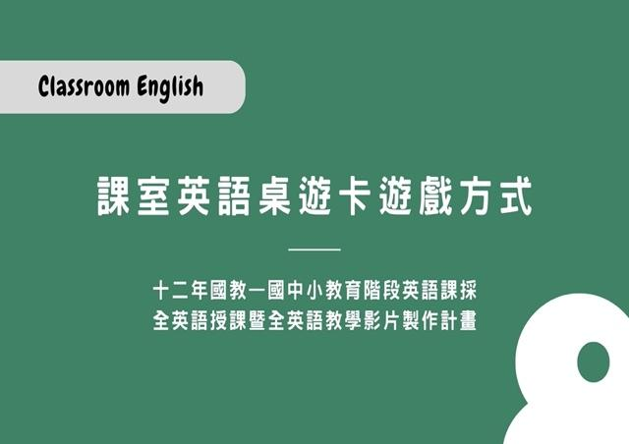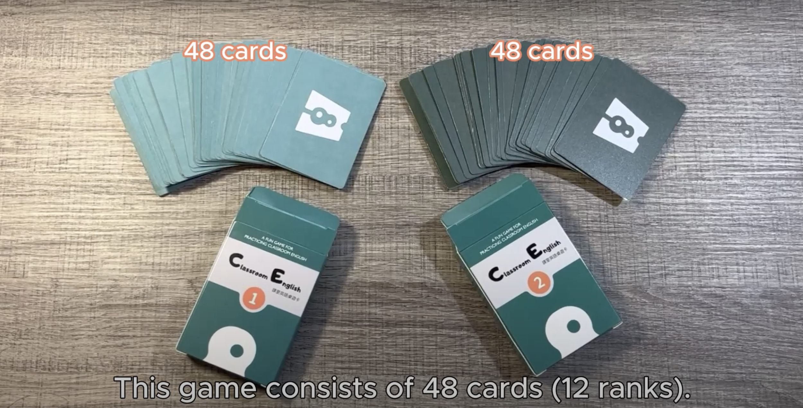

- 中文版介紹影片  https://reurl.cc/nrGR9e | 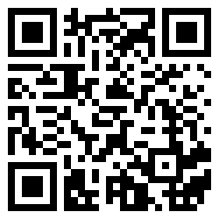

- 英文版介紹影片
https://reurl.cc/13NpyX

三、課室英語一覽表
Classroom English (1)
Student | Teacher
Excuse me. | - Yes, how can I help you?
 | - Yes? Do you need anything?
 | - Please go ahead. I’m listening.
 | - Yes, please go ahead and ask your question.

Student | Teacher
May I go to the restroom? | - Of course, go ahead.
 | - Yes, you may go to the restroom.
 | - Okay, you can go now, but don’t take too long.
 | - Yes, you may go. Come back as soon as you are done!

Student | Teacher
Can I borrow a pencil? | - Yes, but please take good care of it.
 | - No problem. You can borrow this one.
 | - Of course. You can take a pencil from my pencil case.
 | - Sure, but please remember to return it when you’re done.

Student | Teacher
I don’t understand. | - It’s okay. I will help you.
 | - Don’t worry. I will help you.
 | - No problem. I will show you what I mean.
 | - That's alright. Let me tell you in a different way.

Student | Teacher
Could you please repeat it? | - Of course, I will say it one more time.
 | - Sure, I’ll repeat it for you. Please listen closely.
 | - Sure, I’ll say it again. Listen carefully this time.
 | - No problem, I’ll say it again. Make sure you listen carefully.

Student | Teacher
What should I do next? | - I will tell you soon.
 | - You have 10 minutes to finish this.
 | - Please read what it says at the top of the paper.
 | - You should work with a classmate to finish this.

Student | Teacher
I have finished my work. | - Excellent! What’s next?
 | - Good work! You can continue.
 | - Well done! Keep going with this now.
 | - Great job! What are you going to do next?

Student | Teacher
I left my book at home. | - No worries. Make sure to bring it tomorrow.
 | - No problem. You can share with your classmate.
 | - It’s okay. Listen carefully and share what you think.
 | - Don’t forget it next time. Please ask a classmate if you can share their book today.

Student | Teacher
What page are we on? | - We are on page 13. Please turn to that page.
 | - We are on page 31. Please find that page in your book.
 | - We are on page 45 now, so please open your book to that page.
 | - We are on page 25. Make sure you’re on the same page as everyone else.

Student | Teacher
Can you tell me how to play? | - Of course, I will tell you how to play.
 | - Sure, let’s look at how to play together.
 | - Certainly, let me show you how to play.
 | - Yes, I will tell you how to play. Please listen carefully.

Student | Teacher
Can I work with a classmate? | - Sure. Make sure you both work hard.
 | - Yes, feel free to work with a classmate.
 | - Of course! Find someone to work with.
 | - Yes, you can work with a classmate. Find someone who is ready to work with you.

Student | Teacher
When is the next break? | - We’ll take a break soon.
 | - We’ll have a break in 10 minutes.
 | - It’s only a few minutes away, so keep working until then.
 | - You can enjoy your break at 11 a.m. Keep up the good work until then.

Classroom English (2)
Student | Teacher
Can we play a game, please? | - That’s a good idea.
 | - Let's focus on the lesson first, and then we can play a game.
 | - Sure, we can play a game. Let’s choose one about our lesson.
 | - Today we have important topics to cover. We’ll play a game next time.

Student | Teacher
I have a question. | - Sure, what’s your question?
 | - Sure, what would you like to ask?
 | - Sure, go ahead and ask your question.
 | - Feel free to ask your question. I’m here to help you.

Student | Teacher
Can you check my spelling in this sentence? | - Sure, let me check it for you.
 | - Well done, your spelling is correct.
 | - Of course! Let me take a look. Your spelling looks great!
 | - Sure. Let’s go through the sentence together to check the spelling.

Student | Teacher
I don’t know how to do this. | - Don’t worry. I’ll explain it again.
 | - Don’t worry. Let’s work on it together.
 | - No worries. Let me show you an example.
 | - That’s okay. Let’s look at it together step-by-step.
Student | Teacher
I need a piece of paper. | - Of course, here you go.
 | - Alright, I’ll give you one.
 | - Oh no, I don’t have extra paper.
 | - Sure, you can take one from my desk.

Student | Teacher
I’m not feeling well. | - Oh no. What’s wrong?
 | - Oh no. Should I call your parents?
 | - Oh no. Would you like to go to the health center?
 | - Take a rest now. Let me know if you need anything.

Student | Teacher
I need more time to finish my work. | - Alright, take your time.
 | - Sure, I’ll give you some extra time.
 | - Sure, I’ll give you five more minutes to finish.
 | - No problem, you can have a few more minutes to complete your work.

Student | Teacher
I lost my pen. | - Don’t worry. I have an extra pen.
 | - Let’s look around your desk and see if we can find it.
 | - No problem, you can use a pencil until you find your pen.
 | - Don’t worry. Ask your classmates if they have an extra pen.

Student | Teacher
I finished this sheet. Can I have another one? | - Of course, here it is.
 | - Certainly, here’s the next sheet.
 | - Sure, I’ll get you another one. Here you go.
 | - Well done! You finished it so quickly. Here’s the next one.

Student | Teacher
Sorry, I’m late. | - Okay, take a seat.
 | - Alright, let’s get started.
 | - Please arrive on time next time.
 | - No problem, join the class now.

Student | Teacher
May I come in? | - Yes, please join us now.
 | - Certainly, please come in.
 | - Sure, you’re welcome to join us.
 | - Of course, come on in and find a seat.

Student | Teacher
I don’t have a partner. | - Alright, I’ll find a partner for you.
 | - No problem, I’ll help you find a partner.
 | - Okay, I’ll pair you up with another student.
 | - Don’t worry, I’ll make sure you have a partner.

四、自製課室英語桌遊卡方法

自製課室英語桌遊卡時，可依照以下步驟依序完成：
- 購買厚度合適且可供電腦列印的紙張，後續列印後可將紙卡剪裁下來運用。亦至書局購買A4大小已具撕線的DIY名片紙（1頁2列x 5段=10面版本）（如圖一），列印後可輕鬆將紙卡撕下（如圖二）。

圖一
二、以第一項所準備的紙張列印本手冊中第15頁到第24頁的Classroom English (1) 和Classroom English (2) 桌遊卡片，列印後便可將紙卡裁剪下來運用（如圖二）。建議將剪裁下來的卡片​護貝，以方便保存。卡牌列印時若遇排版偏差問題，建議至計畫團隊網站下載卡牌檔案。
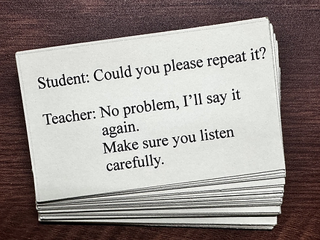
圖二
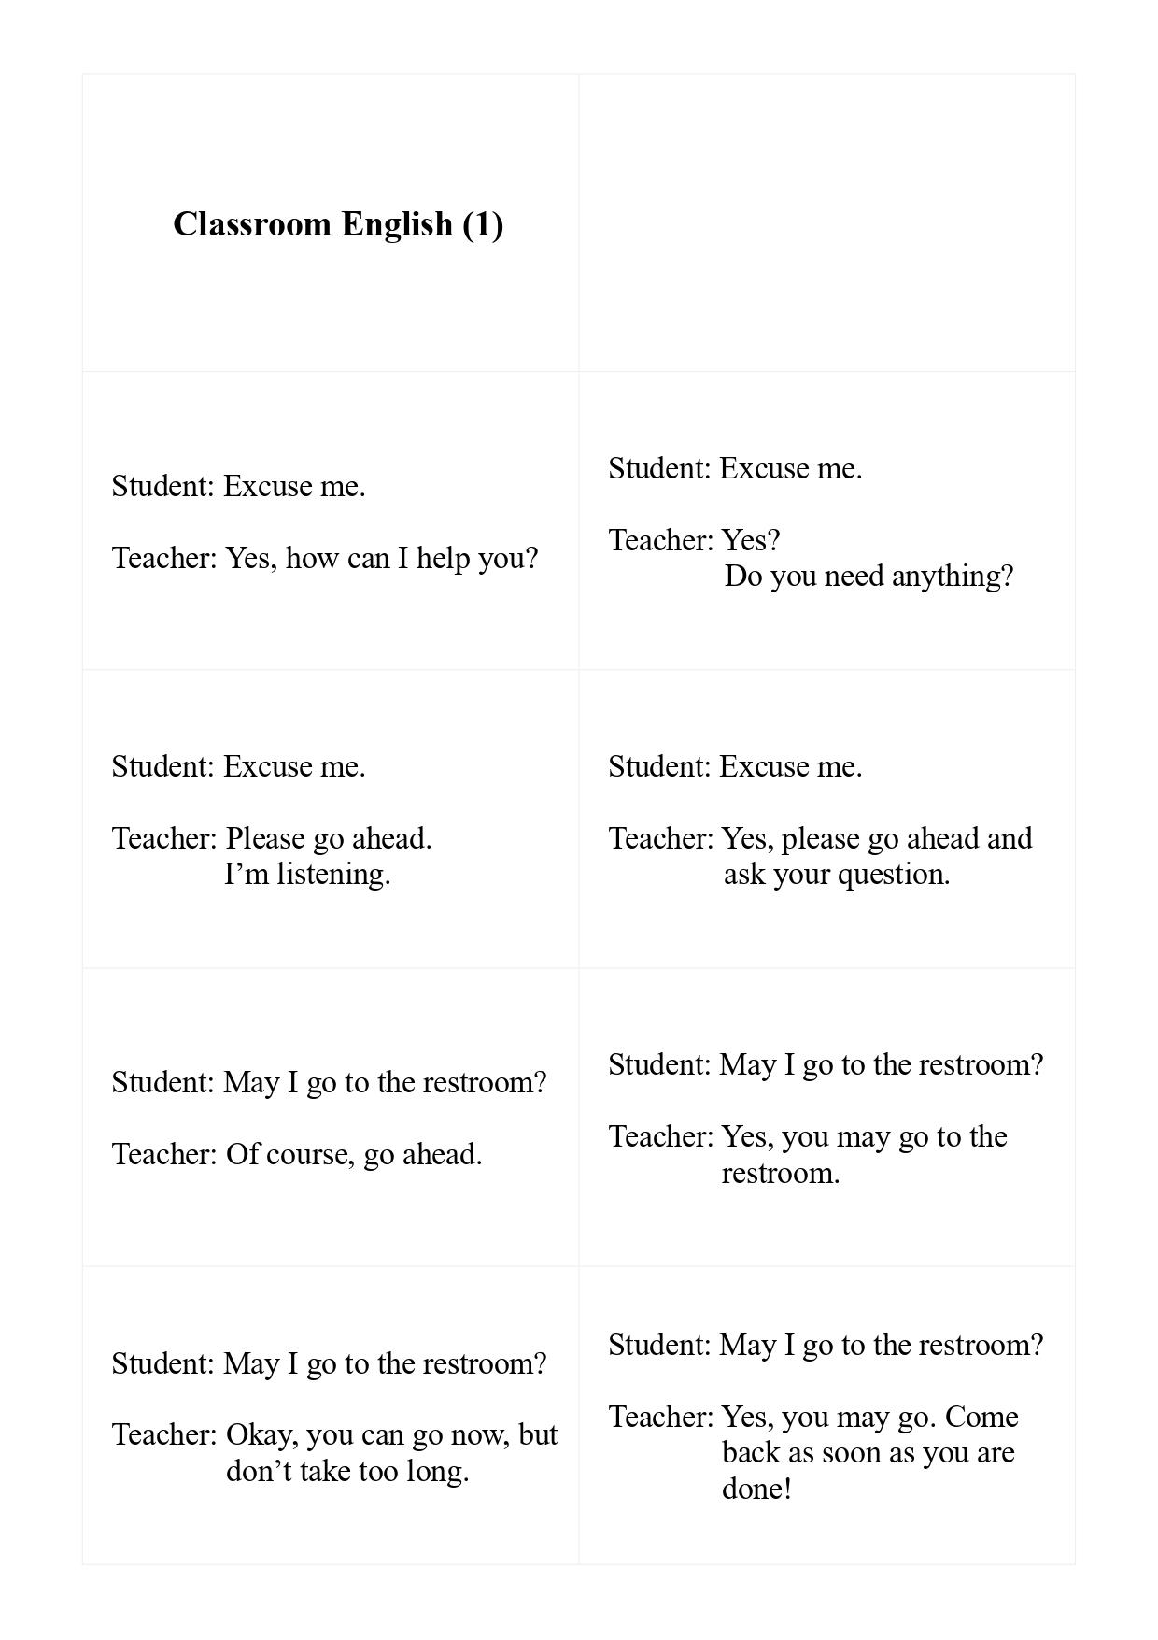
－15－

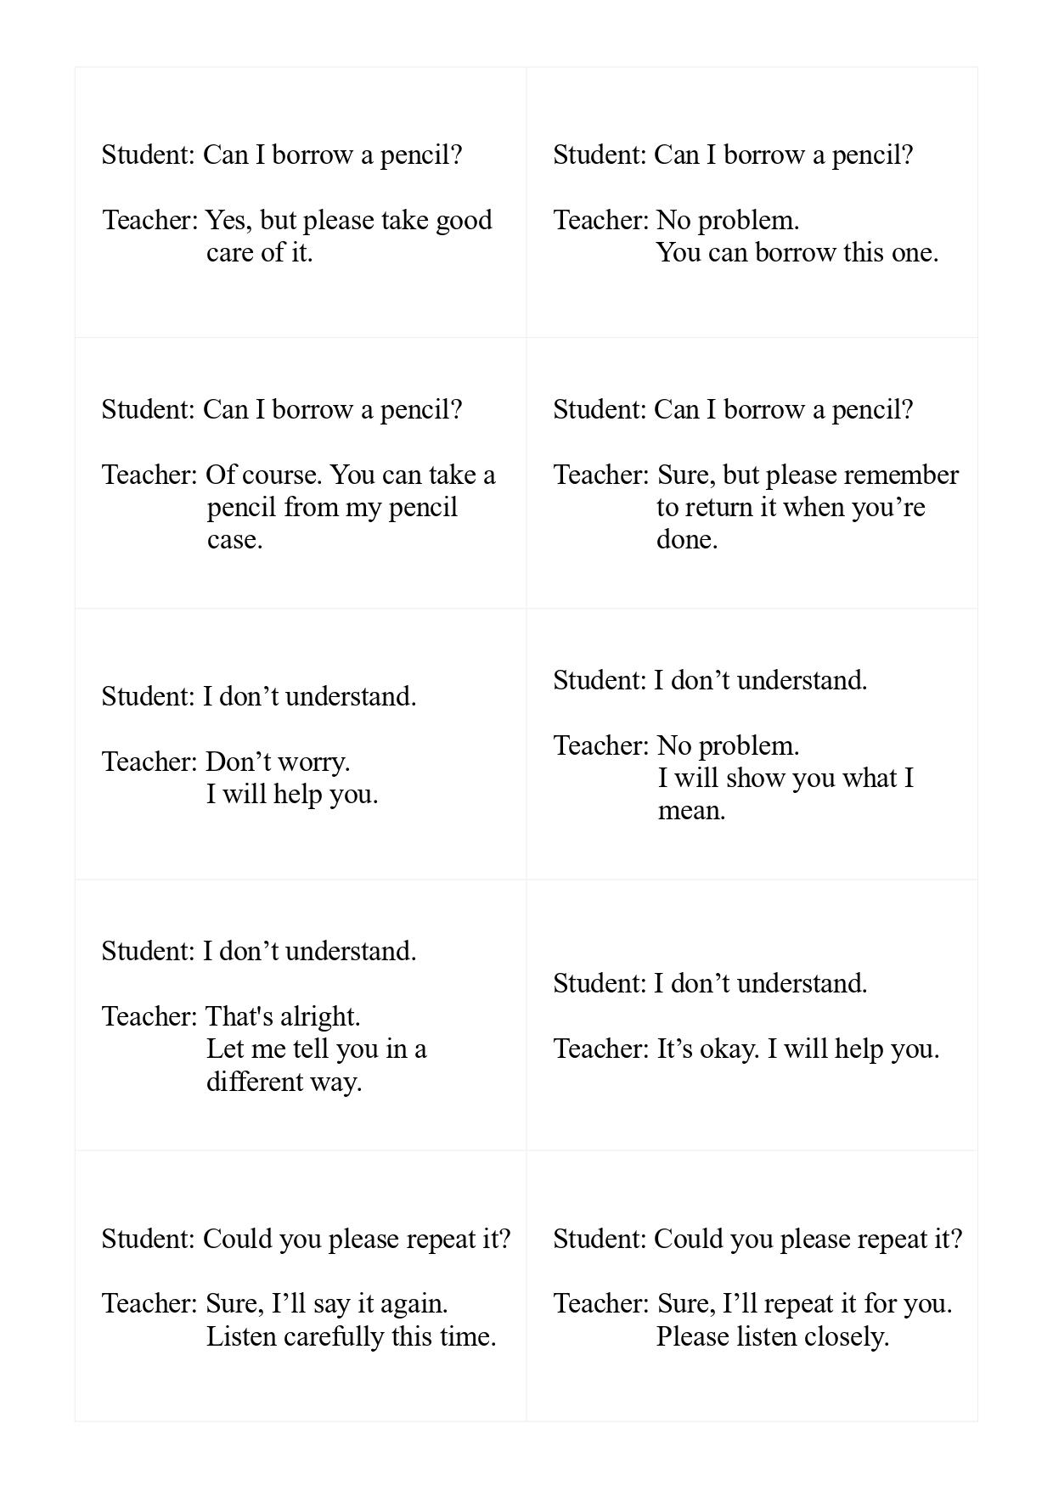
－16－

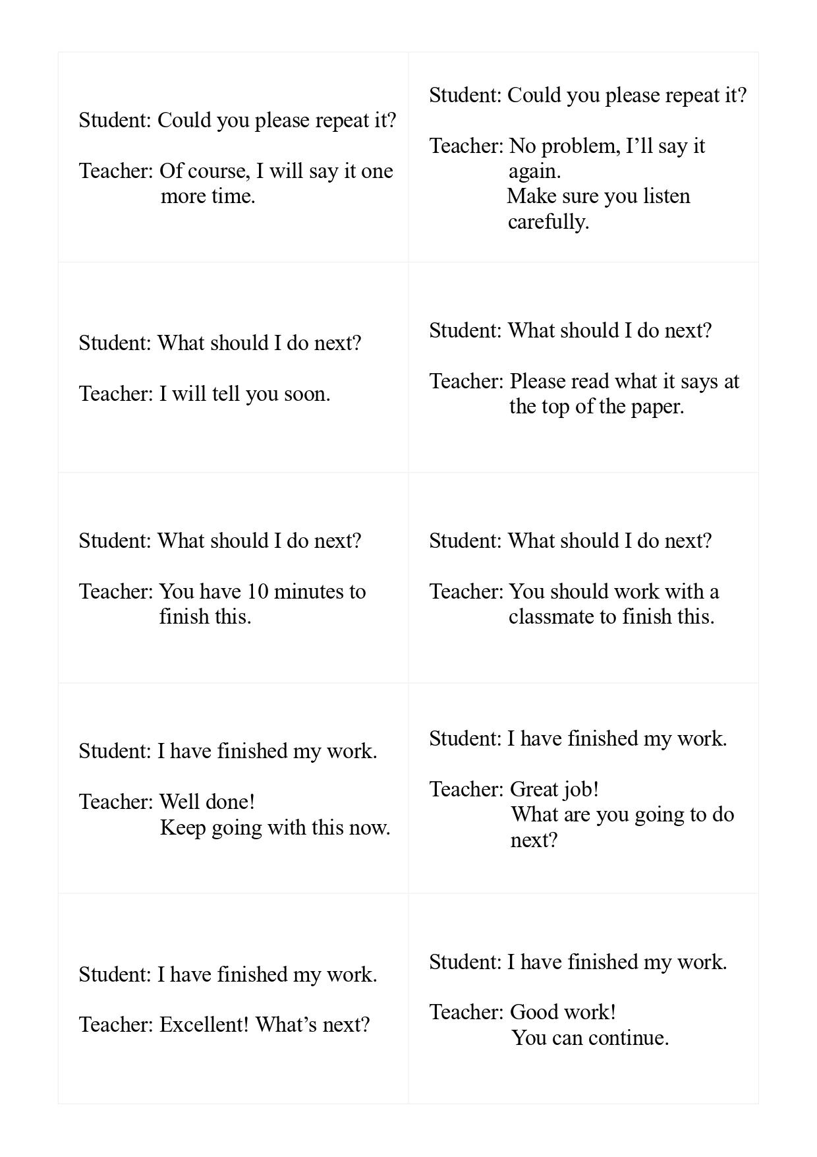
－17－

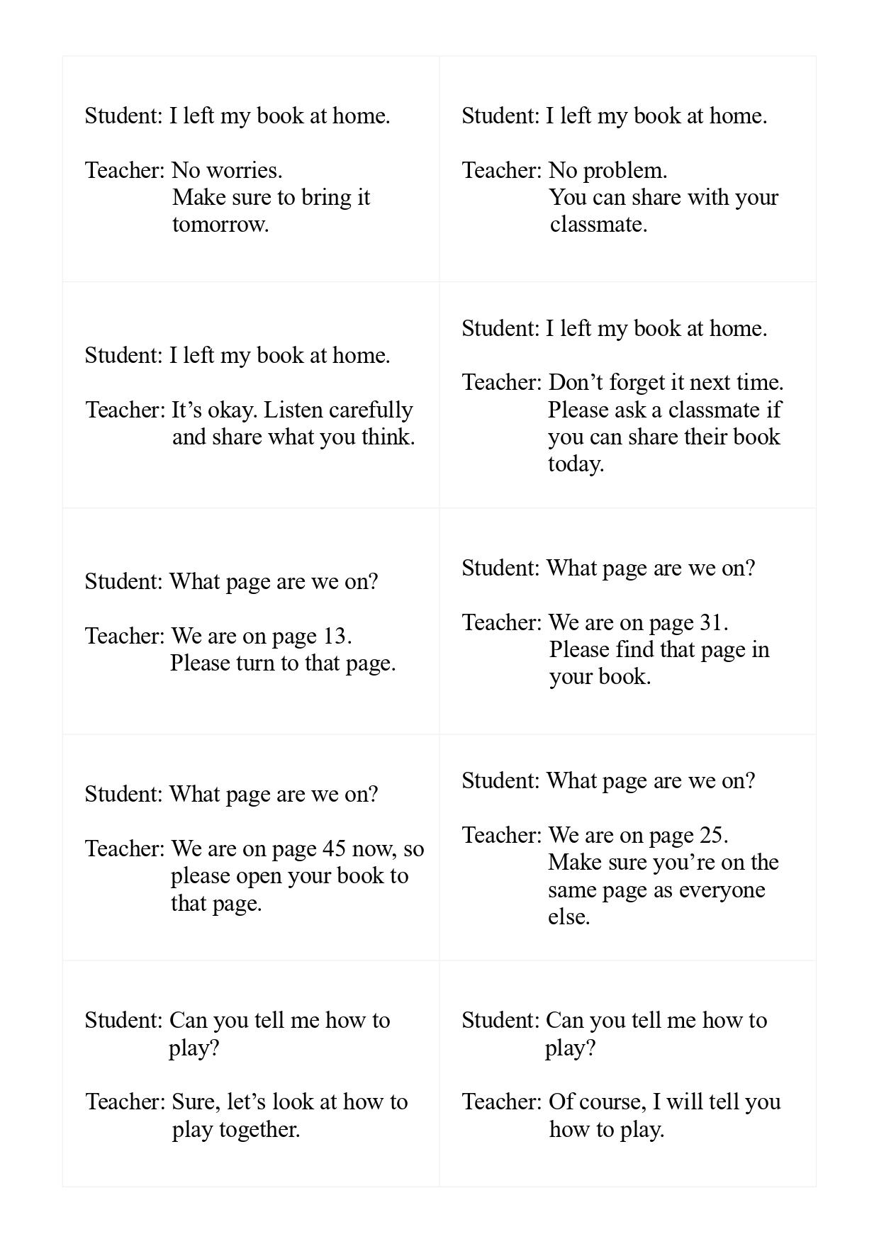
－18－

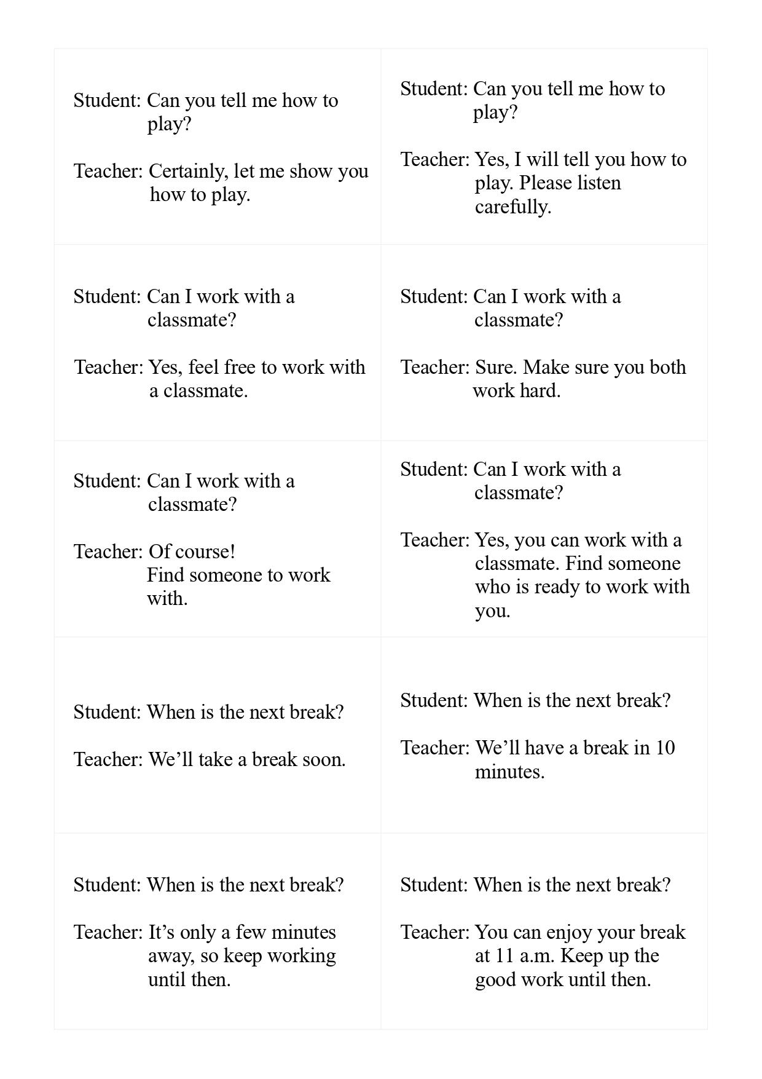
－19－

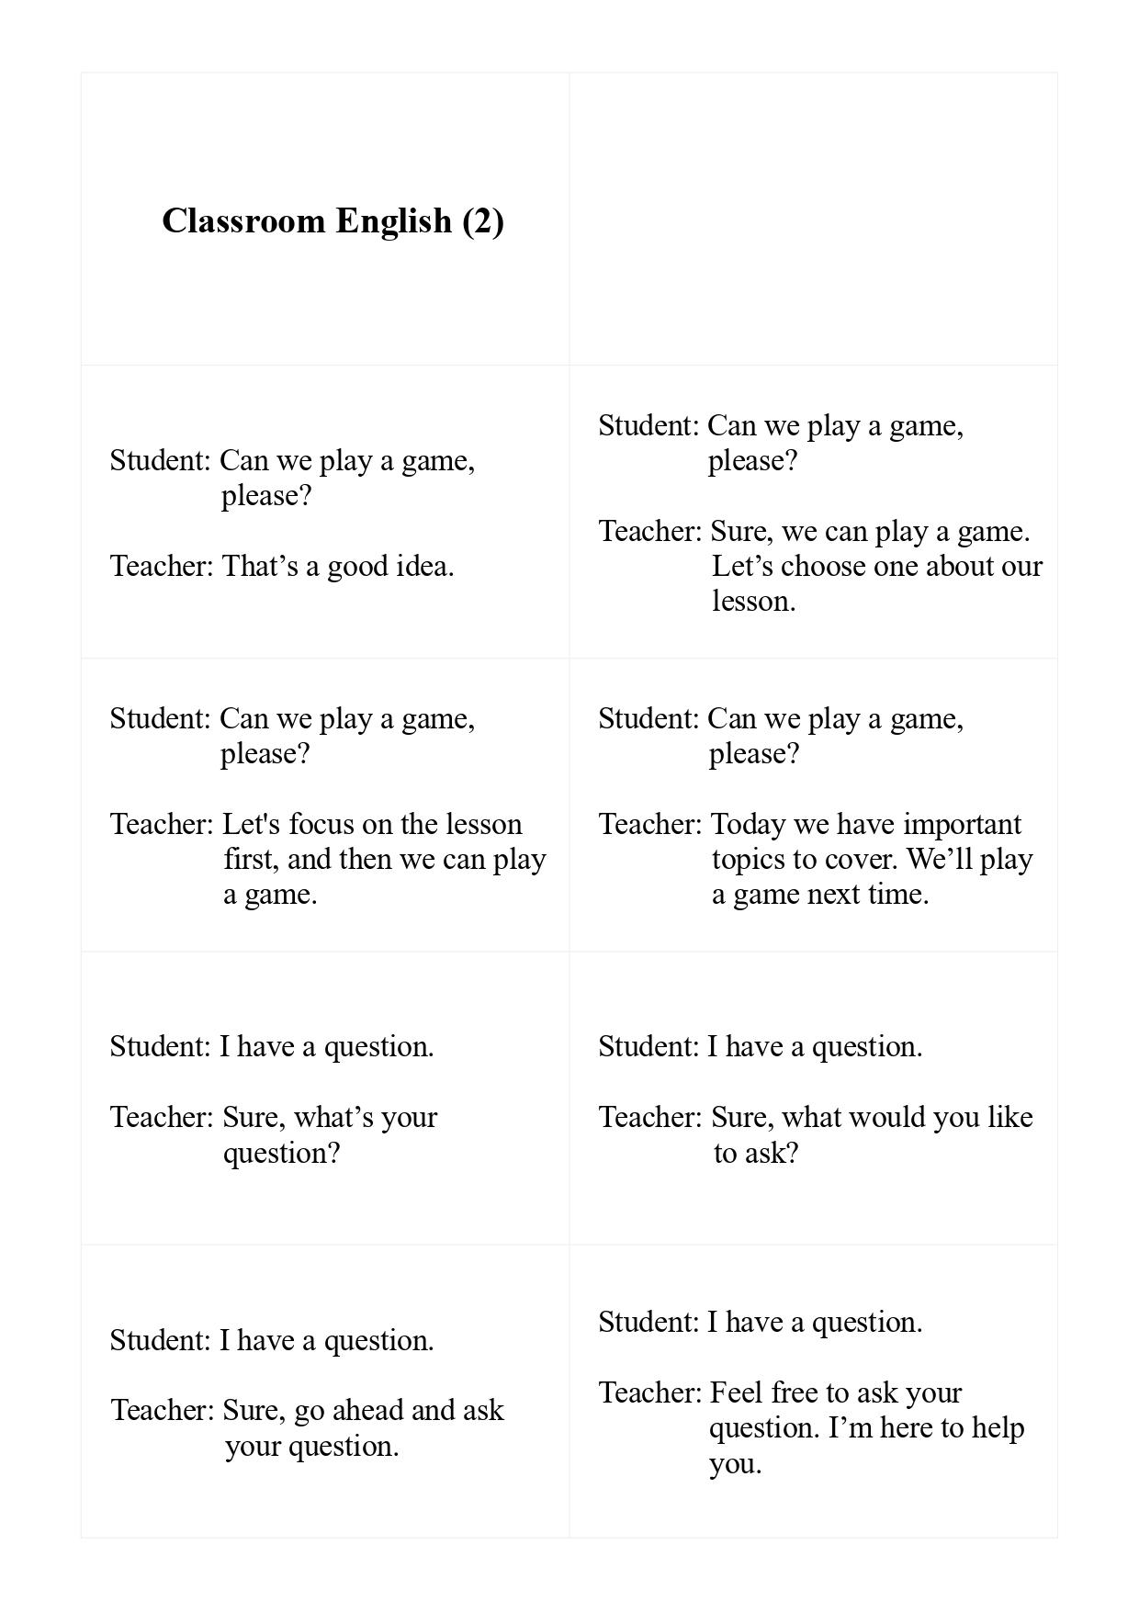
－20－

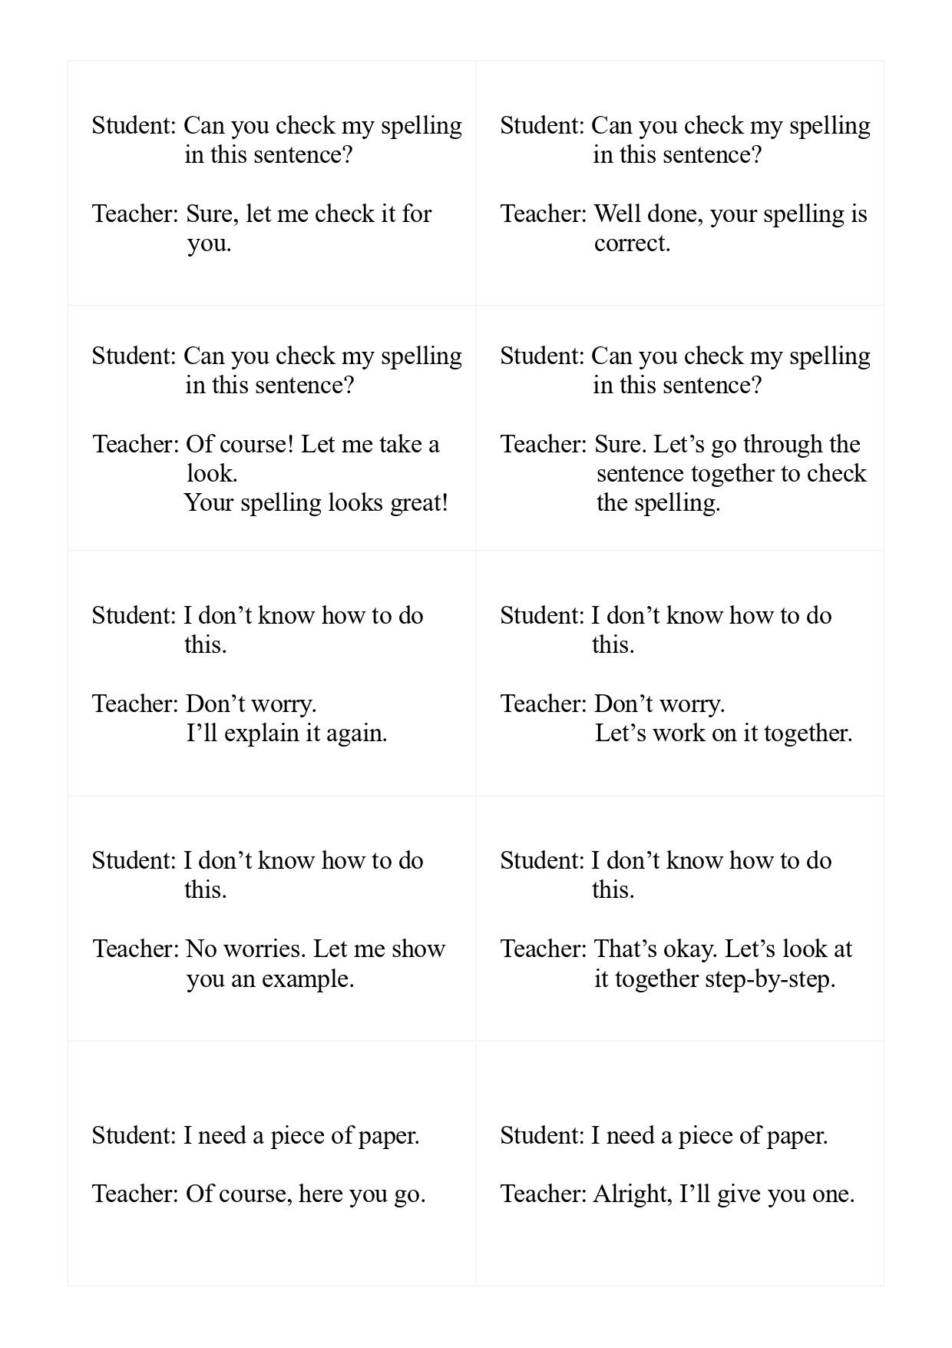
－21－

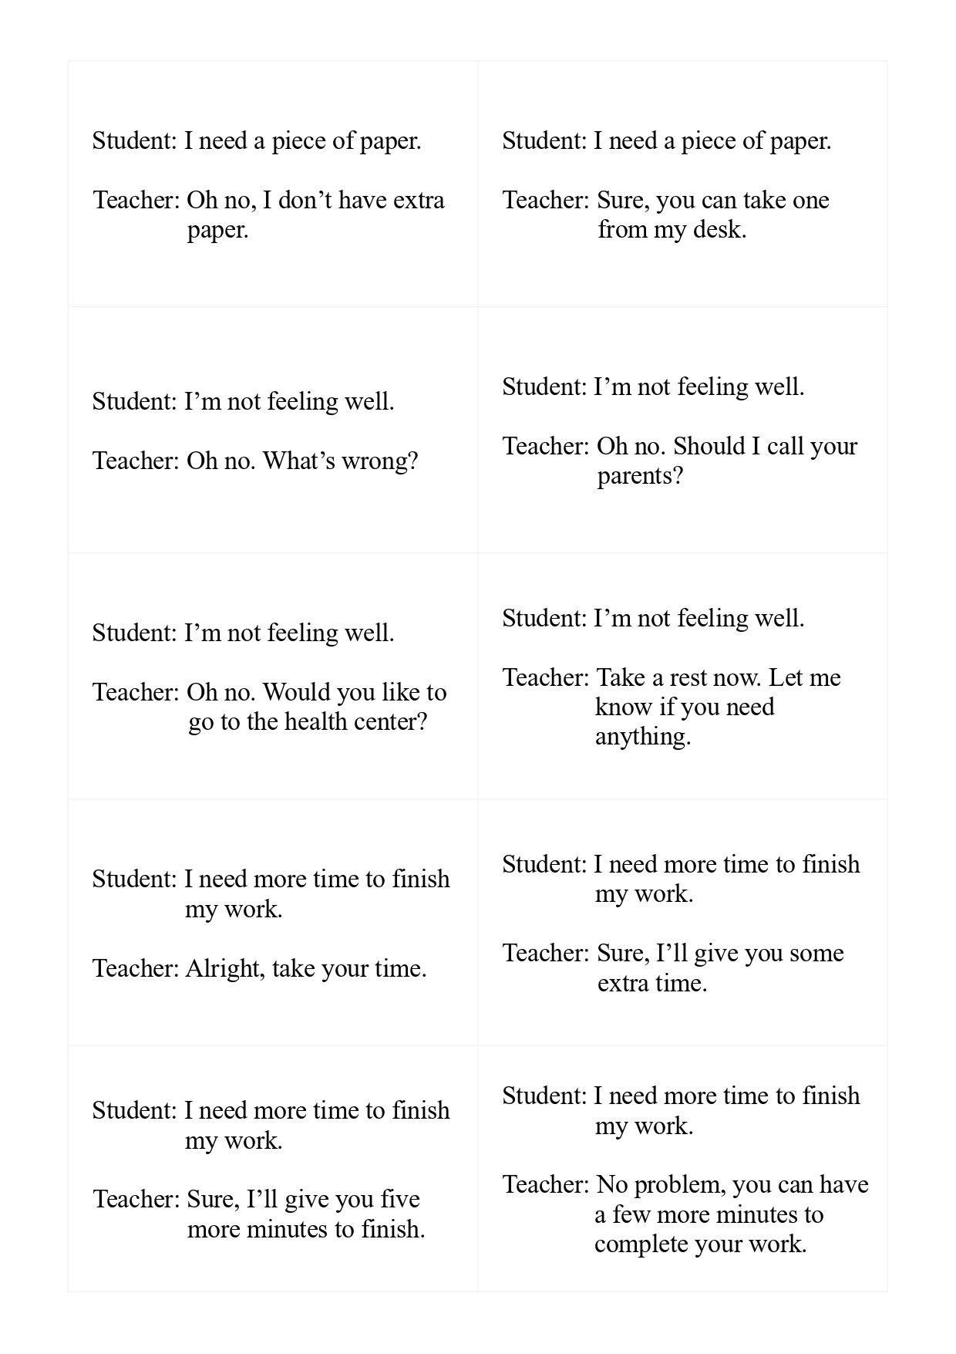
－22－

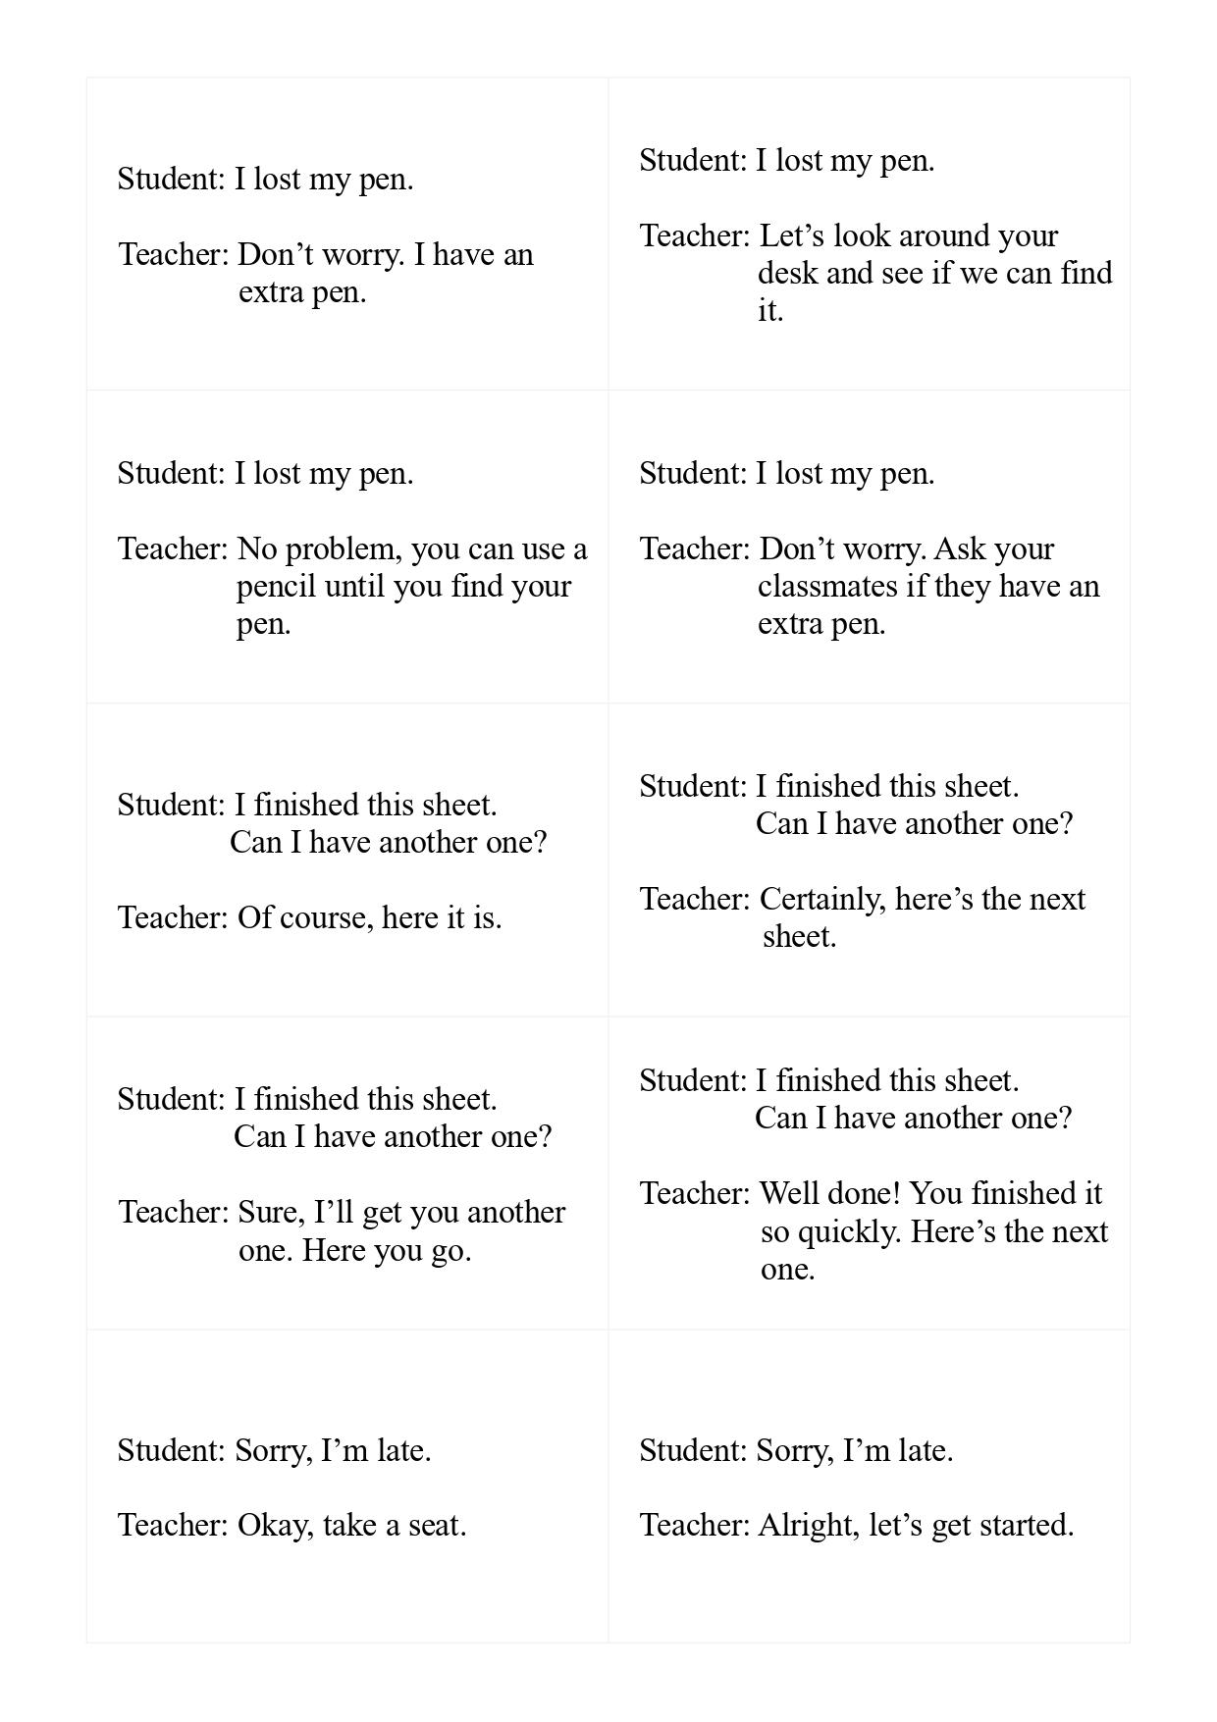
－23－

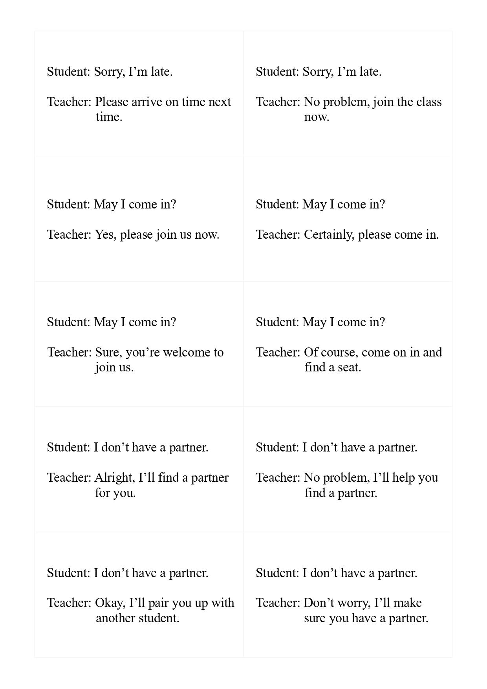
－24－
五、課室英語桌遊卡教學運用方法

宜蘭縣立凱旋國中陳育萱Susan老師

每一個孩子都能夠聽懂課室英語，
每一個孩子都能夠講出課室英語，
藉由課室英語讓孩子們願意勇敢開口說英語，
藉由課室英語讓孩子們真的視英語為溝通工具，
有沒有可能?

感謝臺灣師範大學國中小教育階段英語課採全英語授課計畫團隊發想、規劃、設計並印製課室英語卡牌，讓這一切更有可能。我們希望孩子們能把英語視為一個有用並有效的溝通工具，一個打開通往世界大門的鑰匙，而不只是一個「會考」會考的考試科目。108課綱強調真實情境以及真實問題，「教室」就是孩子們每天面對最真實的情境，因此讓孩子們可以在教室這個真實情境中運用他們所學有關英語的知識、溝通的技巧並展現出適當的態度解決情境中的問題，也就是達成溝通目的，這樣的學習不僅能讓孩子們對於英語學習更有信心，也更能促進學習遷移的發生。

然而，縱使我們知道課室英語的重要性，在教學現場仍然會遇到許多挑戰，例如：最容易上手的課室英語是教學者的語言，當老師們都可以使用適當的課室英語之後，下一個階段就是要孩子們也可以使用課室英語。課室英語桌遊卡就是用師生對話的方式設計，讓孩子能夠知道自己能夠如何表達，而且也藉由卡牌的設計體會到溝通回應的多樣性。課室英語卡牌提供了適當的教材並且讓老師們可以彈性地使用在課程中，運用不同的設計，卡牌遊戲可以是一整節課，也可以一節課只用五分鐘。

Why 為什麼要使用卡牌來推行課室英語呢?
「為什麼」是最重要的，了解卡牌設計的目的及其能達到的效益，老師們才會願意將寶貴的課堂時間投入在學生課室英語的學習。
- 藉由遊戲的方式讓孩子們產生對學習的興趣。
- 透過遊戲以及分組降低孩子們學習的焦慮。
- 課堂就是真實情境，能在真實情境下完成溝通目的能建立孩子們學習的信心。
- 在課堂中講英語能鼓勵孩子們用英語思考。
- 一副卡牌可以設計出多樣的活動，讓孩子們可以達到螺旋式的學習。

What 教學目標是什麼呢?
使用卡牌我們希望能夠達成哪些教學目標呢?有了教學目標，我們就能夠設計教學活動。

- 孩子們能「聽懂」課室英語。
- 孩子們能「讀懂」課室英語。
- 孩子們能用正確的發音「念出」課室英語。
- 孩子們能在適當的情境下「使用」的課室英語。
- 孩子們能夠舉一反三，使用卡牌以外的課室英語。

When課室英語卡牌可以在什麼時候進行呢?
視學生的程度以及學習情況，將課室英語的卡牌融合在國中三年的課程裡，讓課室英語卡牌的內容成為學生學習的共同語言，貫穿國中三年的學習。以我們學校學區的學生為例，搭配課程進度，安排如下：
- 從祈使句那一課開始介紹卡牌內容，安排幾節課練習操作。
- 七年級熟練第一副卡牌；到了八年級，再熟練第二副卡牌。
- 將卡牌當成課程的暖身遊戲，利用課堂一開始的三到五分鐘。
- 也可以當作學生的獎勵，讓他們玩遊戲，或者是差異化學習的學習站，如：較快完成任務的同學可以先玩遊戲。
- 卡牌中若有適當的內容可融入課本的文法句型或對話中，設計相對應的教學任務。

How除了桌遊卡建議的玩法之外，還可以如何使用卡牌呢?
為了要達成我們的學習目標，讓孩子們可以適當的使用課室英語，可以設計不同的教學活動，有些活動只是讓孩子們熟練內容，有些活動確認孩子們的理解，任務時間有長有短，可以增添課程的多樣性。
- 列入定期評量的測驗：將卡牌上的內容列入定期評量的閱讀、聽力或口說測驗中。
- 使用各種網路平台進行線上遊戲，如：Quizlet, Quizizz, Kahoot, Gimkit, Blooket, Wordwall等。
- 比速度：兩人一組唸出卡牌內容，計時較快的獲勝。
- Running dictation：將卡牌貼在教室四周，每組幾位學生去看卡牌內容後回來回報。
- Treasure hunt：把卡片藏在教室不同的角落，學生找到卡片念給老師聽即可得分。
- Quiz-Quiz-Trade：每個人手上拿一張卡片，找到夥伴，互相念彼此卡牌上的句子後交換卡片，可練習朗讀熟練度。
- Board game：可以將卡牌搭配不同的GAME Board讓學生進行兩兩或小組競賽，增加口語練習機會。
- Bingo：做成Bingo卡來進行遊戲，可以小組進行也可以全班一起玩。
- Learning coach 講解：兩兩一組，拿幾張卡牌講解給對方聽，亦可當作口語測驗。
- Jigsaw翻譯：原組4人，將每個組員分配到專家小組，來自不同組別的專家一起討論一組主題卡牌(四張)上的句子意涵，再帶回原組與組員分享，不見得每一個句子都要老師解釋，但是希望孩子能夠理解每一個卡牌的內容。
- Matching：將卡牌面朝下放在桌上，輪流翻牌，一次翻兩張牌，每次翻牌都要念上面的句子，若翻到相同的第一句，則收起來得分，可繼續翻下兩張卡片。
- 連連看：將前後兩句拆開，可使用紙筆測驗或製作簡報讓學生回答或搶答，可確認理解。
- 分類說明原因：將卡牌分類並說明分類原因，引發更多理解以及思考。
- Rate it.：一組對話中讓學生討論哪一個是他們覺得最好用/最好懂/最常用的回應，並解釋原因，可促進思考與理解。
- 插圖配對：讓AI畫有對話框的插圖，請學生選出在情境中最有可能出現的對話。
- 敘述情境：老師用英語敘述一段情境，讓學選擇或搶答可能會發生什麼對話。
- 克漏句：列出一段對話，中間挖空幾句，讓學生選擇適當的卡牌放進去。
- True or false：老師念出一個兩句對話，學生判斷是否正確，可促進理解。
- 反推：老師念出第二句，學生反推回去第一句可能是什麼，雖然不符合一般對話邏輯，但可以檢視學生是否理解語意。
- 舉一反三：除了卡牌上列出的回應之外，請小組討論還有沒有別的回應方式。進階版也可以限制回答的字數，增加趣味性。
- 條件限制：在特定的文法主題時，選擇適當的對話，讓學生練習用該課文法句型造回應句。例如：當學生說I don't understand. 老師如何用關係子句回答呢?如此一來就可以用熟悉的情境練習該文法。
- What's NEXT: 接續卡片上的對話，發展接下來可能的對話或者動作，亦可錄製成短影片，當作多元評量。

課室英語桌遊卡遊戲手冊

委託單位：教育部國民及學前教育署
委辦單位：國立臺灣師範大學英語學系
委辦計畫：2030雙語政策(111至113年)─提升高中以下英語文教師教學效能—十二年國教─國中小教育階段英語課採全英語授課暨全英語教學影片製作計畫
計畫諮詢專家：國立臺灣師範大學英語學系 張武昌教授
計畫主持人：國立臺灣師範大學英語學系 王宏均副教授
協同主持人：國立臺灣師範大學英語學系 曾俊傑副教授
中國醫藥大學 黃文志助理教授
計畫助理：國立臺灣師範大學英語學系 楊慧欣助理
國立臺灣師範大學英語學系 陳柏瑋助理
國立臺灣師範大學英語學系 陳薏如助理
卡牌文字校對：臺北市立中正高級中學 Alex Wallace 老師
影片製作：國立臺灣師範大學英語學系 趙亦萱兼任助理
封面封底設計：國立臺灣師範大學英語學系 楊慧欣助理
特別感謝：宜蘭縣立凱旋國民中學 陳育萱主任
編輯日期：中華民國 113 年 3 月

