宜蘭縣立羅東國民中學107學年度第一學期八年級英語科第三次段考試卷 命題老師:張家翎老師
第1~35 題請將答案劃在電腦卡，第36 ~52 題寫在答案欄
- 聽力測驗20%（每題2分）每題念二次
A. 辨識句意：根據聽到的內容，選出符合描述的圖片。
1. | 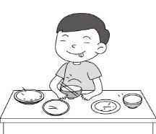  (A) | 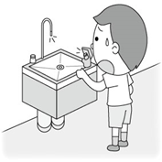  (B) | 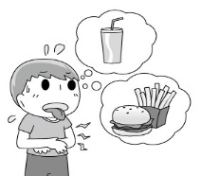  (C)
2. | 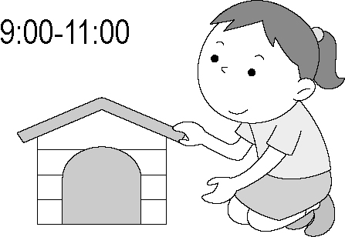  (A) | 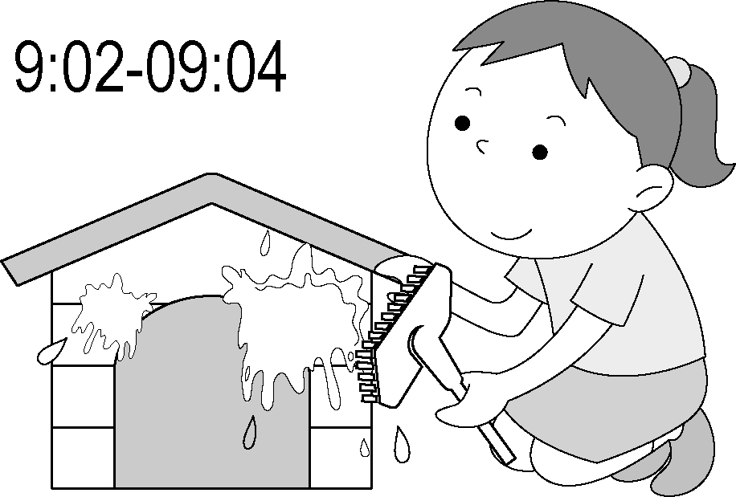  (B) | 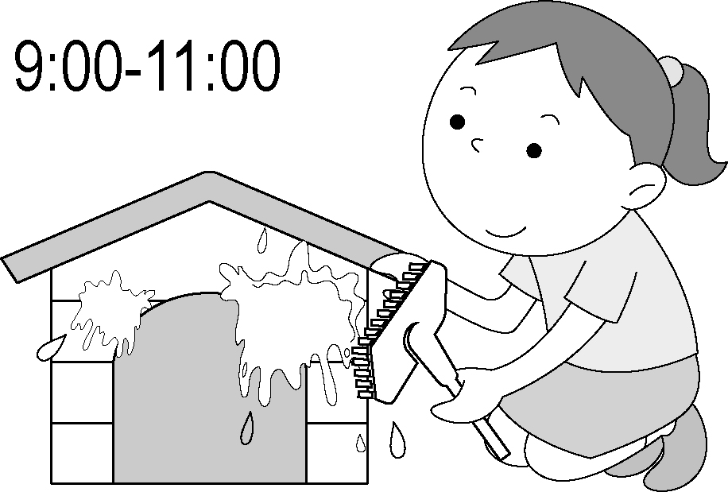  (C)
3. | 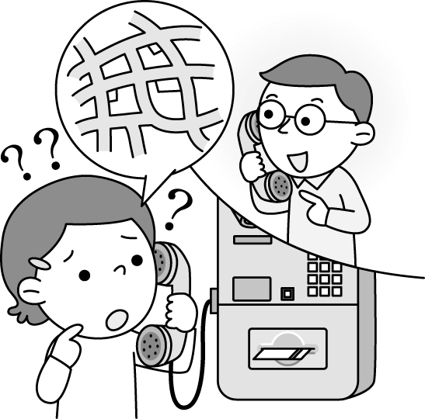  (A) | 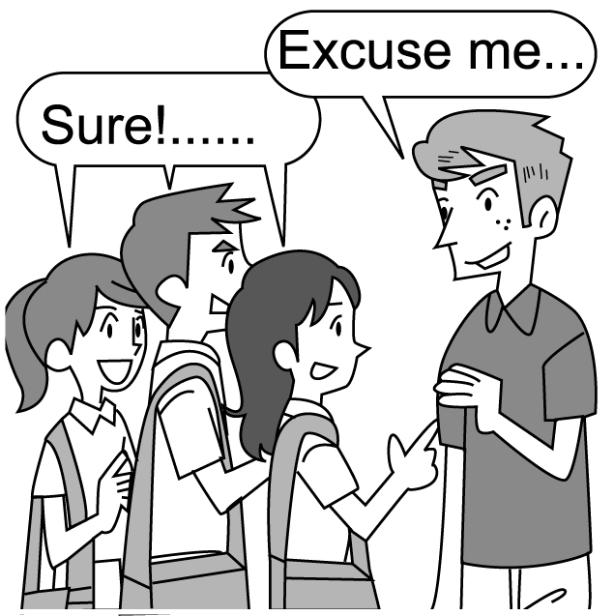  (B) | 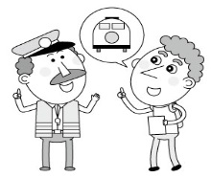  (C)
B. 基本問答：根據聽到的內容，選出一個最適合的回應。
- (Ａ) It was very cheap.
(Ｂ) I bought it at Joy Department Store.
(Ｃ) Thanks. I will buy five T-shirts next weekend.
- (Ａ) Really? Have a good time. (Ｂ) I like hiking.
(Ｃ) Sorry. I have no time.
- (Ａ) It is easy to drive a train.
(Ｂ) You have only one hour to be there .
(Ｃ) It’s not far from here. It’s next to the fire station.
C. 言談理解：根據聽到的內容，選出一個最適合的答案。
- (Ａ) We’re not sure. (Ｂ) Have dinner. (Ｃ) Take a walk.
- (Ａ) Go to the movies. (Ｂ) Have ice cream. (Ｃ) Go biking.
- (Ａ) To the party. (Ｂ) To the hospital. (Ｃ) To the bookstore.
- (Ａ) He hit a little boy, and the boy was hurt.
(Ｂ) He hurt his leg, so he had to walk slowly.
(Ｃ) There was something wrong with his bike.

二、克漏字測驗。8%（每題2分）
There are many different ways to go to work. Some people go to work 11 . Some people go to work _12 MRT. Jason goes to work in a special way. He lives on a small island in Penghu. He gets up at seven and 13 a boat to his office. It 14 him one hour to go to work every day. It's tiring but he is happy because he can learn a lot of knowledge from his boss and his colleague !
★tiring令人疲累的 ★knowledge 知識 ★colleague同事
11. (A) walk (B) on foot (C) ride a bike (D) rides a bike
12. (A) in (B) on (C) by (D) take
13. (A) by (B) takes (C) rides (D) on
14. (A) takes (B) pays (C)costs (D) spends

三、閱讀測驗。12%（每題2分）
＊ Question 15~17
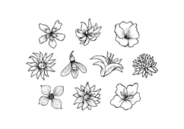
5 Hot Places
at Yuling Floral Expo
Enjoy amazing summer time in Yuling!!
Minnnan Old House & Museum
It is a 300-year-old Fukienese building. There is a square in the middle of the big house. Around the square are 24 rooms and two ponds. There is also a beautiful Chinese garden in back of the house. People can see some beautiful flowers, waters, bridges and Chinese plants in it.
EcoARK
The green building is made of water bottles. They use recycled water to cool down the building, so people don’t feel hot on the first floor, even in summer. There are also some interesting lessons about recycling. Take the MRT to Gym Station. Then go north for two blocks to Zhongshan Rd. and turn right. You’ll first see Minnan Old House and Museum. Then EcoARK is just next to it.
Yuling Story House
The English Tudor style house is now a small museum to show the history of Yuling and also has art activities for people. After visiting the museum, people can have a nice afternoon tea at the Story Tea House and enjoy the beautiful English garden. The museum is from 11 a.m. to 7 p.m., every Tuesday to Sunday.
Fine Arts Park
There are Floral Tunnel and Yuling Fine Art Museum in Fine Arts Park. Walking along Floral Tunnel, people can see different gardens from the United States, Thailand, Belau, Japan…… In the art museum, people can find a special Russian painting show. Parents can also take their children to Children’s Art Center to join some activities like painting or story telling.
Yuling Rose Garden
The garden is home to over 700 kinds of roses after seven years. Why seven years? It is hard to plant these many roses in Yuling because of its hot weather and the typhoons. Now people can enjoy the sweet smell and the beautiful flowers. Just get off at Gym Station and walk through Fine Arts Park to get there.
Expo博覽會 building建築物 square廣場 bridge橋
recycle再利用 north北方 style 形式 tunnel隧道 kind種類 rose玫瑰 smell 味道 get off下車
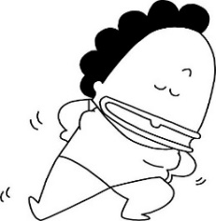
15. My husband and I plan to take our daughters to visit the Floral Expo this Saturday afternoon. The sisters enjoy listening to stories, the dad enjoys gardening, and I want to see some wonderful paintings. Where should we visit for our lovely Saturday afternoon?
(A) EcoARK. (B) Yuling Story House.
(C) Fine Art Park. (D) Yuling Rose Garden.
16. Cindy and her classmates are going to do a report about how to help Mother Earth. They are trying to find out the place on the map at Gym Station. Which can be the place on the map?
(A)A (B) B (C) C (D) D
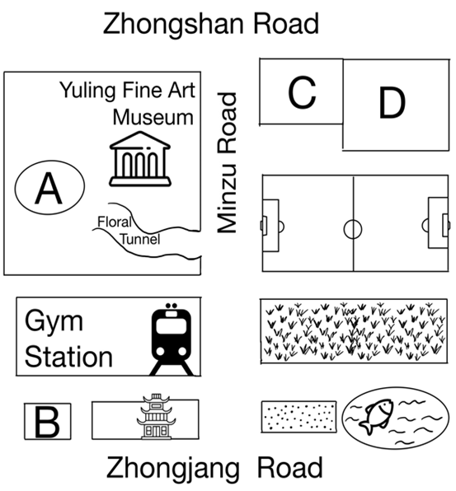

17. Which of the following is TRUE about the reading?
(A) EcoARk can stay cool because of the cool wind.
(B) The weather in Yuling is nice for roses to grow.
(C) People can see different building styles at Yuling Floral Expo.
(D) People can watch Chinese plants in the middle of Minnan
Old House and Museum.
＊ Question 18~20.
 | First Street | Spring Road |  | Second Street
YOYO  Gym |  | bookstore | ice cream shop |  | LTJH School
 |  |  | movie theater
 |  | Summer Road
Andy’s  home |  | restaurant | supermarket |  | park
 |  | Autumn Road
Kevin’s  home |  | library | sports shop |  | TP Train Station
 |  | Winter Road
18. Where is the bookstore?
(A) It is in front of the park.
(B) It is next to the restaurant.
(C) It is between the sports shop and the library.
(D) It is on the corner of First Street and Spring Road.
19. Mandy is now at the ice cream shop. She wants to buy some snacks and drinks first, and then goes to Kevin’s place. Which way is most likely to take? most likely 最有可能的
(A) Spring Road Winter Road First Street
(B) Second Street Autumn Road First Street
(C) First Street Summer Road Second Street
(D) Spring Road First Street Summer Road
20. Someone blocks(阻塞) the corner of Summer Road and Second Street. Which can’t Andy go past when he goes to school from home?
(A) A restaurant. (B) A gym.
(C) An ice cream shop. (D) A supermarket.

四、綜合測驗：請選出最適當答案。15%（每題1分）
21. The little girl is lost. Let’s take her to the _____.
(A) bank (B) supermarket (C) train station (D) police station
22. Lucy likes to live in the ___ because of the fresh(新鮮的) air.
(A) hotel (B) map (C) station (D) country
23. Tommy plans ______ _____with his family.
(A) going ; watching birds (B) to go ; bird watching
(C) going ; bird watching (D) to go ; watching birds
24. Tim will see a movie with friends, but I ____.
(A) will (B) won’t (C) am not (D) am not going
25. A: Oh my goodness! We’re lost.
B: Here comes ____. Let’s ask him for help.
(A) a man (B) Judy
(C) the men (D) he
26. Sandra’s ________ Japan next month.
(A) go to (B) will go to (C) going to (D) going to go
27. A: _____ did you ___ for the dress ? B: About 3000 dollars.
(A) How much;pay (B) How much;spend
(C) How many;pay (D) How many;spend
28. We will ___ Sara like a princess for the Halloween party.
(A) get to (B) break down (C) put on (D) dress up
29. Derek is on his way to Japan now. He _______ be back to Taiwan until Friday. Let’s meet him this Saturday.
(A) won’t (B) isn’t going (C) will (D) is going to
30. The dress looks good ___ you. Why not take it?
(A) for (B) at (C) in (D) on
31. My birthday is coming. I can’t wait ____ my gifts from my parents. (A) to see (B) seeing (C) see (D) will see
32. A: How can we ____ there ?
B: I don’t know. Let’s google the map first.
(A) arrive in (B) get (C) get to (D) take
33. A: Tom donated many toys to the kids at the children’s home.
B: Wow, he’s really _____.
(A) all together (B) having fun
(C) far from here (D) out of this world
34. Tina: Will we win or lose the game tomorrow, Mr. Wu?
Mr. Wu: Don’t worry. __________
(A) I’m happy to hear that. (B) It’s very kind of you.
(C) It won’t take long. (D) You will win for sure.
35. Judy: May I try on this jacket? Clerk: Sure. _______
(A) You couldn’t miss them. (B) Here you are.
(C) We had great fun. (D) Let’s get it ready.

五、文意字彙。9%（每題1分）
36. Put on your s r and jacket. It’s cold outside.
37. The cellphone is nine th d dollars.
38. E e me. Where is the library?
39. My mom always p es a big dinner for my birthday.
40. In Taiwan, people under 18 can’t ride a m e.
41. It’s hard to find water and plants in a d t.
42. Please draw 3 s t lines with a ruler on the paper first.
43. Let’s go to the p d for the swing there.
44. There’s a school a s from the bank.

六、依提示作答。4%（每題2分）
45. There was much snow last winter.
(將畫線部分改為next winter, 並以be開頭改寫句子)
46. This pair of shoes cost her 300 dollars. (用spend改寫)

七、填空翻譯。12%
47. 上週我們從這裡出發並且沿著橡樹路開車。
We (1) (2) from here and (3) along Oak Road last week.
48. 我拜訪了我祖母並且拍了她狗狗們的照片。
I visited my grandma and (1) (2) (3) her dogs.
49. Amy上周帶我們去玩翹翹板。
Amy took us to (1) (2) the (3) last week.
50. 到達那公園要多久?
(1) (2) does it (3) to get to the park?

答 案 欄 班級: 座號: 姓名:
五、文意字彙。9%（每題1分）
36 |  | 37 |  | 38
39 |  | 40 |  | 41
42 |  | 43 |  | 44
六、依提示作答。4%（每題2分）
45.__________________________________________________
46.__________________________________________________ 七、填空翻譯。12%
47 | (1) | (2) | (3)
48 | (1) | (2) | (3)
49 | (1) | (2) | (3)
50 | (1) | (2) | (3)

