宜蘭縣立羅東國中107學年度第一學期七年級英語科第二次段考試卷 命題老師：聯合命題
＊本份考卷共有56題，1~38題答案請畫在答案卡上，39~56題答案請依題號書寫在答案欄。本試題共兩頁。

一、聽力測驗 (本測驗分為 A、B、C三部分，共計十題，每題將唸兩次，皆為單選。請將答案畫在答案卡上。)
每題2分，佔20%
- 辨識句意：根據聽到的內容，選出符合描述的圖片。
1.
(A) 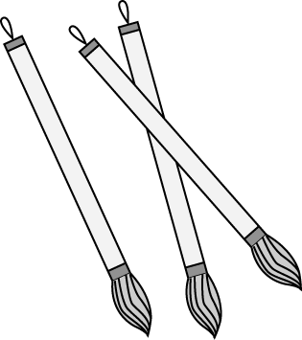 | (B) 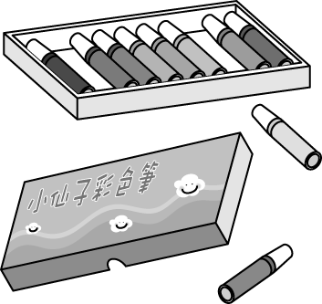 | (C) 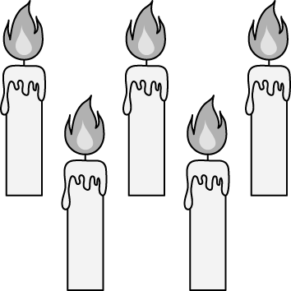
2.
(A) 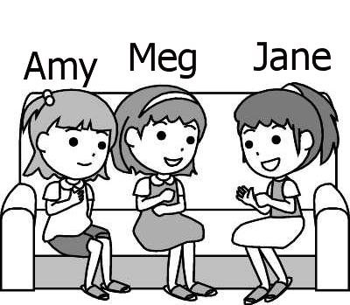 | (B) 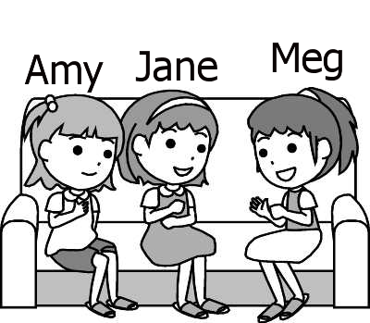 | (C) 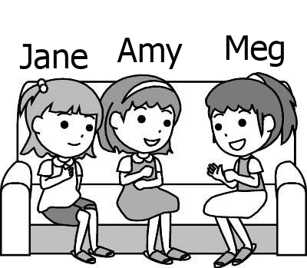
3.
(A) 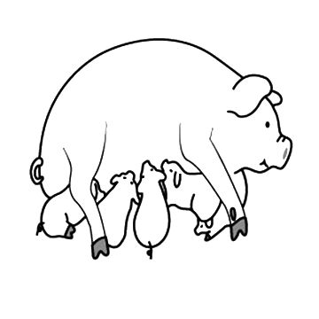 | (B) 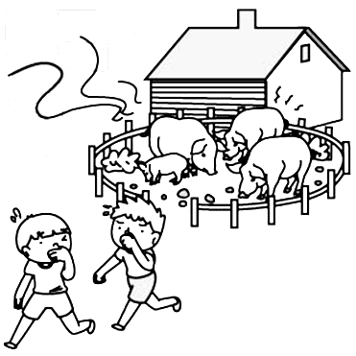 | (C) 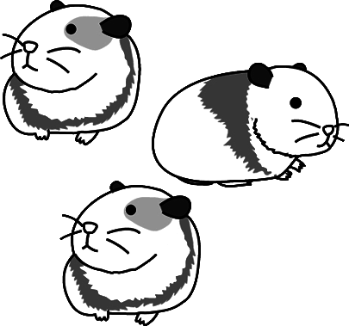
B、基本問答：根據聽到的內容，選出一個最適合的回應句。
4. (A) You’re welcome.
(B) Thanks. I’m very happy.
(C) Really? It’s your birthday today!
5. (A) Yes, it’s a box.
(B) No. That’s a brush.
(C) Those are beautiful boxes.
6. (A) Yes, she is at the park.
(B) Yes, it is a big and new park.
(C) Yes, Joy Park is in back of our school.
C、言談理解：根據聽到的內容，選出一個最適合的答案。
7. (A) Pinky is the man’s dog.
(B) The black hat is for the dog.
(C) The hat is white, and the dog is pink.
8. (A) In the red box.
(B) In the green box.
(C) In the white box.
9. (A) A school.
(B) Four teachers.
(C) Twenty students.
10. (A) It’s next to the bedroom.
(B) It’s next to the kitchen.
(C) It’s next to the dining room.

二、配合題: （第11~14題）於下列選項中選出一個適合的回應，每題1分，佔4%
11. What is that?＿＿＿ | 12. What are those?＿＿＿
13. Is this a book?_____ | 14. Are those watches?＿＿
(A) Yes, it’s an English book. (B) They are rulers.
(C) It’s a workbook. (D) Yes, they are watches.
(E) No, this isn’t. (AB) No, those aren’t.
三、看圖回答: （第15~18題）下列敘述與圖片相符填C，不符填E，每題1分，共佔4%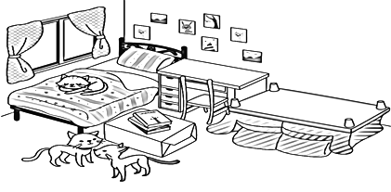
15.( )The chair in the room is upside down.
16.( )The desk is between the bed and the sofa.
17.( )There aren’t any books on the desk.
18.( )There is a cat under the bed.

四、請選出一個正確或最佳的答案，每題1分，佔15%。
19. A: Are ______ any cookies in the bag? B: Yes, ______one.
(A) they; it’s (B) those; there’s
(C) there; it’s (D) there; there’s
20. A: Is your family _____ Germany?
B: Yes, we have (有) a house there.
(A) at (B) in (C) for (D) on
21. A:_______ is Bill? B: He’s behind the tree.
(A) Who (B) How (C) What (D) Where
22. Where are _______?
(A) a ruler and a pen (B) watches
(C) the brushes (D) his pencil case
23. A:______ many pencils in your pencil case?
B: No, there is only one.
(A) Are there (B) Are they (C) Is there (D) Is it
24. A: Where ________? B: They’re on the table.
(A) is the workbook (B) is my gift
(C) are workbooks (D) are my gifts
25. A: Are there four foxes in the picture?
B: No, there aren’t _____.
(A) one (B) some (C) any (D) many
26. There are ______ in the pool.
(A) hippo (B) some hippos (C) any hippos (D) a hippo
27. A: Is that Meg’s notebook? B: Yes, ______
(A) it is (B) it’s (C) that is (D) that’s
28. A: The hat is cool! Thank you, Johnny. B:____
(A) Thanks. (B) You’re welcome.
(C) It’s cute. (D) That’s right.
29 A: Who is the birthday cake for? B: ______
(A) It’s from my cousin. (B) The cake is yummy.
(C) It’s for you. (D) The gifts are for you, too.
30. A: _____ B: It’s in the tree.
(A) Where is the koala? (B) Is the koala in the tree?
(C) How is the koala? (D) Is there a koala?
31. A: Is there a lion under the tree? B:_____
(A) Yes, there is. (B) No, it isn’t under a tree.
(C) Yes, there is a tiger. (D) No, there aren’t many lions.
32. A: What’s there under your bed? B:______
(A) No, there isn’t any. (B) Yes, there are five comic books.
(C) A box of comic books. (D) It’s my bed, not your bed.

背面尚有試題

33. A: Aren’t Mia’s grandpa and grandma at home? B:____
(A) They are very well.
(B) They are near the pool.
(C) No, they are at home.
(D) Yes, they are in the living room.

五、閱讀測驗：第34～38題，每題2分，佔10%。
(34~35)
Welcome to Betty’s Shop
Many new things are here for you.
Look! These cats are really cute. But are they real cats? No. Are they toys? No. What are they? They are lunch boxes. Aren’t they cool? Yes, they are.
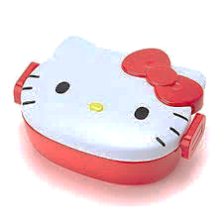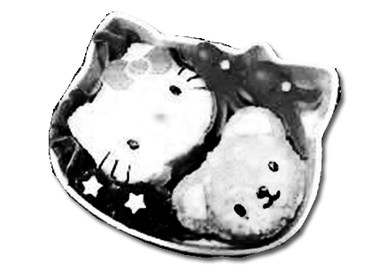
※Word Bank: shop商店 thing東西 real真的 lunch午餐

34. What’s special (特別) about the box?
(A) The shape (形狀) is a cat. (B) It’s a new toy.
(C) A cat is in the box. (D) The shop is cool.
35. “Betty’s Shop” is picture ______

(A) | (B)
(C) | (D)

(36~38)
Rose: | Look! BTS show is on TV.
Lucy: | Those seven boys are singers and song writers from South Korea, right?
Rose: | Yes, many girls like their songs and dance. They also designed their LINE stickers.
Lucy: | Are those boys popular with girls?
Rose: | Yes, they are. They are tall, thin and handsome. They are hot in girls’ eyes.
Lucy: | Are they handsome and hot in your eyes, too?
Rose: | Yes, they are so charming.
※Word Bank: show表演 South Korea南韓 designed設計 stickers貼圖 popular受歡迎 eyes眼睛
36. What isn’t BTS good at?
- Singing (B) Dancing (C) Drawing (D) Cooking
37. What is the meaning(意思) of “charming”?
- Bad and ugly. (B) Handsome and popular.
- Cool and sad. (D) Young and short.
38. What is right?
- BTS are not song writers. (B) “BTS” is a show.
- Many girls like BTS. (D) BTS feel (感覺) hot.
六、文意字彙：每題1分，佔12% (請將答案書寫於答案欄內)
39. They are Amy’s p ts, Mr. and Mrs. Brown.
40. Please wear(穿) a c me to Sam’s party.
41. There are thirteen c les on the birthday cake.
42. The little girls are playing(玩) on the s de now.
43. What’s that o r there? Is it a birthday hat?
44. The F n black bears in the Taipei Zoo are handsome.
45. A: Dad, there’s a horse near the tree.
B: Oh, it’s a z a, not a horse.
46. A: How are you? B: E ing is fine.
47. K os and foxes are my favorite animals.
48. Look! Your teacher is in f t of our classroom.
49. A: Where is Josh? B: M be he’s in his room.
50. A:What’s in the box? B: G s! A: Is it a pen?

七、依提示作答 6% (請將答案書寫於下方答案欄內)
51. These are erasers, and those are brushes.
(將複數句改成單數句)
52. Yes, there are some elephants in the zoo.
(請依畫線部分造原問句)
53. Your glasses are on your head. (請依畫線部分造原問句)

八、翻譯：佔9%。(請將答案書寫於下方答案欄內)
54. 這個面具是你送的嗎？非常謝謝你! (3%)
55. 那些女人在廁所附近。(3%)
56. 這隻天竺鼠最喜歡的地方是池子。(3%)

~~~~~~~~~~~~~~~~~~~~~~答案欄~~~~~~~~~~~~~~~~~~~~~~

班級： 座號： 姓名：
六、文意字彙：每題1分，佔12%
39. | 40. | 41.
42. | 43. | 44.
45. | 46. | 47.
48. | 49. | 50.

七、依提示作答：每題2分，佔6%

51.__________________________________________________
52.__________________________________________________
53.__________________________________________________
八、翻譯：佔9%。

54._________________________________________________________________________________________________(3%)
55._________________________________________________________________________________________________(3%)
56._________________________________________________________________________________________________(3%)

宜蘭縣立羅東國中107學年度第一學期七年級英語科第二次段考聽力測驗(聽力稿)
一、聽力測驗
本測驗分為 A、B、C三部分，共計十題，每題將唸兩次，皆為單選。請將答案畫在答案卡上。

A、辨識句意：根據聽到的內容，選出符合描述的圖片。
(每題唸兩次,第一次唸完請隔2秒再唸第二次，題與題之間間隔5秒。 )
1. G: What are these? B: They are Ken’s brushes.
2. Jane is between Meg and Amy.
3. The guinea pigs are small and cute.

B、基本問答：根據聽到的內容，選出一個最適合的回應句。
(每題唸兩次,第一次唸完請隔2秒再唸第二次，題與題之間間隔7秒。 )
4. Happy birthday to you, Matt. This robot is for you.
5. What’s in the box? Is it a ruler?
6. Is there any park near our school?

C、言談理解：根據聽到的內容，選出一個最適合的答案。
(每題唸兩次,第一次唸完請隔5秒再唸第二次，題與題之間間隔8秒。 )
7. W: Who is the white hat for?
M: It’s for my dog, Pinky.
W: What color is your dog?
M: My dog is a black dog.
Q: What is right?

8. M: Today is my birthday. There are some gifts on the table. A book is in the red box. The green box is from my cousin, Eric. A toy car is in it. The white box is a gift from my wife, Mary. Maybe it’s a watch.
Q: Where is the toy car?

9. G: Andy, look at the picture. This is my school.
M: Wow! It is a very small school.
G: Yes, there are only four teachers and twenty students.
M: Are the teachers nice?
G: Yes, they are very nice. I love my school.
Q: What is in the picture?

10. W: Hi. Welcome to my house.
M: Your house is pretty nice. Where is your kitchen?
W: It is next to my bedroom.
M: Where is the dining room?
W: It is next to the living room.
M: Wow, your house is really big.
Q: Where is the living room?

