宜蘭縣立羅東國中一百零七學年度第一學期九年級英語科第一次段考
班級： 座號： 姓名： 命題教師：李雅玲
＊第1~42題的答案請畫在電腦卡上，非選擇題部份請寫在答案欄內。

本測驗分三部分，共10題。 20 %

第一部分：請根據聽到的內容，選出符合描述的圖片。
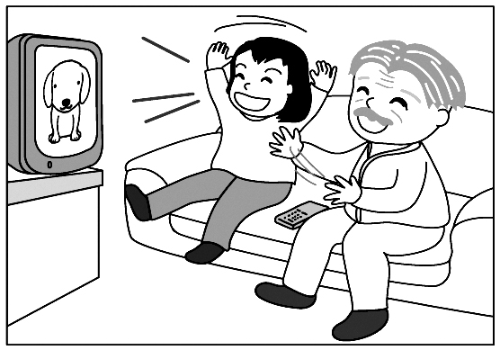( ) 1. (A) (B) (C)
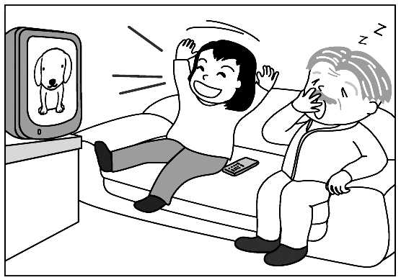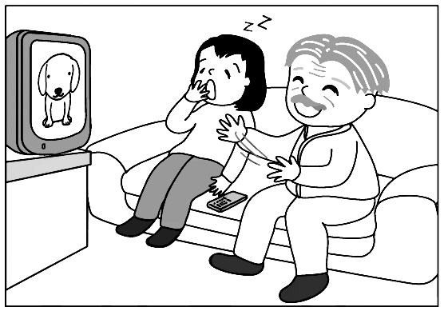
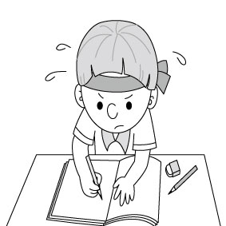( ) 2. (A) (B) (C)
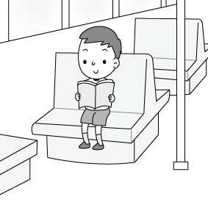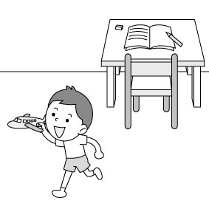

( ) 3. (A) (B) (C)
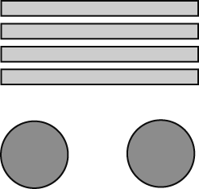 | 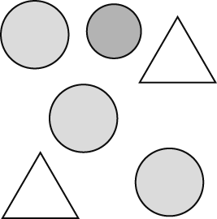 | 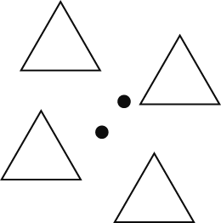

第二部分：請根據聽到的內容，選出一個最適當的回應或最適當的問句。
( ) 4. (A) I’ll be out in a minute. (B) Sorry. Let me help you out.
(C) You don’t have much time.
( ) 5. (A) Sounds like fun. (B) So far so good.
(C) It’s going forward.
( ) 6. (A) Yes, I can swim well. (B) No, I don’t like it.
(C) Yes, I pracitce it every day.
( ) 7. (A) When will it start? (B) Do you need a new TV?
(C) What do you want to watch?
第三部分：請根據聽到的內容，選出一個最適合的答案。
( ) 8. (A) I can’t wait. (B) It didn’t take long. (C) That’s too slow.
( ) 9. (A) A video game. (B) A movie. (C) A book.
( )10.(A) For a week. (B) For five days. (C) For three days.
二、請依文意選出一個正確或最佳的答案 19 % (每題1分)
( )11.Look! That man is brushing his cat’s hair with a .
(A) wish (B) lamp (C) paper (D) comb
( )12.In the picture, the dark around Square A makes Square B look light.
(A) playground (B) envelop (C) background (D) brain
( )13.I haven’t Danial for a long time. I miss him very
much. I decide to make him a phone call after work.
(A) met (B) heard of (C) received (D) heard from
( )14.Have you got anything for Little John ? He’s
expecting(期待) your gift from the USA.
- yet (B) already (C) either (D) ever
( )15.A: There’ll be a Halloween parade in Loutung this year.
B: Yes, I’m so excited it.
(A) at (B) in (C) with (D) about
( )16.After you make a lantern, don’t forget to .
(A) show it off (B) fill it up (C) put it on (D) ask for it
( )17.That dog has a short tail, ?
(A) does; that (B) doesn’t; it (C) has, that (D) hasn’t it
( )18.Son, you out until you finish all your homework
Got it?
(A) go (B) can go (C) will go (D) can not go
( )19.Fiona to Japan in 2008. She there for many years.
- moved; lived (B) has moved; lived
(C) moved; has lived (D) has moved; has lived
( )20.Grandma, thanks ____ care of us after our parents died.
(A) to take (B) about taking (C) of taking (D) for taking
( )21.Making this key ring took you much time, ?
- didn’t it (B) isn’t it (C) didn’t you (D) weren’t you
( )22.The math classes are always _____. I’m _____ of doing
lots of exercises in every class.
(A) boring; boring (B) bored; boring (C) boring; bored
(D) bored; bored
( )23.Look at those strawberries at that stand! They’re as _ ___
as apples. And… they’re very expensive!
(A) big (B) bigger (C) biggest (D) the biggest
( )24.This morning she heard from the TV news ____ her
favorite tennis player won the game.
(A) when (B) what (C) because (D) that
( )25.There are many holes on the ground, ?
(A) are they (B) aren’t they (C) are there (D) aren’t there
( )26.A: Long time no see. How have you been? B: ___ _
(A) Not bad. (B) I can’t agree more.
(C) Not at all. (D) Well…not always.
( )27.A: You don’t like pizza, do you? B: _ _
(A) No, I like pizza a lot.
(B) No, I never eat pizza, do you?
(C) That’s true. The shape of this pizza is round.
(D) Yes, I do, and I have pizza for lunch very often.
( )28.A: Can you help me with the math problems?
B: Sure.
(A) We have a whale of a time. (B) I”ll look around.
(C) They’re not my cup of tea. (D) It’s a piece of cake.
( )29.A: Let’s celebrate Mother’s Day by camping at Wulin.
B: The air in the mountains is fresher.
(A) Isn’t it a great time to eat a big dinner?
- What a way to celebrate this holiday!
(C) We can save money, right?
(D) Isn’t it good for kids, but not for adults?
三、克漏字選擇 5% (每題1分)
Ray: Ben, have you decided 30 Cousin Ted’s wedding gift?
Ben: Well, I’ve been thinking about it since he 31 me his
good news. But it seems like lots of cultural taboos(禁忌) to
give people gifts.
Ray: You can say that again. For example, we don’t send others
clocks because the sound of the word ”clock” is like “the
end” in Chinese. Besides, the umbrellas shouldn’t be gifts,
either. The word 32 “umbrella” sounds like “separate”.
Ben: Really? I didn’t know that. 33 Cousin Ted’s wife is a
Japanese, right? I read a report the other day. And it said
towels were Top 8 wedding gifts in Japan because they are
very useful.
Ray: I don’t think so. People in Taiwan give towels when one of
their family dies. Well…I got it! Sending two pairs of chopsticks is a great idea. A pair of chopsticks means a couple (一對). Two pairs may bring more good luck to Cousin Ted.
Ben: 34 , let’s ask Mom first. Thanks, Ray.
( )30.(A) in (B) on (C) at (D) of
( )31.(A) told (B) tells (C) has told (D) will tell
( )32.(A) about (B) for (C) of (D) in
( )33.(A) How about the towels? (B) Where are they from?
(C) What comes to your mind? (D) Are you sure enough?
( )34.(A) Just to play it safe (B) To see is to believe
(C) It doesn’t make sense (D) I can’t help it
四、閱讀測驗 16 % (每題2分)
I.
A little boy was kneeling(跪著) beside his bed with his mother
and grandmother and softly(輕聲地) saying his prayers(祈禱文),
"Dear God, please bless Mummy and Daddy and all the family and
please give me a good night's sleep."
Suddenly he looked up and shouted, "And don't forget to give
me a bicycle for my birthday!"
"There is no need to shout," said his mother. "God isn't deaf.”
"No," said the little boy, "but Grandma is."
( )35.What is true about the reading?
(A) The word “deaf” means “being sleeping”.
(B) The little boy is going to eat dinner.
(C) The grandfather doen’t live with the little boy.
(D) The little boy’s birthday may be around the corner.
II.
David Blaine, born on April 4, 1973, is an excellent American
magician. He is famous for close-up magic and endurance stunts.
Blaine began to be interested in magic and performance after a
street performer inspired him at age of four. Magic was not his
only interest, however, and Blaine went on to attend a drama
school and appeared on several TV shows. Soon after, he began to
perform magic tricks for famous people, like Al Pacino.
He made a tape of a performance and sent it to ABC when he
was about twenty. The response was amazing, and soon he got an
interview. His first TV special, David Blaine: Street Magic was a
big hit in his country in 1997. When performing on the street, he
was only a few meters away from people.
In 1999, David Blaine performed his first endurance stunt:
submerging himself in 4,000 pounds of water for over one week.
During 2003's "Above the Below," he lived in a glass box by
the River Thames in London for 44 days, without food. The stunt
got the notice of the world media, and thousands of reporters went
near Tower Bridge to witness his performance.
In 2014, David Blaine started his first-ever Live tour. He waited
10 years for this tour. He is a man with great dreams. Even now,
David Blaine is still working on his dream of performing live for
people of over 20,000 places around the world.
magician魔術師 endurance stunts耐力特技 performance表演
response回應 submerging淹沒 media媒體 witness目睹
( ) 36.What does “inspired” mean in this reading?
(A) Scared. (B) Appeared. (C) Cheered. (D) Invited.
( ) 37.Which is NOT true about David Blaine?
(A) He performed magic far away from people on the street.
(B) Before 2014, he never performed magic in other countries.
(C) His endurance stunt is more famous than his street magic.
(D) He started his first show when he was four years old.
( ) 38.What information can we get from the reading?
(A) Performing magic in front of famous people is a kind of
endurance stunt.
(B) Making more TV magic shows is David Blaine’s dream.
(C) David Blaine learned magic all by himself.
(D) People may have a chance to watch David Blaine’s magic
performance in Taiwan.
III.
American children like to play apple bobbing on Halloween.
Parents fill a large basin with a lot of water and put apples in it.
Children need to catch one with their teeth, not with their hands.
Players need to hold the basin with both of their hands or place
their hands behind their back.
The game is not as popular as it was many years ago because
parents think it may be unsanitary. Children may get sick because
the water gets dirty easily after so many kids keep their mouths
open and try to catch apples in the basin. However, apple bobbing
has its other pleasures. If you get the apple first in the group, you
will be the first to get engaged. And if girls get the apple and put it
under their pillows, they would dream of their future husband.
Want to play the game on Halloween? Why not try it then?
basin 水盆 pillow 枕頭 pleasure 樂趣 engaged 訂婚
( )39.How do children catch apples in the basin?
(A) With their heads. (B) With their mouths.
(C) With their hands. (D) With their feet.
( )40.What does unsanitary mean?
(A) Not funny. (B) Not clean. (C) Not heavy.
(D) Not happy.
( )41.In the reading, what would happen to a girl if she gets an apple from the game and puts it under her pillow?
(A) She’d see her future husband in her dream.
(B) She’d dream of her future child.
(C) She’d get a lot of money in the future.
(D) She’d win the apple bobbing game next year.
( )42.Which is true about the reading?
(A) If a man wants to marry, he should not win the game.
(B) Apple bobbing now is more popular than before.
(C) Players can not use their hands to catch the apples.
(D) Apple bobbing is the only game for American kids
to play on Halloween.
五、文意字彙 12 % (每題1分)
1. Allie is good at l ges. She can speak English, French, and Germany.
2.Joe and Jill have been m ied for fifty years. More
importantly, they are still in love with each other.
3. The businessman took a name card from his w t and gave it to me.
4. Joyce looked like a c y person after she put on that mask and costume.
5.Angela is a s e girl. She likes talking to herself in
class, so she has very few friends.
6. David Blaine: Real or Magic is one of my favorite Amarican TV p ms.
7. Miss Li: What shapes are you drawing?
Billy: A cirle and two r les .
8. Joan almost t ked us when she said she just saw a ghost walking by.
9. Zack is p d; he thinks he’s right about everything.
10. Angel is tall; she is five feet eight i hes.
11. Penny: The cup of coffee tastes good. Can I have a r cup?
Bonnie: Here you are.
12. Aileen always sends her family a p d every time she visits a country.
六、翻譯 8%
1. 每個人都知道你不怕任何東西的。3%
2. 我們可以相信我們的眼睛，是嗎? (請用附加問句) 2%
3. 他們已經買了一頂草帽給Meg當作生日禮物。 3%
非選擇題答案欄 班級： 姓名： 座號：
五、文意字彙 12 % (每題1分)
1. | 2. | 3.
4. | 5. | 6.
7. | 8. | 9.
10. | 11. | 12.
六、翻譯 8% (第1及第3題3分；第2題2分)
1.
2.
3.

