宜蘭縣立羅東國中106學年度第二學期七年級英語科第三次段考試卷 命題老師：聯合命題
-------------------------------------------------------------------------------------------------------------------------------------------------------------------------------

＊本份考卷共有57題，1~38題答案請畫在答案卡上，
39~57題答案請依題號書寫在答案欄。本試題共兩頁。
一、聽力測驗 (本測驗分為 A、B、C三部分，共計十題，每題皆為單選，請將答案畫在答案卡上)每題2分，佔20%
A、辨識句意：根據聽到的內容，選出符合描述的圖片，每題將唸兩次。
1.（ ）
(A) | (B) | (C)
 |  | 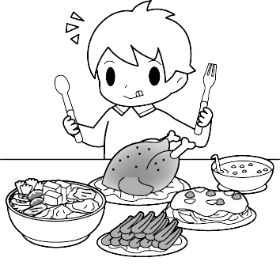
2.（ ）
(A) | (B) | (C)
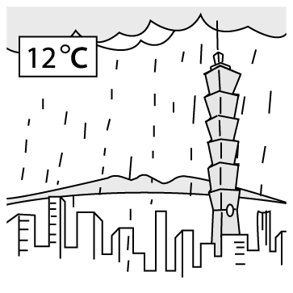 | 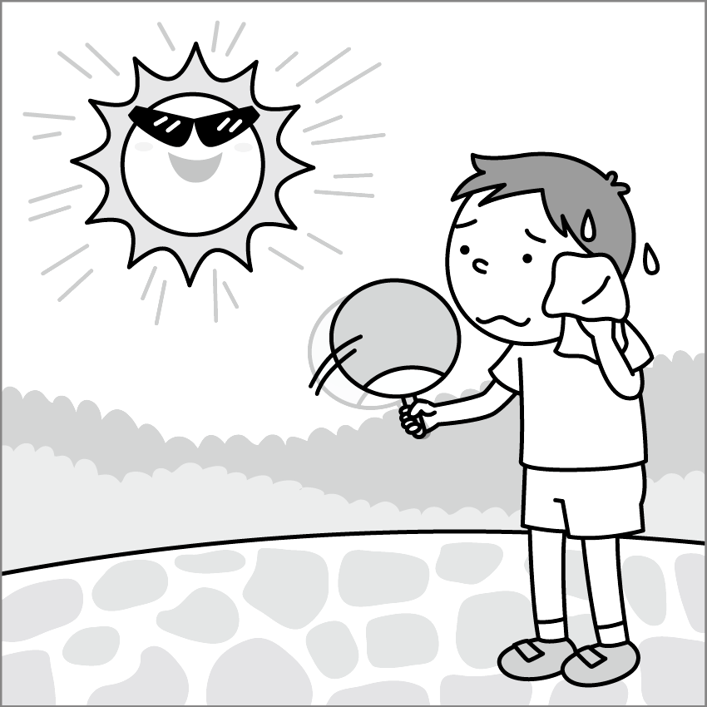 | 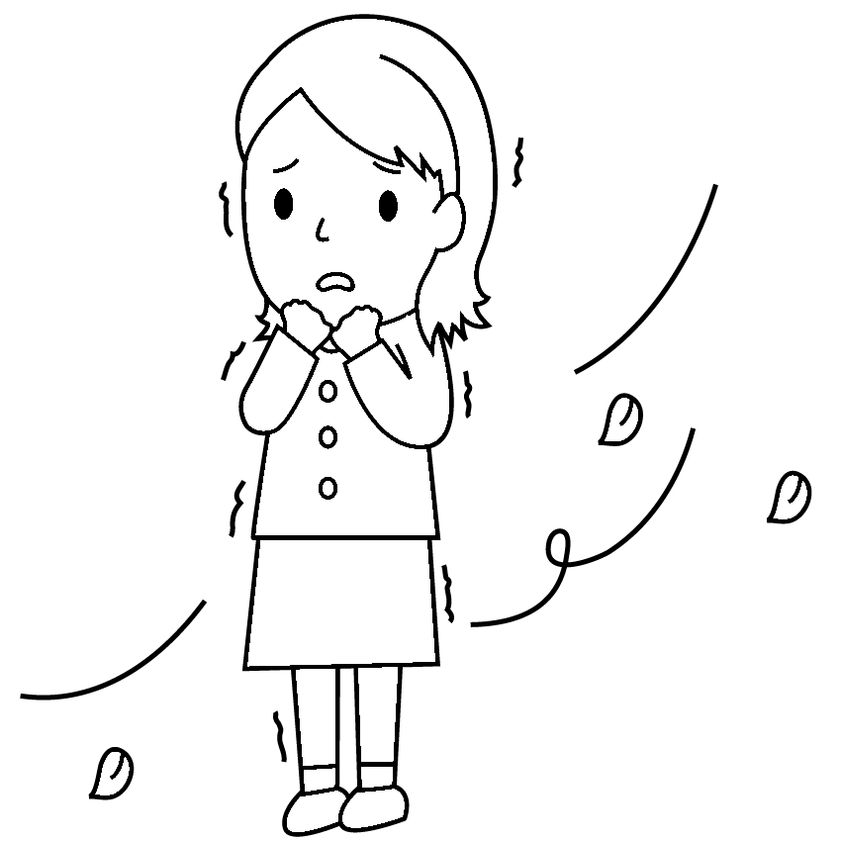
3.（ ）
(A) | (B) | (C)
 | 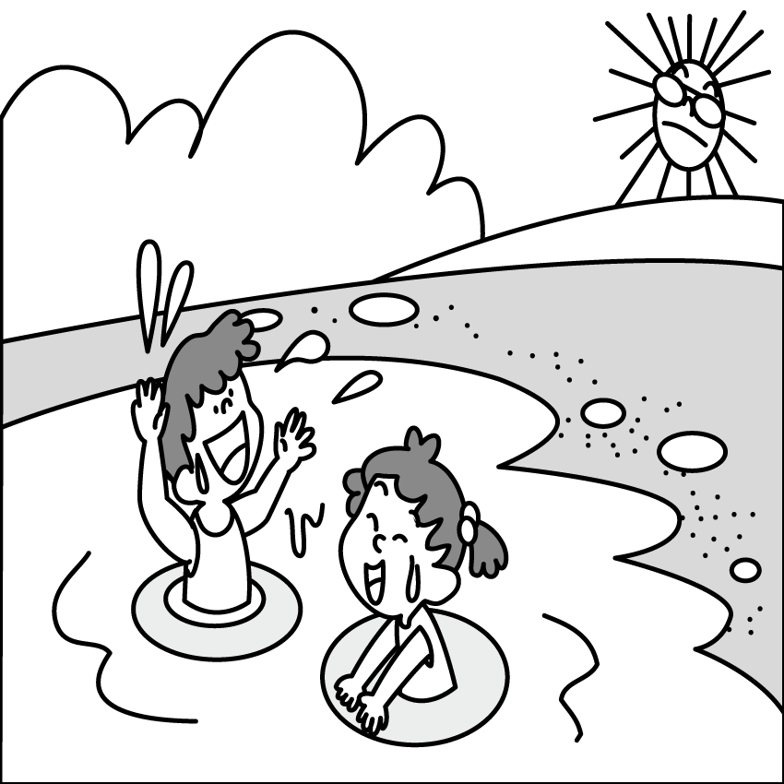 | 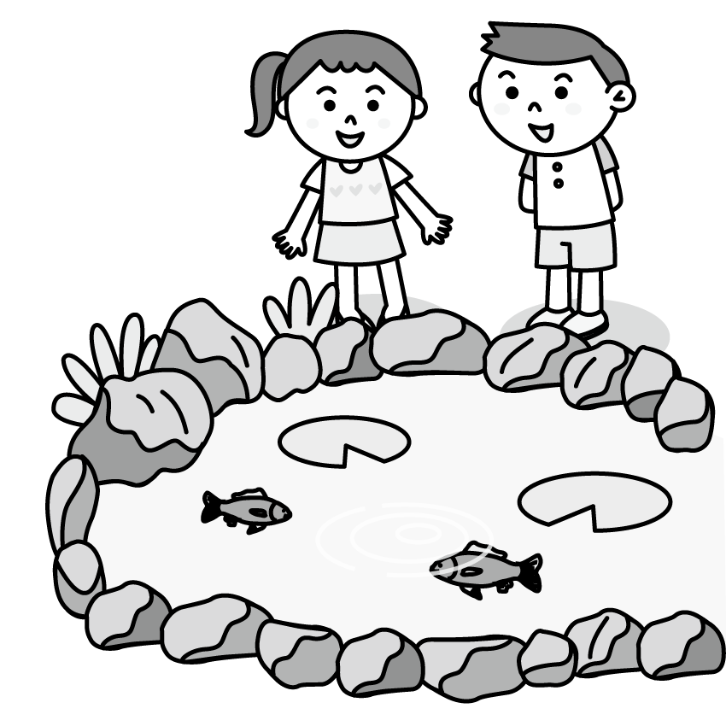
4.（ ）
(A) | (B) | (C)
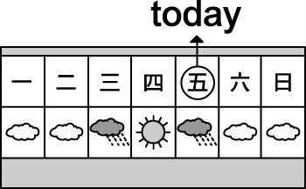 | 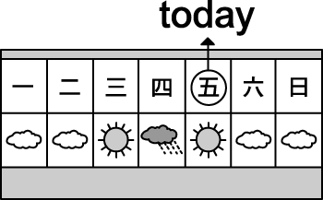 | 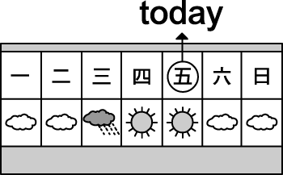
B、基本問答：根據聽到的內容，選出一個最適合的回應句。
( ) 5. (A) Once a week.
(B) No, never.
(C) About one time.
( ) 6. (A) It is very hot.
(B) It’s from June to August.
(C) It comes after autumn.
( ) 7. (A) He was a writer.
(B) He was sad then.
(C) He was at the pond.
C、言談理解：根據聽到的內容，選出一個最適合的答案。
( ) 8. (A) Milk. (B) A cow. (C) A little boy.
( ) 9. (A) Yes, it is. (B) No, it doesn’t. (C) Yes, it does.
( )10.(A) Some fish. (B) Some birds. (C) Some tadpoles.
二、請依文意選出一個正確或最佳的答案。每題1分，佔15%。
11. My dad is ____ busy. He seldom eats dinner at home. (A) never (B) usually (C) seldom (D) sometimes
12. A: _____ do you exercise? B: I exercise three times a week.
(A) What time (B) How long (C) How much (D) How often
13. My dog is sick(生病). I need to take it to the ____.
(A) vet (B) beach (C) singer (D) lake
14. The snow is too ____. Don’t go out.
(A) big (B) cool (C) small (D) heavy
15. A: Yilan(宜蘭) is so beautiful. B: ____ I like Yilan, too.
(A)Hold on! (B)Come on!
(C)Really? (D) You can say that again!
16. A: Do you have a lot of rain in Kaohsiung(高雄) in summer?
B: No. ______
- It’s rainy here in summer.
- It’s always a dry season.
- It’s often rainy.
- It’s usually rainy.
17. My dad usually walks to work, but ____ he rides his bike there. (A) often (B) always (C) usually (D) sometimes
18. A: Where were you and John two weeks ago?
B: _____.
(A) We were at Joe’s place then.
(B) We were sad at that time.
(C) Really? We were here two days ago.
(D) We were not on the farm.
19. ______ sunny here last weekend.
(A) It was (B) There was (C) It is (D) We have
20. Mary _____ late for school. She is always on time.
(A) seldom is (B) never is (C) is never (D) is seldom
21. It ____ a lot in Japan in winter. Kids love making snowmen.
(A) is snowy (B) snows (C) has snow (D)has much snow
22. Tom: Mom, is there any food in the kitchen? I am so hungry.
Mom: Here _____ some cake for you.
- is (B) has (C) are (D) have
23. Mom: _____ do you surf the Net? Tom: Only for twenty minutes.
(A) How many times (B) How long
(C) How much (D) How often
24. Let’s _____snow and make a snowman at Hehuanshan.
(A) look at (B) look (C) read (D) watch
25. A: ______ rain a lot here in spring?
B: No, _____ much rain here in spring.
- Do they have; it doesn’t
- Do you have; it isn’t
- Is it; we don’t have
- Does it; there isn’t
三、克漏字：請依文意選出最適當的答案。每題2分，佔10%
Amy: Hi, Tim. Welcome back to Taiwan. 26 your trip to Hokkaido last month?
Tim: Great!
Amy: 27 the weather like there at that time?
Tim: Very very cold. So, there are a lot of barbecue shops on the streets.
Amy: By the way, 28 a lot of snow then?
Tim: Of course. A lot of people went skiing on the snow grounds there.
Amy: Maybe we can go there in summer. It 29 beautiful flowers.
Tim: Really? I really can’t _30 that day to come.
: Hokkaido:北海道 so:所以 barbecue:烤肉 streets:街道went skiing:去滑雪 snow grounds:滑雪場
26. (A) How is (B)What is (C) How was (D) What was
27. (A) How is (B) How was (C) What is (D) What was
28. (A) was there (B) were there (C) is there (D) are there
29. (A) changes into (B) is famous for (C) looks for (D) worries about
30. (A) get into trouble
(B) take care of
(C) wait for
(D) take pictures

背面還有試題!
四、閱讀測驗：第31~38題，每題2分，佔16%
(31~33)
Here is John’s plan(計畫) for this week.
 | Sun. | Mon. | Tue. | Wed. | Thu. | Fri. | Sat.
Study English | ˇ | ˇ |  | ˇ |  | ˇ | ˇ
Exercise | ˇ | ˇ | ˇ | ˇ | ˇ | ˇ | ˇ
Clean the bedroom |  |  |  |  |  |  | ˇ
Walk the dog | ˇ |  | ˇ |  | ˇ |  | ˇ
See a movie |  |  |  |  |  |  | ˇ
Listen to music |  | ˇ | ˇ | ˇ | ˇ | ˇ
31. What does John do only once a week?
(A) Study English. (B) Exercise.
(C) Clean the bathroom. (D) See a movie.
32. What does John NOT do on the weekend?
(A) Clean the bedroom. (B) Walk the dog.
(C) Listen to music. (D) See a movie.
33. Which is true(正確的)?
(A) John exercises every day this week.
(B) John’s plan is full on Saturday.
(C) John doesn’t study English very often.
(D) John walks the dog three times a week.
(34~35)
In the past and the present of Dong
In the past, few people knew this beautiful village, Dong; now a lot of people know it. Before, the fish market was clean; now, it is dirty. Three months ago, there were not many people at the beach; now, there are a lot of people there. In the past, there were not many cars on the streets on weekends; now, there are many every day. In the past, there was not a lot of trash; now, there is a lot. Are the local people in Dong happy now? Can we be nice to Dong?
: past:過去 present:現在 few:少數 knew:知道 village:村莊 street:街道 local:當地 trash 垃圾
34. What does there mean (意謂)?
(A) The flower market. (B) At the beach.
(C) On the streets. (D) The fish market.
35. Which is true?
(A) There is not a lot of trash in Dong now.
(B) There were many people and cars in Dong on weekends last December.
(C) There were many fish markets in Dong.
(D)The fish market is not clean now.
(36~38)
Today is May 4.This is Teresa’s schedule(行程表) from May 2 to 4.
May 2- go to Keelung for basketball games
May 3- go to the morning market with Mom
6 p.m.Grandpa’s birthday party at Uncle Tim’s house
May 4- family trip at Fulung Beach
36. What date was the day before yesterday?
(A) May 1. (B) May 2. (C) May 3. (D) May 4.
37. Where was Teresa yesterday evening?
(A)At the beach. (B) At the market.
(C) In Keelung. (D) At her uncle’s place.
38. Which is true?
(A) Teresa doesn’t like basketball.
(B) Teresa goes to Keelung for a family trip
(C) Teresa was at the market yesterday morning.
(D) Teresa was at her grandpa’s house yesterday.
非選擇題:
五、文意字彙：每題1分，佔12%
(請將答案書寫於下方答案欄內)
39. In e ly summer in Japan, sometimes it’s cool.
40. Cats are cute. I want to keep a p t cat.
41. Tadpoles have d k skin.
42. I am from Tainan, but I l e in Yilan(宜蘭) now.
43. Mom grows(種) many flowers in our g n.
44. It was c y on Sports Day this year. It wasn’t hot that day.
45. Mom, please feed our dog t ce a day.
46. Look! Those boys and girls are playing f ee on the grass (在草地上).
47. There are a lot of fish swimming in the r r.
48. A lot of people fly kites on w y days.
49. Spring in Taiwan is w m, not cold.
50. It’s raining now. Please take an u a with you.

六、翻譯填空：每格1分，佔7%
(請將答案書寫於下方答案欄內)
A. 我總是在晚上10點洗澡。
I always (51) a (52) at 10 p.m.
B. 昨天整個早上，我跟我的狗都在山丘上。
The (53) morning yesterday, my dog and I (54) on the (55) .
- 你可以在山區爬樹嗎?
Can you (56) trees in the (57) ?

~~~~~~~~~~~~~~~~~~~~~~~~~~~~~~~~~~~~~~~~~~~~~~~~~~~
☆☆☆答案欄☆☆☆

班級： 座號： 姓名：

五、文意字彙：每題1分，佔12%
39. | 40. | 41. | 42.
43. | 44. | 45. | 46.
47. | 48. | 49. | 50.

六、翻譯填空：每格1分，佔7%
A.
51. | 52.
B.
53. | 54. | 55.
C.
56. | 57.

