宜蘭縣立羅東國中106學年度第二學期八年級英語科第一次段考試卷 命題老師：聯合命題
＊本份考卷共有52題，1~35題答案請畫在答案卡上，36~52題答案請依題號書寫在答案欄。本試題共兩頁。

一、聽力測驗 (本測驗分為 A、B、C三部分，共計十題，每題將唸兩次，皆為單選。請將答案畫在答案卡上。)
每題2分，佔20%
- 辨識句意：根據聽到的內容，選出符合描述的圖片。
1.
(A) 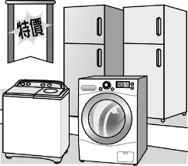 | (B) 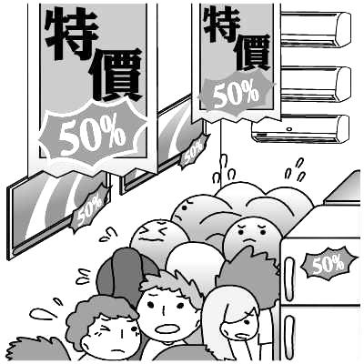 | (C) 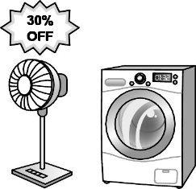
2.
(A)  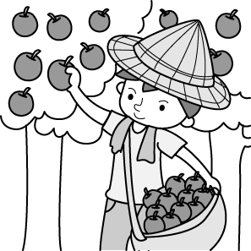 | (B)  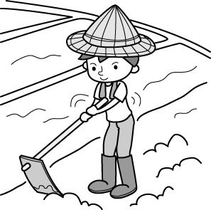 | (C)  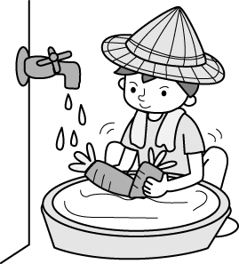
3.
(A) 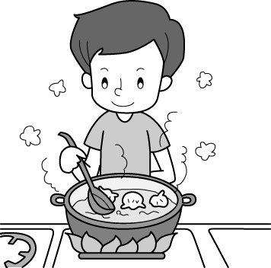 | (B) 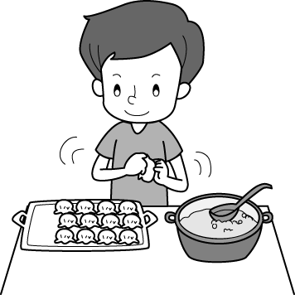 | (C) 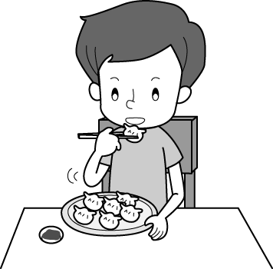

B、基本問答：根據聽到的內容，選出一個最適合的回應句。
4. (A) I usually use it to make phone calls.
(B) The white one on the left.
(C) The red one is on sale.
5. (A) We’ll have a lot of fun there.
(B) The strawberries on his farm are delicious.
(C) Let’s go by train. It’s the fastest way.
6. (A) I’ll go candy hunting at Joy Park.
(B) There are many activities for you.
(C) It’s going to be an interesting one.
C、言談理解：根據聽到的內容，選出一個最適合的答案。
7. (A) A writer.
(B) A story reader.
(C) A famous cook.
8. (A) The weather is as hot as before.
(B) We have more typhoons this summer.
(C)There’s less rain than before.
9. (A) Because she couldn’t go to New York.
(B) Because she broke her favorite cup.
(C) Because her mother didn’t want to buy a cup for her.
10.(A) They will eat the fried rice for dinner because it is cheap.
(B) They own the best food stand in the night market.
(C) They decided to eat rice balls and soy milk for dinner.

二、請選出一個正確或最佳的答案，每題1分，佔15%。
11. I like the black shoes because they’re cooler than the pink _____. (A) it (B) one (C) them (D) ones
12. Jolin’s dress is more beautiful than _____.
(A) everyone (B) Lucy’s (C) me (D) her sister
13. The red MP3 player is more _____.
(A) special than the tape recorder (C) popular of all
(B) light and easy to carry (D) heavier but cheaper
14. The weather in Taipei is _____ hotter than that of in London.
(A) much more (B) very (C) much (D) so
15. Who always gets _____ grades in history, Mike or Judy?
(A) the best (B) best (C) the better (D) better
16. Of all the players on the school team, Sam got _____ points(分數) today.
(A) much (B) the most (C) many (D) more
17. To most students, science is _____ subject at school.
(A) difficult (B) more difficult
(C) much more difficult (D) the most difficult
18. Seven years ago, Mrs. Chen started to _____ a flower shop. Now she _____ two shops in town.
(A) run; owns (B) ran; owns (C) run; won (D) ran; won
19. A: Who ____ my candy? I can’t find it! B: Little Johnny ____.
(A) hide; does (B) hid; did (C) drops; does (D) dropped; did
20. The fried fish in the restaurant smells ____. I feel a little hungry. (A) the most (B) the better (C) good (D) well
21. I really want to take a picture of Mr. Brown because he looks like _____. (A) handsome (B) young (C) boss (D) my uncle
22.Because of the heavy rain, the vegetables at the market became_______.
(A) cheaper and cheaper (B) more expensive
(C) fresher and fresher (D) less popular
23. Clerk: How may I help you, ma’am? Ms. Wu: _____
(A) Setting up the camera isn’t difficult.
(B) Are these two cameras on sale?
(C) I can send e-mails with the smartphone.
(D) Upload your pictures right away, and you’ll get one for free.
24. A:_________. You almost hit me!
B: Sorry. I was thinking about how to finish my report.
(A) Hurry up! (B) I feel a little sad.
(C) What’s so special? (D) Watch out!
25. A: We usually have a lot of activities on Sports Day. Want to join us? B: ___________
(A) Everyone looks excited.
(B) That sounds interesting.
(C) I can’t think of any ideas.
(D) How are we going to get there?

三、克漏字：請依文意選出最適當的答案。每題2分，佔10%。
Ken: | Cindy, we’re going (26) on Lake Farm tomorrow. Would you like to join us?
Cindy: | Lake Farm?
Ken: | Yes. It’s my uncle’s farm. He’s good at (27) organic fruit, like guavas, strawberries, and pears.  (28) , he also raises some animals on his farm. We can buy some fresh (29) there. The milk and the eggs are all from his own animals.
Cindy: | Wow, that’s amazing! I think I should stop using my smartphone and walk outside to enjoy nature. OK! I’ll go with you.
Ken: | That’s great! (30) is the best way to relax. We’ll pick you up tomorrow morning.
※Word Bank:
organic 有機的 raise 飼養 nature 大自然 relax 放鬆
26. (A) pick fruit (B) fruit pick (C) picking fruit (D) fruit picking
27. (A) grows (B) growing (C) grew (D) to grow
28. (A) Besides (B) In fact (C) Hurry up (D) That’s too bad
29. (A) products (B) baskets (C) bands (D) seeds
30. (A) Be with nature and friends (B) With nature and friends
(C) Being with nature and friends (D) Nature and friends

四、閱讀測驗：第31~35題，每題2分，佔10%。
(31~32)
Amy’s Kitchen
Opening Hours Tue–Fri 6:00 –13:30
Sat–Sun 7:00 –14:00
Tue 11:30–13:30 20% off
Spaghetti $90  Beef Pizza $150  Pork Hamburger $55  Chicken Hamburger $60 | Orange Juice $50  Milk Tea $30  Black Tea $20  Papaya Milk Shake $60  Black Coffee $40
31. Lucy and her best friend went to Amy’s Kitchen for lunch this Tuesday. They ordered one beef pizza, one chicken hamburger, one papaya milk shake, and one black coffee. What’s the total?
(A) $216 (B) $248 (C) $270 (D) $310
32. Which is TRUE?
(A) Orange juice costs less than black coffee.
(B) Beef pizza is the most expensive food in Amy’s Kitchen.
(C) People can have dinner at Amy’s Kitchen on Friday.
(D) Amy’s Kitchen sells breakfast only.
(33~35)
A very long time ago, there lived an Easter Rabbit. He was a big bad bunny. The Easter Rabbit did not like children. He did not like anything in the world, not even chocolate. At Easter, the Easter Rabbit was always late and every child only got one Easter egg. However, a new Easter Bunny was born. The Easter Rabbit was very angry and not happy. So the two started fighting. The Easter Bunny didn’t like the Easter Rabbit, so he decided to give children more Easter eggs for Easter. Soon children around the world started to become fatter. The Easter Rabbit laughed at the Easter Bunny because of that. Soon they were fighting again.
One morning, the Easter Bunny decided to talk to the Easter Rabbit and he said, ‘I don’t like fighting and we are both Easter rabbits. Let’s be friends.’ Later, the Easter Rabbit taught the Easter Bunny how to celebrate Easter and how to make children happy. They became good friends. They worked together to give eggs at Easter but not too many chocolate eggs. Most important of all, the Easter Rabbit became friendlier and friendlier.
※Word Bank: born出生 friendlier較友善的
33. Why do you think the kids in the reading became fatter and fatter?
(A) They stopped fighting.
(B) They didn’t like to exercise.
(C) They got too much sugar because of Easter eggs.
(D) They got Easter eggs from both the Easter Bunny and the Easter Rabbit.
34. Which is true about the Easter Rabbit?
(A) He likes chocolate a lot.
(B) He is always kind to children.
(C) He and the Easter Bunny were friends in the end.
(D) In the beginning, each kid could get more than one egg from him.
35. Which may be the best title (標題) for the story?
(A) Easter Bunny and Easter Rabbit
(B) Friends or Family
(C) Chocolate! It Will Make You Fat
(D) Happy Children. Happy Easter

五、文意字彙：每題1分，佔12% (請將答案書寫於右方答案欄內)
36. Let’s keep the grape ice cream in the r r and enjoy it later.
37. Grandma r ed a letter from Uncle John in Italy. We read it together and shared the joy of his trip.
38. When Dad drives me to school, he likes to listen to the news from the r o.
39. The smartphone has a 6-inch s n. It can show pictures and words more clearly.
40. The worker has many kinds of t ls. They are useful to fix bikes.
41. It’s good for our health to eat more v es and fruit.
42. W ns are my favorite fruit in summer because they’re sweet and juicy.
43. Mom usually uses the washing m e to wash our clothes. I think we can’t live without it.
44. There is some trash on the g d. Please pick it up.
45. The taste of v r is sour. Chinese people like to add it into their noodles or soup.
46. After many days of hard-working, I finally won the big p ze.
47. Grandpa has a big house, and he has many papaya trees in the y d.
六、依提示作答: 每題2分，佔4% (請將答案書寫於下方答案欄內)
48. Emily has less money than Grace. Grace has less money than Kelly. (用最高級… of …合併句子)
49. The meat roll tastes like chicken.(請依畫線部分造原問句)
七、翻譯：每題3分，佔9%。(請將答案書寫於下方答案欄內)
50. 你想要體驗種植番茄的樂趣嗎?
51. 上傳影片比拍高畫質的照片還容易。(以Uploading…開頭)
52. 這顆有彈性的蛋從牆上滾下來了。
~~~~~~~~~~~~~~~~~~~~~~答案欄~~~~~~~~~~~~~~~~~~~~~~

班級： 座號： 姓名：
五、文意字彙：每題1分，佔12%
36. | 37. | 38.
39. | 40. | 41.
42. | 43. | 44.
45. | 46. | 47.
六、依提示作答: 每題2分，佔4%

48._________________________________________________________________________________________________(2%)
49.______________________________________________(2%)
七、翻譯：每題3分，佔9%。

50._______________________________________________________________________________________________(3%)
51._______________________________________________________________________________________________(3%)
52._______________________________________________________________________________________________(3%)

