宜蘭縣立羅東國中106學年度第一學期八年級英語科第三次段考試卷 聯合命題

＊本份考卷共有50題，1~38題答案請畫在答案卡上，39~50題答案請寫在答案欄部份。
一、聽力測驗:本測驗共分為三部份。20%(每題2分)
第一部份：辨識句義
第1題到第3題，每題有三張圖片，請依據所聽到的內容，選出符合描述的圖片。每題播放兩次。
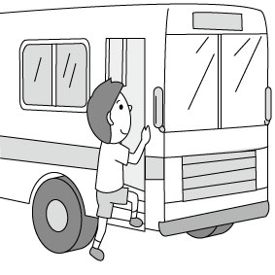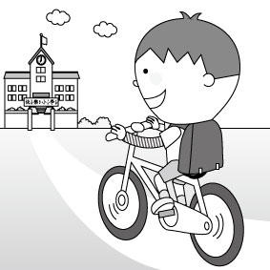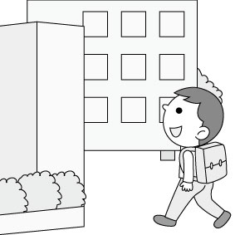 1(A) (B) (C)

2(A) (B) (C)

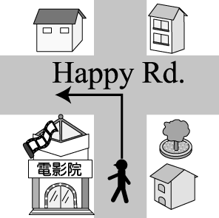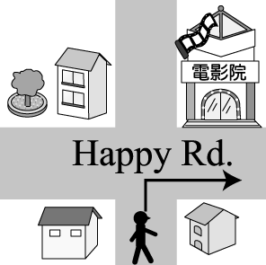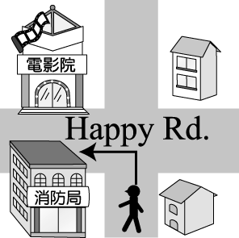3(A) (B) (C)

第二部份：基本問答
第4題到第7題，每題有三個選項，請依據所聽到的內容，選出一個最適合的回應。每題播放兩次。
4. (A) After school. (B) At the park. (C) In my life.
5. (A) We’ll go to London next year.
(B) We’re taking a photo of animals.
(C) We’re going bird watching.
6. (A) It costs $250.
(B) There are fifty tickets.
(C) I bought it for Mother’s Day.
7. (A) Yes, there’s one behind the market.
(B) No, the parking lot is very big.
(C) No, people can park their cars there.
第三部份：言談理解
第8題到第10題，每題有三個選項，請依據所聽到的內容及一個相關的問題，選出一個最適合的答案，每題播放兩次。
8. (A) Go fishing. (B) Have their dinner. (C) Do some housework.
9. (A) Go to a game. (B)Have a test. (C) Study for a test.
10. (A) At a bookstore. (B) At a clothes shop. (C) At a hotel.

二、依文意選出一個最佳的答案。18% (11~18每題1分，餘2分)
11. At this costume party, Ted like a pig. He was funny.
(A) dressed up (B) tried on (C) got to (D) started off
12. A: New shoes, right? They look cool _____ you.
B: My aunt gave me for Christmas. I like them very much.
(A) at (B) to (C) in (D) on
13. What a day today! I spent a whole day my house.
(A) clean (B) cleaned (C) cleaning (D) to clean
14. Sam isn’t in Taiwan. He come back until Friday.
(A) won’t (B) didn’t (C) isn’t (D) doesn’t
15. Last year, we went _____ in the mountains in Japan.
(A) sailing (B) surfing (C) hiking (D) shopping
16. Hank: does it take to go to Sun Hotel?
Rita: About thirty minutes.
- How (B) How long (C) When (D) How much
17. A: Who is going to take care of the dogs? B: Ben and Joe .
(A) will (B) is (C) are (D) do
18. A: Our science teacher, Ms. Lin, knows a lot about plants.
B: Yes.
- She lives in the desert. (B) She has fun feeding goats.
(C) She enjoys hunting. (D) She is just out of this world.
19. A: Where’s the city museum? Help me check the Google Map.
B: Ok, it says, “Turn right, and it’s left.”
(A) to: on the (B) X; on the (C) to the; on (D) X; on
20. A: Did you mail the love letter to your dream girl?
B: No, I want to check it again. I _____ it after dinner.
(A) mailed (B) mail (C) am mailing (D) will mail
21. It Mom NT$2,000 to buy this pair of jeans.
(A) paid (B) took (C) spent (D) cost
22. It is now 8 a.m. Some people are the MRT to work, and
some are going to work car.
(A) by; by (B) taking : by (C) taking; drove a (D) by ; drove a
23. There a pet contest at New Park this weekend. Why don’t we take Skippy to join it?
(A) are going to (B) will have (C) will be (D) is going to have

三、克漏字選擇，選出一個最佳的答案。18%(每題2分)
(一)
To: | Benchen@school.edu.tw
Subject: | Happy New Year!
Dear Ben,
How are you? Sorry, I can't go to New Year Countdown (倒數) Party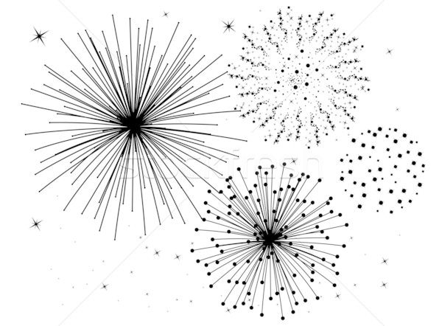 with you tomorrow 24 my father has a high fever. He 25 in the hospital now, and tomorrow night I 26 there with him.
I 27 you ten minutes ago, but you didn’t answer me. Maybe you 28 yourself for the party then. Happy New Year!
Ann
24. (A) because (B) so (C) when (D) but
25. (A) was (B) is (C) will be (D) is going to be
26. (A) stay (B) stayed (C) will stay (D) were staying
27. (A) call (B) called (C) am calling (D) will call
28. (A) prepared (B) were preparing (C) are preparing
(D) will prepare
(二) (In front of the railway station)
Jill: Honey, we’re lost. I can’t find that famous ice cream shop. What can we do?
Jay: I have no idea. Let’s ask someone 29 help.
Jill: Excuse me. How can we go to Yummy Ice Cream Shop?
Boy:Well, it’s not far 30 here. Just go down Spring Street for
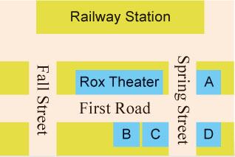 one block, and you’ll see it across from
Rox Theater, 31 Spring Street
and First Road.
29. (A) at (B) for (C) about (D) from
30. (A) to (B) away (C) in (D) from
31. (A) next to (B) between (C) behind
(D) on the corner of
32. Look at the map. Where is Yummy Ice Cream Shop?
(A) A. (B) B. (C) C. (D) D.

四、閱讀測驗: 12% (每題2分)
(一) Here are the rules for the game “Toss & Go”:
(1) Each player begins at START.
(2) In each turn, a player tosses a coin to decide one or two steps to move.
(3) There is a sentence on every place. It asks you to do something or answer the question. If you do it right or your answer is right, you can get the points of the place. Then, you can move.
(4) The first one to get to FINISH or the one to get the most

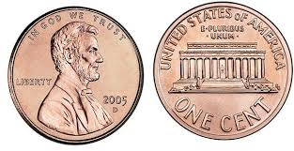 points at the end of the game is the winner.
toss 投擲 coin 硬幣 decide 決定 if 如果
sentence 句子 most 最多 point 分數 1 step (步) 2 steps
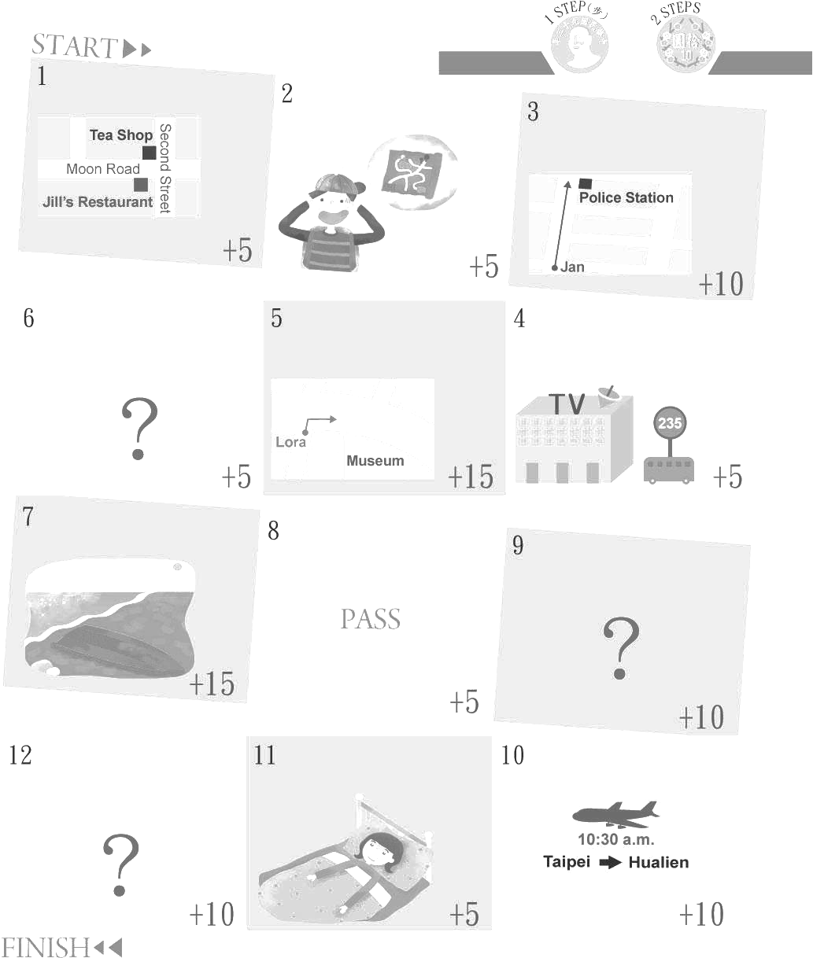
Where is the tea shop?

What’s wrong with
the boy?
How can Jan get to the police station?
How do you go to the train station from here?
Lora is going to the museum. What can she do ?
Which bus can Carrie
take to the TV station?
Do you often go to school by bus?
What did you do last night?
Were you eating breakfast at seven this morning?
What is May doing now?
May doing at nine p.m.?

Where did the plane go?

33. What can we learn about the game?
(A) There can be only four players in the game.
(B) One can never win the game less than (少於) four turns.
(C) One can not go to the place when another (另一人) is on it.
(D) One may begin his first turn on a place with a question.
34. What does It mean in this reading?
(A) The picture for the rules. (B) The question on every place.
(C) The game “Toss & Go”. (D) The place on the map.
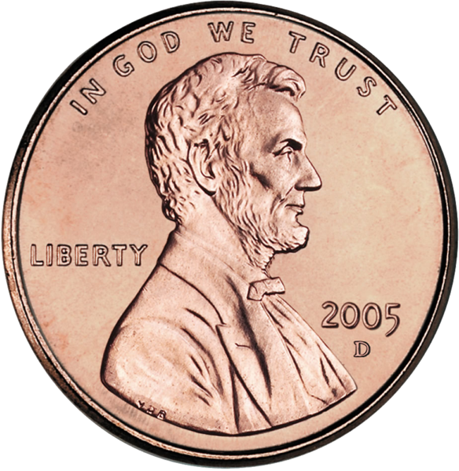35. Mary had a bad day today. She tossed the coin three times, but she always got . In the next turn, she tossed the coin and moved to the place successfully (成功地). Which is NOT true about her?
- On her third turn, she answered,” Go along this road.”
- She got 20 points in total in the three turns of toss.
- She might (可能) be at Number 5 in the fourth toss.
- She might need to answer Question 6 in the next toss.

(二)
All the items (商品) are 30% off.
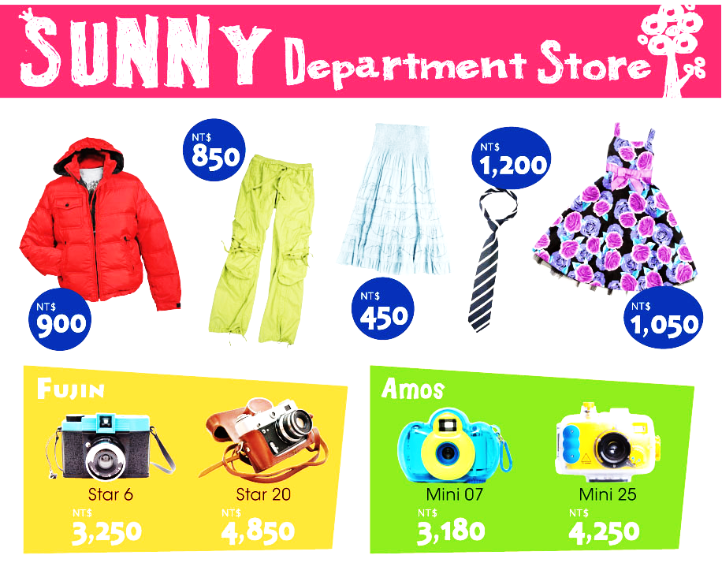
Shipping (運費): 24 hours…NT$200
2-4 days…NT$100
5-6 days…NT$50
36. Jenny wants a tie and a pair of pants for a meeting tonight. How much will she pay?
(A) NT$2,250. (B) NT$2,050. (C) NT$1,635. (D) NT$1,435.
37. Joe bought a Mini 25 on Monday and got it on Wednesday. How much did he spend?
(A) NT$2,975. (B) NT$3,025. (C) NT$3,075. (D) NT$3,175.
38. Janice paid NT$785 for a dress, and she will get it on May 8. When did she most likely (最可能) buy it?
(A) May 7. (B) May 5. (C) May 6. (D) May 3.
五、文意字彙: 12% (每題1分)
39. I don’t like yellow. Do you have other c rs?
40. A: The vest is only NT$299!
B: Yeah. It has a good p e. You can take it.
41. Look! It’s starting to snow. Where’s my c a? I want to take photos with white snow.
42. Good news. Our school library is having an English book fair (書展). We can b w some English books from it.
43. Many people in Taiwn are crazy about winning at the claw machine (夾娃娃機). It is really an e tng game for them.
44. My grandma is a super grandma. She is seventy years old, and she likes driving her j p around this place.
45. You can see many differenet i ts in the park, like butterflies.
46. Life in the c y is free and quiet for old people.
47. The kids like to play on this p d. There are many seesaws and swings there.
48.Our English teacher has long and s__ __t hair. She’s beautiful.
49. A year ago, we were still e y school students. We are now in junior high school. Time really flies!
50. Coco is a great movie. It’s on at the t r now. Let’s see it later.

答 案 欄 班級: ______ 座號: _____ 姓名: __________
39. | 40. | 41.
42. | 43. | 44.
45. | 46. | 47.
48. | 49. | 50.

