宜蘭縣立羅東國中104學年度第一學期八年級英語科第三次段考試卷 命題老師：聯合命題
＊本份考卷共有53題，1~36題答案請畫在答案卡上，37~53題答案請依題號書寫在答案欄。本試題共兩頁。

一、聽力測驗 (本測驗分為 A、B、C三部分，共計十題，每題將唸兩次，皆為單選。請將答案畫在答案卡上。)
每題2分，佔20%
- 辨識句意：根據聽到的內容，選出符合描述的圖片或符
合圖片的描述。
1.
(A) | (B) | (C)
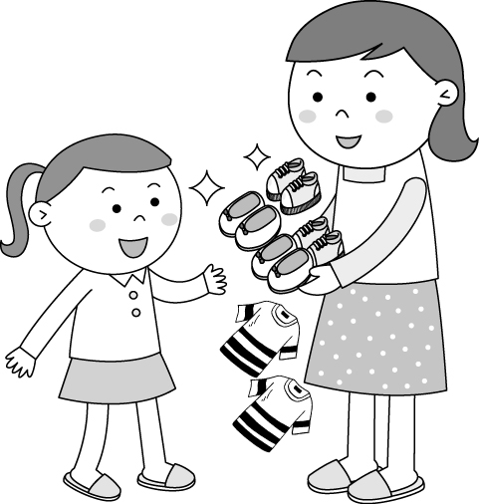 | 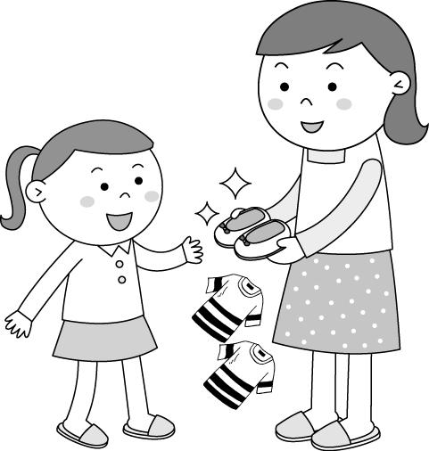 | 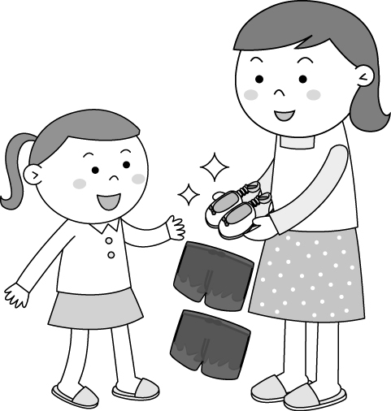
2.(Ａ)
(Ｂ)
(Ｃ)
3.
(A) | (B) | (C)
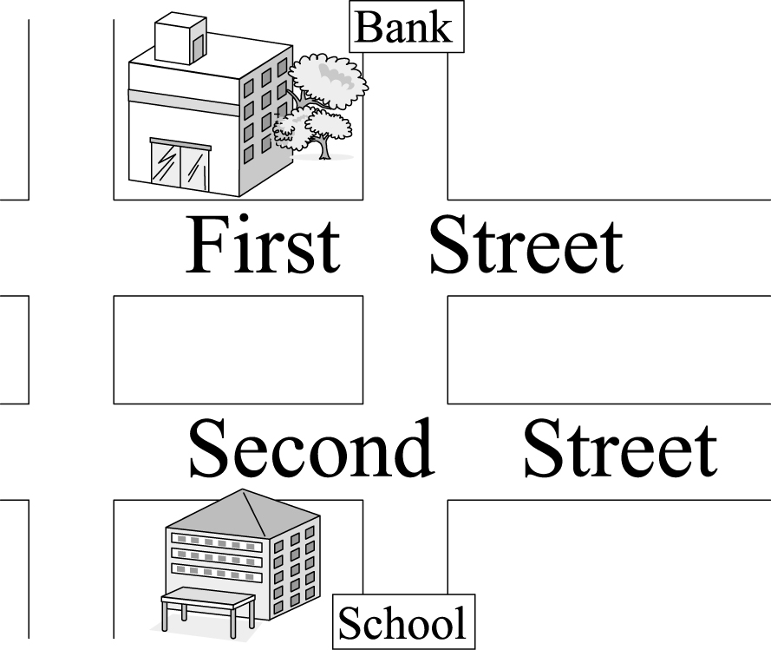 | 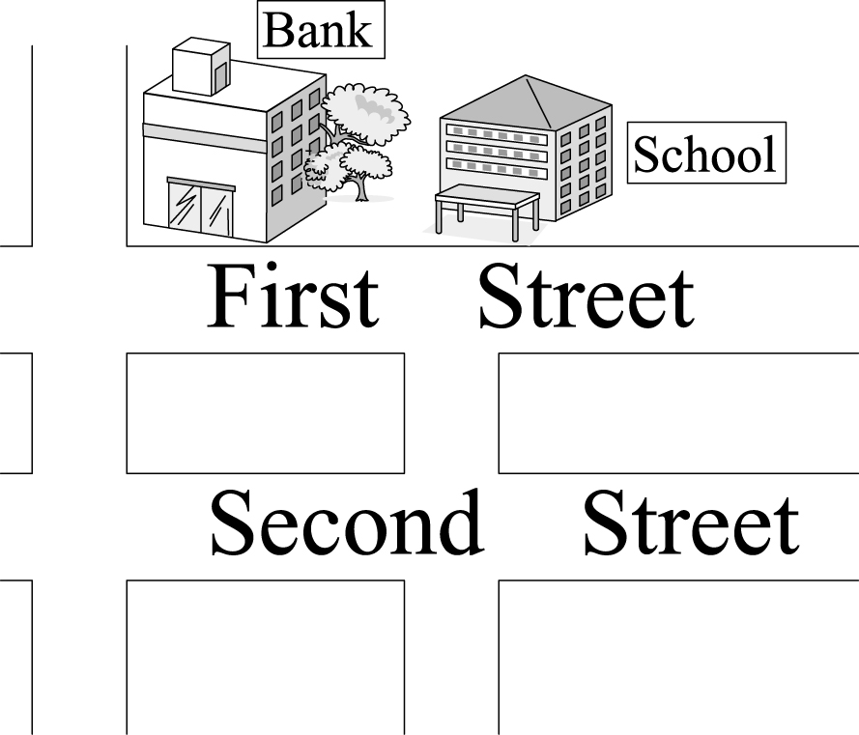 | 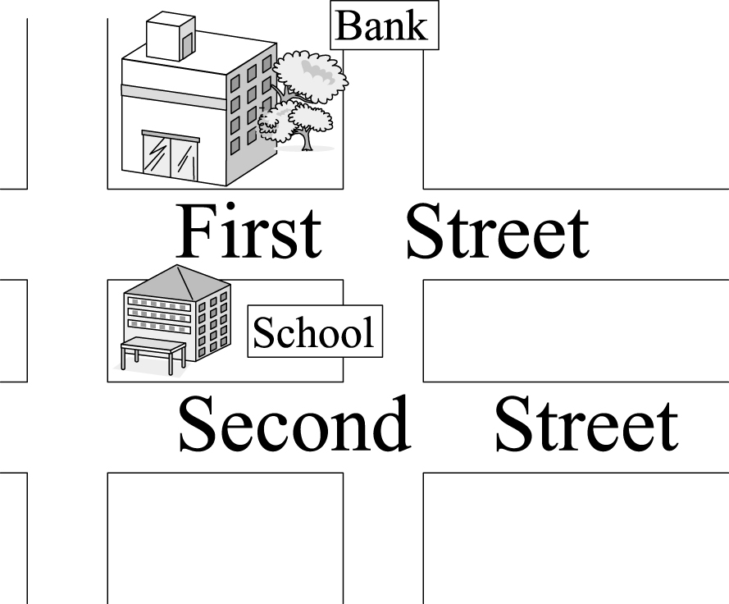
B、基本問答：根據聽到的內容，選出一個最適合的回應句。
4. (A) They got there at 2 p.m.
(B) They will take a bus to Taipei.
(C) They won’t arrive here until about 11 p.m.
5. (A) It’s going to be a great trip.
(B) We’re going back to Hualien.
(C) I’m going to do my homework.
6. (A) In the early morning. (B) At the MRT station. (C) By bus.
7. (A) Well, the parking lot is very big.
(B) Yes, there is one behind the hotel.
(C) No, people can park their cars there.
C、言談理解：根據聽到的內容，選出一個最適合的答案。
8. (A) A purple shirt. (B) A pink skirt. (C) A purple skirt.
9. (A) Ted does. (B) Laura does. (C) Jennifer does.
10.(A) It’s on First Street.
(B) It’s across from a post office.
(C) It’s on the corner of Happy Road and Beach Road.
二、請選出一個正確或最佳的答案，每題1分，佔18%。
11. The dress looks pretty _____ you. Where did you buy it?
(A) to (B) for (C) in (D) on
12. There will ____ heavy rain in Yilan this weekend.
(A) have (B) going to have (C) be (D) going to be
13. Mom: Your hair is still wet.
Sam: Don’t worry. I ______ it later.
(A) dry (B) dried (C) was drying (D) will dry
14. The price of the shirt isn’t _______. I’ll take it.
(A) cheap (B) expensive (C) good (D) bad
15. Simon spent much money ______ his child’s clothes.
(A) buy (B) bought (C) buying (D) to buy
16. The dress ______ me lots of money.
(A) spent (B) cost (C) took (D) bought
17. Hurry up! The bus will arrive ____ three minutes.
(A) for (B) in (C) at (D) between
18. Tim is 14. He doesn’t have a bike, so he usually goes to school ____ .
(A) on foot (B) walk (C) on a bike (D) by scooter
19. Here ___________.
(A) the train comes (B) comes he (C) it is (D) she goes
20. Let’s not _____ ____ ____ in Kenting . It’s too late.
(A) go; watching; birds (B) going; bird; watching
(C) go; bird; watching (D) going; watching; birds
21. _______ _______ the movie is. I want to see it again.
(A) How; excited (B) How; exciting
(C) What; excited (D) What; exciting
22. Thomas: _____ can I go to the train station?
Sara: Just ______ Bus 101.
(A) How; take (B) How; taking
(C) What; take (D) What; taking
23. Tom, a great baseball player, always works hard ____ the
games. (A) to win (B) winning (C) win (D) and win
24. Students, please keep quiet and ________ me.
(A) listen (B) listen to (C) hear (D) hear from
25. We need to get up _____, so we can _____ the sunrise.
(A) early; look (B) early; watch (C) late; look (D) late; watch
26. Leo: We’re lost. I can’t find the way to the night market.
Sean: _________
(A) I don’t have the map.
(B) I lost my money in the night market.
(C) Let’s ask that police officer for help.
(D) There are so many people in the night market.
27.Susan: Honey, we bought some jeans, ate some food, and
had some drinks. What are we going to do next?
Paul:_______ I really want to go home.
(A) How about doing some shopping? (B) I’m still hungry.
(C) It’s a good idea. (D) Aren’t you tired?
28. Joe: Hey, there’s no fishing here. Please stop it.
Sara: _______.
- Don’t worry. Fishing costs only little.
- Why not go fishing later?
- Really? I can’t wait!
- Oops. I’m sorry.
三、克漏字：請依文意選出最適當的答案。每題2分，佔8%。
(Peter and Jane are planning their trip for the coming winter vacation.)
Peter: Where (29) we (29) to take a trip this winter vacation?
Jane: How about Alishan? It’s famous for its (30) . The sun comes up on a sea of clouds between Alishan and Yushan.
Peter: Good idea. Will Dad and Mom go with us?
Jane: They (31) TV in the living room. I’m going to ask them.
Peter: I’m afraid they are not interested.
Jane: Why not?
Peter: They (32) Alishan this summer vacation, and brought
some high mountain tea home. Don’t you remember?
Jane: Yes, but maybe they want to enjoy the nature in Alishan again!
29. (A) will; go (B) did; go (C) do; go (D) are; going
30. (A) sunrise (B) sunset (C) tea (D) mountains
31. (A) are watching (B) will watch
(C) were watching (D) are going to watch
32. (A) visited (B) will visit (C) are going to visit (D) were visiting
四、閱讀測驗：第33~36題，每題2分，佔8%。
(33~34)
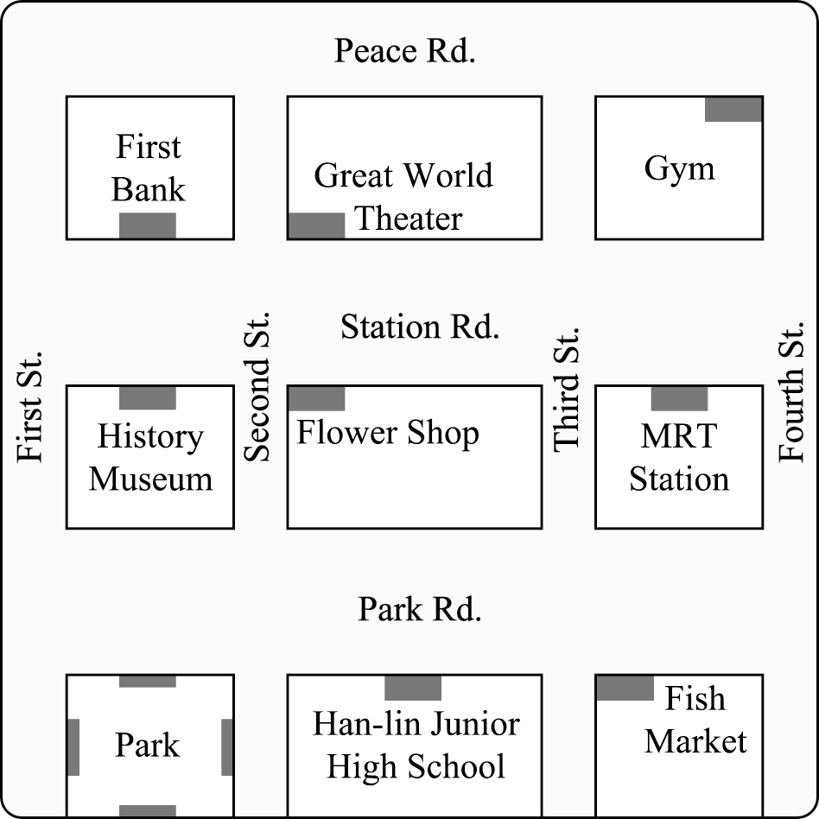
33. Selina is at the fish market. She needs to go to the bank. Which way is right?
(A) Go down Park Road and turn right on Second Road.
It’s on the corner.
(B) Go down Park Road and turn right on Second Street.
Go straight for 1 block, and it’s on the right.
(C) Go along Park Road and turn right on First Street. Then turn right on Station Road. It’s across from the museum.
(D) Go along Third Street and turn left on Station Road.
Go straight for 2 blocks. It’s on the left.
34. Which one is right?
(A) There is a flower shop next to a theater.
(B) The MRT station is across from the fish market.
(C) The museum is on the corner.
(D) There is a school between the fish market and the park.

(35~36)
Jennifer loves to spend her vacation in the country. Last month, she visited the country again. She stayed at a small but pretty hotel there for five days. Its name is Little Forest. People usually don’t go to Little Forest by car because it doesn’t have a parking lot. So Jennifer went there by train. It is a five-minute walk from the railway station to Little Forest. Jennifer likes Little Forest very much because there are an insect museum and a bookstore next to it. During her stay, Jennifer visited the museum every morning, and in the afternoon, she read some books at the bookstore. Staying at Little Forest for five days was only six thousand dollars. It was not too much for her.
35. What is Little Forest?
(A) A museum. (B) A country. (C) A bookstore. (D) A hotel.
36. Which is true about Little Forest?
(A) It is in the country.
(B) You can see many insects in it.
(C) There is a bookstore in the forest.
(D) Staying there for one day was one thousand dollars.

五、文意字彙：每題1分，佔12%
(請將答案書寫於右方答案欄內)
37. It’s getting cold. You need to wear a s r to keep you
warm.
38. I am really t y. Can I have a glass of water?

39. I b wed the cellphone from Miss Lin. She’s really a nice teacher.
40. You cannot take photos in this museum. Please put away
your c a.
41. I didn’t go to the concert because the t t was too expensive.
42. It’s raining . Can you d e me to the station, please?
43. Everyone needs to p t nature.
44. It’s illegal (非法的) for people under 18 to ride a m e.
45. E e me. May I have your name?
46. Mary, a ten-year-old girl, is an e y school student.
47. We will have a barbecue tomorrow. We need to go to the
s t for everything.
48. Many kids like the p d in the park because of the swing and the seesaw.

六、依提示作答 4% (請將答案書寫於下方答案欄內)
49. Joe went to school by MRT yesterday. (用take改寫)
50. It took me an hour to get there. (依畫線部分造原問句)

七、翻譯填空：每格1分，佔10%。
(請將答案書寫於下方答案欄內)
51. 搭飛機很好玩。
(1) on an (2) (3) fun.
52. 我爸今天會來接我。
My father will (1) (2) (3) today.
53. 我會去百貨公司試穿那件紅夾克。
I’ll (1) (2) the red (3) at the (4) store.

~~~~~~~~~~~~~~~~~~~~~~答案欄~~~~~~~~~~~~~~~~~~~~~~

班級： 座號： 姓名：
五、文意字彙：每題1分，佔10%
37. | 38. | 39.
40. | 41. | 42.
43. | 44. | 45.
46. | 47. | 48.
六、依提示作答，佔4%
49._____________________________________________(2%)
50._____________________________________________(2%)
七、翻譯填空：每格1分，佔10%。
51.(1) | (2) | (3)
52.(1) | (2) | (3)
53.(1) | (2) | (3) | (4)

宜蘭縣立羅東國中104學年度第一學期八年級英語科第三次段考聽力測驗(聽力稿)

一、 聽力測驗
本測驗分為 A、B、C三部分，共計十題，每題將唸兩次，皆為單選。請將答案畫在答案卡上。

A、辨識句意：根據聽到的內容，選出符合描述的圖片或符合圖片的描述。
(每題唸兩次,第一次唸完請隔2秒再唸第二次，題與題之間間隔5秒。 )
1. Ms. Huang bought two shirts and four pairs of shoes for her daughter.
2. My father seldom drives to work. He usually rides his motorcycle.
3. The school is next to the bank.

B、基本問答：根據聽到的內容，選出一個最適合的回應句。
(每題唸兩次,第一次唸完請隔2秒再唸第二次，題與題之間間隔8秒。 )
4. It’s 4:00 p.m. What time will your parents get to Taipei?
5. Where are you going next week?
6. You’re going to the art museum tomorrow. How are you going there?
7. Excuse me. Is there a parking lot near here?

C、言談理解：根據聽到的內容，選出一個最適合的答案。
(每題唸兩次,第一次唸完請隔5秒再唸第二次，題與題之間間隔10秒。 )
8.
B: Mother’s Day is coming. I plan to buy something for Mom.
G: You should know Mom’s favorite.
B: She likes to wear skirts on hot days. I’d like to buy a skirt.
G: By the way, purple is her favorite color. She hates pink and green.
B: I got it! Thanks.
Q: What may the boy buy for his mom?
9.
W: Hello, I am Jennifer, a junior high school student. I walk to school every morning. My brother, Ted, rides a bike to school, and my sister, Laura, goes to school by bus.
Q: Who goes to school on foot?
10.
M: How do we go to the railway station?
W: Drive along First Street and turn left on Beach Road. There’s a post office on the corner. The railway station is on Happy Road, across from the post office.
M: OK! Let’s go!
Q: Where is the railway station?

