宜蘭縣立羅東國中104學年度第一學期七年級第三次段考英語科試題
七年____班 _____號 姓名：______________ 聯合命題
◎1~36題，請用2B鉛筆作答於答案卡；37~52題，請寫於作答欄內◎

一、聽力測驗： 20% (每題2分)
本測驗每題念兩遍，請仔細聽，並將答案畫在答案卡上。
A部分: 請根據所聽到的內容及圖片 ，選出一個最適當的答案:
1. 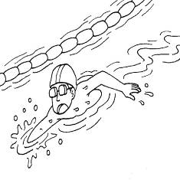 | 2. | 3. 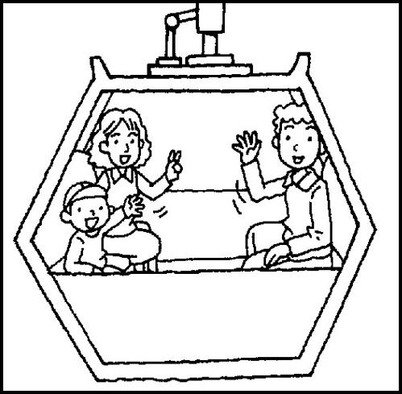
1. (A) Yes, he is running. (B) No, he is swimming.
(C) No, he is crying.
2. (A) Yes, it is. (B) Yes, it’s on the book.
(C) No, it’s under the book.
3. (A) Yes, there is. (B) No, there are three. (C) Yes, there are.
B部分:請根據所聽到的內容，選出最適當的回應句:
4.(A) Wait for me! (B) Oops, sorry! (C) Oh, thank you.
5. (A) He is over there. (B) He is making lunch.
(C) He is talking to Mrs. Lin.
6. (A) Yes, it is. (B) Yes, there is. (C) No, it’s not.
C部分: 請根據所聽到的短文，選出與短文內容相符的答案:
7. (A) They are singing . (B) They are making lunch. (C) They are having tea.
8. (A) It is in front of the tea house. (B) It is beside the bus station. (C) It is in back of the bus station.
9. (A) Yes, there is. (B) No, it is beside the bus station.
(C) No, it’s in front of the bus station.
10.(A) Jet is a small town. (B) The tea house is very busy in the afternoon. (C) The station is beside the cellphone shop.
二、單ㄧ選擇題： 17% (每題1分)
11. Peter’s father, Mr. Brown, building a new house for Cody.
(A) be (B) am (C) are (D) is
12. A: The new cellphone is my birthday gift.
B: Really? Show .
(A) I (B) my (C) me (D) they
13. A: Where his shoes? B: Under the chair.
(A) be (B) am (C) are (D) is
14. It’s nine thirty. =
(A) It’s a quarter to ten. (B) It’s a quarter to nine.
(C) It’s half past nine. (D) It’s half past ten.

15. People go to a bank, not a river bank, for ____.
(A) fruit (B) blossom (C) vacation (D) money
16. A: Are there small fish in the lake?
B: Yes, and there some big fish, too.
(A) is (B) isn’ t (C) are (D) be
17. A： is John doing?
B：He’s dancing.
(A)Where (B)Who (C) How (D) What
18. They are Amy’s sisters. Bill’s playing with now.
(A) her (B) they (C) their (D) them
19. A： is it?
B：It’s two o’clock.
(A) Who (B) What time (C)Where (D) How
20. A： is your cat?
B：She’s in my room.
(A) Who (B) How (C) What (D) Where
21. Ted’s book is on John’s robot, and Sam’s pen is on Ted’s book. Therefore(因此), John’s robot is Sam’s pen.
(A) under (B) on (C) beside (D) in
22. These new boxes are three colors.
(A) on (B) in (C) under (D) at
23. Peter and his family are fun at Wuling Farm.
(A) has (B) have (C) having (D) be
24. A：Where is my cellphone?
B： your pocket.
(A) In (B) Of (C) For (D) To
25. There a lot of men in the living room now.
(A) am (B) is (C) are (D) be
26. A：Don’t forget（忘記）your schoolbag.
B：Thanks.
(A) Where is your schoolbag? (B) It’s on your chair.
(C) Isn’t it big? (D) I have a schoolbag.
27. A：Is Linda painting the house?
B：
(A) Yes, she is. (B) No, he is not.
(C) Linda is in the house. (D) They are not painting.
三、克漏字選擇： 10% (每題2分)
- Dad：Honey, 28 Lisa?
Mom：She’s in the yard.
Dad：What’s she doing 29 there?
Mom：She’s playing with Lucky.
Dad：By the way, what time is it?
Mom：It’s 30 seven thirty.
Dad： 31 She’s late for class.
Mom：Take it easy. It’s Sunday today.
Dad： Great. 32 a new shop near our house. Let’s buy something. yard 院子
Mom：OK.

（ ）28. (A) What’s (B) Who’s (C) What time is
(D) Where’s
（ ）29. (A) on (B) off (C) over (D) in
（ ）30. (A) at (B)x (C)in (D) on

（ ）31. (A) Great! (B) Hurry up. (C) See you.
(D) Wake up.
（ ）32. (A) There are (B) There is (C) Are there
(D) Is there
四、閱讀測驗： 8% (每題2分)
sheep 綿羊 scenery 風景 following 下列的 activity 活動 feed 餵
watch 看
A大題
Welcome. This is Cingjing Farm. There are a lot of sheep on our big farm. People come here for the beautiful scenery and cute sheep. At the farm, you can do the following activities:
1. Hike around the farm.
2. Feed the sheep.
3. Watch the sheep show.
4. Have sheep milk and sheep milk ice cream.
（ ）33. What CAN’T people do at the Farm?
(A) Have sheep milk.
(B) Hike.
(C) Watch sheep show.
(D) Eat the sheep.
（ ）34. Which is true?
(A) Some people go to Cingjing Farm for its beautiful
scenery.
(B) Cingjing is a small farm.
(C) You can make sheep milk ice cream there.
(D) You can’t（不能）feed sheep there.

B大題
Amanda：Look, a lot of people are standing in line beside the
stadium. What are they doing?
Peter：They are waiting for One Direction’s special show.
Amanda：Wow! Cool!
Peter：There are some fans singing One direction’s song.
Amanda：There are some fans dancing, too.
Peter：They are really crazy.
Amanda：They are showing their love. Let’s stand in line and
join them, OK?
stadium 體育館 fan 歌迷 crazy 瘋狂的 join 加入

（ ）35. Who are “They”?
(A) One Direction and their friends.
(B) Peter and Amanda.
(C) One Direction and their fans.
(D) One Direction’s fans.
（ ）36. What AREN’T One Direction’s fans doing?
(A) Standing in line.
(B) Waiting for One Direction’s show.
(C) Painting.
(D) Dancing.
五、文意字彙： 10% 37~52題，請寫於作答欄內
37. Cody is a smart dog. He can play f e with Peter.
38. It's 12:50. I am very h y, and Mom is cooking in the kitchen.

39. Jack’s friends are busy p ring gifts for his birthday.
40. The baby is sleeping now. Please don’ t s t.
41. Look at the traffic light(紅綠燈). The yellow light is b n the green one and the red one.
42. It’s 7:00 in the morning. Bill is having b t in the dining room.
43. A: Is the food here OK? B: Don’ t w y. It’s famous.
44. E g at Sun Moon Lake is very beautiful. No wonder it’s a popular vacation spot.
45. Let’s go to the new r t near our school. I can’ t wait for the great food.
46. A lot of people are having a p c in the park. They can enjoy(享受) food and nature(大自然) there.

作 答 欄

班級：____ 座號：____ 姓名：_____________

五、文意字彙： 10% (每題1分)
37. | 38. | 39.
40. | 41. | 42.
43. | 44. | 45.
46.
六、依提示回答或完成句子： 6% (每題2 分)
47. The boy is roller-skating. (依畫線部分造原問句)
_______________________________________________
48. There are some puppies under the chair. (改為否定句) _______________________________________________
49. My book is on the book. (依畫線部分造原問句) _______________________________________________
七、翻譯題： 9%
50. 看！一位女孩正跑向我們。(3%)
51. 那些手錶在你的抽屜裡嗎？(3%)
52. 這附近有很多公車嗎？(3%)

