宜蘭縣立羅東國中 102學年度 第二學期 八年級 英語科 第一次段考 試卷 命題老師：聯合命題
第1~39題請將答案劃在電腦卡上，第40~54題請寫在答案欄上

- 聽力測驗：本測驗共分為A、B、C三部分，共計10題， 每題皆唸兩遍，請將答案劃在答案卡上。20%(每題2分)
A. 若圖片與聽到的內容相符選A，不符則選B。
- 2. 3. 4.
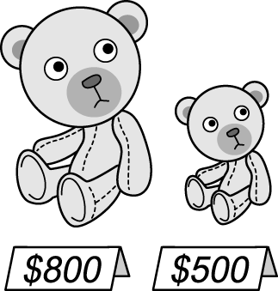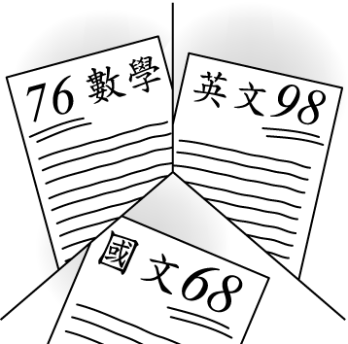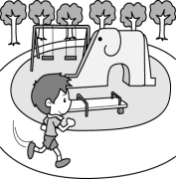
B. 選出適當的回應句。
5. (A)Here you are.(B)I bought it at the shop.
(C)They can show a different picture every three
minutes.
6.(A)Grapes are the sweetest fruit.(B)They grow
tomatoes and papayas.(C)They enjoy eating water-
melons in summer.
7.(A)Easter is my favorite holiday.(B)Let’s go buy a
bag of flour to make the buns.(C)I can’t wait to
have a taste of them.
C. 根據聽到的對話內容，回答下列三題。正確的敘述選A，錯誤的則選B。
8.The boys are near a river.
9.The boys found some fish in the river.
10.The boys will call the police for help.
二、單選題：請選出最適當答案40%（每題2分）
11.___ Easter, people paint eggs ___ beautiful colors and have an egg hunt.
(A) For; by (B) In; with (C) On; in (D) At; in
12.Jason is the most generous ___.
(A) of the two men (B) than those two men
(C) of all my subjects (D) in my office
13.My sister has two pairs of jeans, but she doesn’t like
the black ___.
- ones (B) those (C) it (D) one
14.The towel is so special. It ___ a flower.
(A) looks like (B) tastes like (C) looks (D) tastes
15.Besides ___, the actress is also good at ___.
(A) sing; dance (B) singing; dancing
(C) singing; dance (D) sing; dancing
16.The kind lady ___ clothes and rice to poor people every month.
(A) pays for (B) gives away
(C) throws away (D) spends on
17.The oranges don’t ___ good, but they ___ sweet!
(A) sound; taste (B) feel; smell
(C) look; taste (D) taste; sound
18.Clerk: How would you ___? Tom: ___ cash.
- pay; For (B) want; In
(C) love to pay; By (D) like to pay; In
19There are ___ department stores in Yilan than in
Taipei.
- fewer (B) many (C) less (D) more
20.My parents want me to ___ a businessman in the
future.
- smell (B) get (C) sound (D) become
21.This telescope is ___ of all.
(A) good (B) better (C) the best (D) best
22.Sean: Did your parents buy you a bike?
Ben: Yes, they bought ___ for me, and I like ___ so much.(A) one; one (B) one; it (C)it; one (D)it; it
23.Which is ___, papaya milk, watermelon juice, or
apple juice?
(A) cheaper (B) the cheaper
(C) the cheapest (D) cheapest
24.Mt. Everest (聖母峰)is ___ mountain ___ the world.
(A) the highest; in (B) the taller; in
(C) tallest; on (D) highest; on
25.They are ___ next Saturday.
(A) to go strawberries picking (B) going picking
strawberries (C) go to pick strawberries
(D) going strawberry picking
26.Allen: ___ does the coffee smell?
Ken: It smells ___.
(A)What; good (B) How; well
(C) How; good (D)What; fine
27.Jill: How much did Ted ___ for the bike?
Emily: NT$8,800.
Jill: Wow! It really ___ him a lot.
(A) spend; cost (B) cost; paid
(C) pay; cost (D) pay; spent
28.Smartphones are convenient (便利的), and everyone
in my family has ___.
- one (B) them (C) it (D) those
29.Kate: Can I listen to music with the cellphone?
Clerk: ___
- Sorry, ma’am. We didn’t find your cellphone.
- Sure. Here you are, ma’am. Have a nice day!
- Yes. Three times a day after meal!
- Yes. You can listen to the radio with it, too.
30.Abby: I bought a new digital(數位的) camera.
Joyce: ___
Abby: It is waterproof(防水的)!
- Where did you buy it?
- How much does it cost?
- That’s so sweet of you!
- What’s so special about it?
三、克漏字選擇：10%（每題2分）
Last Saturday was Tony’s birthday. His friend, Mandy, wanted to give him some special gifts. She 31. him 31. at a bus stop near his place in the morning. She then drove him to a farm. Tony was happy because he wanted to pick strawberries there. He liked to eat them.
Mandy wanted to buy an MP3 player as(當作) his birthday 32. . She bought one in the department store . At that time, MP3 players were 33. sale. Tony was very happy when ( 當) he got it.
At noon, they got 34. .Mandy said, “Let’s buy some buns for lunch.” So they bought some buns. They tasted 35. . It was a wonderful day for Tony.
31. (A) gave away (B) picked up (C) took out (D) sent to
32. (A) gifts (B) parent (C) present (D) picture
33.(A) in (B) with (C) for (D) on
34.(A) full (B) fuller (C) the hungrier (D) hungry
35.(A) yummy (B) the yummier
(C) yummiest (D) the yummiest

四、閱讀測驗：8%（每題2分）
The following table shows grades in different subjects
for four students. Please answer questions 36-39
according to this table.
 | Chinese | English | Math | History | Science
Helen | 88 | 88 | 55 | 85 | 80
Iris | 92 | 89 | 90 | 88 | 78
Greg | 76 | 80 | 83 | 52 | 84
Alan | 85 | 59 | 53 | 80 | 90
*table表格; grade成績; according to 根據
36.Who needs to spend more time on his/her Chinese than anyone else(其他)?
- Helen (B) Iris (C) Greg (D) Alan
37.Which subject is the easiest for Greg?
- Science (B) History (C) Chinese (D) Math
38.Who might(可能) find it difficult to study English?
(A) Helen (B) Iris (C) Greg (D) Alan
39. A teacher said to one of these students, “You are good at languages(語言). But you need to spend more time doing math exercises(練習題) and pay more attention(注意) to what the teacher says in class.!” Who might this student be?
(A) Helen (B) Iris (C) Greg (D) Alan
五、文意字彙：10%（每題1分）
40. A smartphone is a u______l tool in my life.
41. My parents bought a new w g m_______e to
clean our clothes.
42. The weather is so hot. You need to put the milk in
the r r.
43. Eating enough fruit and v s every day is good for our health.
44. Many people e ed 921 earthquake(地震) in
Taiwan before.
45. The chocolate “Big Thunder”(大雷神) is a very
p r kind of sweet food in Taiwan now. Many junior high school students like to eat it.
46.Joyce studied English for two hours. She felt tired
and wanted to take a b k.
47. Many People plan to c e New Year in Taipei
101.
48. Andy d________ed his house with flowers for his
wife’s birthday party.
49. The movie is for a______ts. Children under 18 can’t
see it.

六、依提示作答：4% (每題2分)
50. Jay is famous.
Andy is not so famous. (用比較級合併句子)
51.The dish tastes like sweet and sour fish.
(依畫線部分造原問句)
七、翻譯：8%
52.這台紫色相框將你的記憶帶入生活。它也能播放
影片(3分)
53.當個快樂農夫只有ㄧ通電話或ㄧ封電子郵件的距
離。(3分)
54.錄音機變得越來越貴。(get) (2分)

答 案 欄

班級: 座號: 姓名:

五、文意字彙：10%（每題1分）
40. | 41.
42. | 43. | 44.
45. | 46. | 47.
48. | 49.

六、依提示作答：4% (每題2分)
50.___________________________________________________________________________ (2%)
51.______________________________________
____________________________________(2%)
七、翻譯：8%
52._________________________________________________________________________________________________________________ (3%)
53.______________________________________
____________________________________(3%)
54.___________________________________________________________________________ (2%)

