宜蘭縣立羅東國中一o二學年度第一學期九年級英語科第二次段考試卷 命題老師：聯合命題

＊本份考卷共有55題，1~37題答案請畫在答案卡上，38~55題答案請依題號書寫在答案欄。本試題共兩頁。

一、聽力測驗: 本聽力測驗共分為兩部份
第一部份 辨識句意：1到4題每題有三張圖片，請依據所聽到的內容，選出符合描述的圖片。每題播出兩次。
每題1分。佔4%。
1. | (Ａ) | (Ｂ) | (Ｃ)
 | 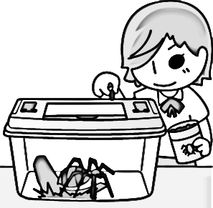 | 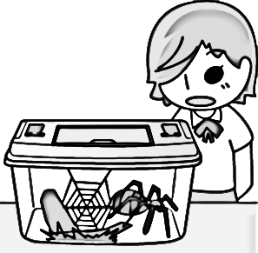 | 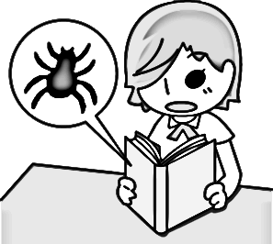
2. | (Ａ) | (Ｂ) | (Ｃ)
 |  | 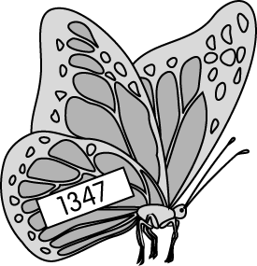 | 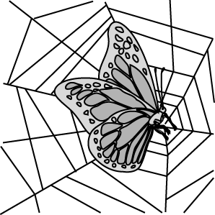
3. | (Ａ) | (Ｂ) | (Ｃ)
 | 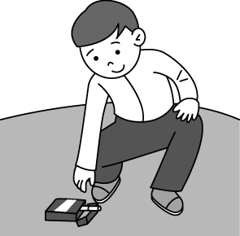 | 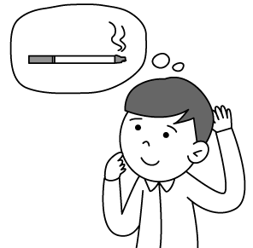 | 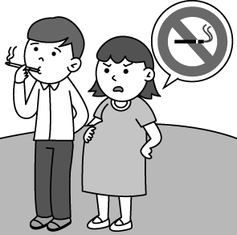
4. | (Ａ) | (Ｂ) | (Ｃ)
 | 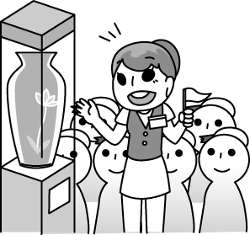 | 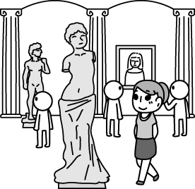 | 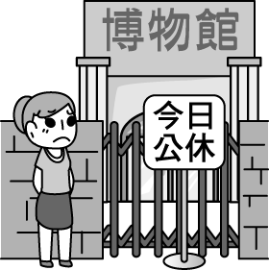

第二部份 基本問答：5到7題請依據所聽到的內容，選出一個最適合的回應句，每題播出兩次。每題2分。佔6%。
5. (A) They were caught by a high net.
(B) They fly one thousand kilometers a day.
(C) They don’t spend the winter in the north.
6. (A) Perhaps you’re right.
(B) We can work it out together.
(C) Maybe we should stop talking.
7. (A) It’s hot all year round.
(B) It’s held every August.
(C) The singing and dancing are too good to miss.

二、克漏字：請依文意選出最適當的答案。每題2分，佔10%。
(8~12)
Have you ever cheated on a test? (8) after you cheat? Proud? Excited? Or sorry? Let me share my story with you.
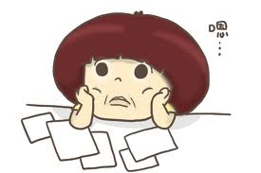
My name is Betty. I am a junior high school student. I prepare well for the test almost every day. One day, (9) and fell asleep. But, I did not want to fail the test. So (10) the night before the test, I decided to write some notes on a piece of paper and hid it in my pocket. “What a great idea!” I thought.
The next day during the test, I carefully took out the piece of paper from my pocket. Luckily, I (11) cheating by Mr. Lee. Of course I got good grades on the test. However, I started feeling nervous and I was afraid that our teacher might find out the truth.
After thinking about what I did for three days, I decided to tell Mr. Lee the truth. In the end, I got a zero on the test, but I felt relieved (安心). Now I realize that cheating is not right, and I will not cheat (12) .

8. (A) What do you think (B) How do you feel
(C) What will you do (D) How can you do it
9. (A) I was too tired to concentrate on my study
(B) I was so proud of myself
(C) I started to care about my apperance
(D) I was thinking too much
10. (A) in (B) at (C) on (D) after
11. (A) was (B) was caught (C) was not (D) was not caught
12. (A) no longer (B) no more (C) any (D) any more

三、單選：請依題意選出最適當的答案。每題2分。佔42%。
13. In Taiwan, some people hang a doll to ____ for nice weather.
(A) pray (B) play (C) shine (D) make
14. Jack is a(n) ______ person. He may get angry if you play a trick on him.
(A) funny (B) important (C) serious (D) lonely
15. Almost all of the wild geese ______ at this time of the year, so you can see few of them here.
(A) be gone (B) are gone (C) are found (D) be found
16. After he put on his uniform and _______ the office, he turned on his computer right away.
- entered (B) solved
(C) went through (D) walked across
17.The company _______ Susan, so she works harder than anyone else.
- sets up (B) works out (C) belongs to (D) opens up to
18. Diary of a Whimpy Kid (遜咖日記) is written in very ____ English, so even young children are able to read it.
(A) difficult (B) simple (C) crazy (D) colorful
19. Could you please stop being angry ______ me? I promise I will never lie ______ you again.
(A) to; with (B) to; to (C) with; with (D) with; to
20. Brian appears ______ because he is getting married this weekend.
(A) being happy (B) to be happy
(C) happily (D) more happily
21. Mandy: I saw Nick in the office this afternoon. Do you know _____ he was there?
Vivian: Perhaps Miss Lin asked him to correct his mistakes.
(A) that (B) if (C) why (D) when
22. I am wondering ______________.
(A) when can we meet each other
(B) how to do
(C) where he went to the lighthouse
(D) what happened to him
23. I have no idea if ________ on the Net tomorrow.
(A) will he post the picture (B) he will post the picture
(C) the picture is posted (D) the picture posts
24. He is not sure ________ they smoked outside the restroom.
(A) that (B) whether (C) where (D) who
25. The test was ______ difficult for everyone ______ pass.
(A) too; to (B) too; didn’t (C) so; to (D) so; didn’t
26. Jean’s kids are ______ cute _____ everyone loves them.
(A) so; that (B) too; to (C) enough; to (D) such; that
27. I ______ that Mrs. Green was a scientist before.
- told (B) tell (C) been told (D) was told
28. Should the garbage ______ by eight o’clock?
- take out (B) been taken out
(C) being taken out (D) be taken out
29. Has the movie, Zone Pro Site (總鋪師), _____ by millions of people since last month?
- seen (B) be seen (C) been seen (D) being seen
30. You don’t have to feel so sad because no one could stop the accident ________.
(A) of happening (B) to happen
(C) from happening (D) happening
31. Billy: Paula, I’m planning to go boat rowing. Want to join me?
Paula: __________
(A) You can drop me a note. (B) I have to take action!
(C) Please don’t turn me down. (D) Count me in!
32. Kobe: Are Andy and John going to move to the south of the island next Sunday?
Fiona:________
Kobe: Maybe I can help them then.
(A) They sometimes work in groups. (B) I suppose so.
(C) I can’t agree with you more! (D) Sounds interesting!
33. Stella: Excuse me. What is this net set up for?
Peter:__________
Stella: What a good idea!
(A) Butterflies can live through the winter.
(B) I’ve heard of this.
(C) It can keep stray dogs away.
(D) Can you tell me what this is?

四、閱讀測驗：第34~37題，每題2分，佔8%
(34~37)
The world’s larget rubber duck was created by Dutch artist Florentijn Hofman in 2007. Since then, the duck has traveled around the world, and millions of people have been made happy just by looking at it. It was on display in cities such as Osaka (Japan), Sydney (Australia), Hong Kong (China) and Kaohsiung (Taiwan) until October 20, 2013. Then it would be on display in Pittsburgh (America).
Lots of people are wondering why Hofman chose the yellow rubber duck as his work of art. Hofman feels that its cute appearance and giant size can bring people happiness and remind them of their childhood. Take a look at the giant rubber duck, and people may take a break from their daily lives, and… smile!
Did you miss the giant rubber duck in Kaohsiung and Taoyuan this autumn? Perhaps you’ll have another chance to see it! The giant rubber duck will float to Keelung from December 21, 2013. The display will last for six weeks! Don’t want to miss it again? This will be the last chance for you to take a look at it in Taiwan.
＊Word Bank
rubber duck黃色小鴨 display展出 remind…of回想起 childhood 童年 float 漂浮
34.Why did Hofman choose the rubber duck as his work of art?
(A) Because it makes people think of their busy lives.
(B) Because people like to smile.
(C) Because the duck makes people feel happy.
(D) Because children love toy ducks.
35. If you want to look at the rubber duck during this Christmas, where should you stay?
(A) Keelung, Taiwan.
(B) Pittsburgh, America.
(C) Taoyuan, Taiwan.
(D) Osaka, Japan.
36.Which is true about the article?
(A) You will never see the giant rubber duck after the display in Taiwan.
(B) The giant duck was created by a Dutch artist.
(C) Hofman cares about appearance.
(D) The giant rubber duck went on display only in Asia (亞洲).
37.Which may be the best title of the article?
(A) The Life of Florentijn Hofman
(B) The Size of the Rubber Duck
(C) The Duck Needs Some Rest
(D) Here Comes the Rubber Duck

五、文意字彙：每題1分，佔12% (請將答案書寫於右方答案欄內)
- Many people like to watch the planes take off at the
a t.
- At that m t, we were touched y by their true love.
- You need to exercise more. Let’s take the s rs to the fifth floor!
- Helen was excited about going to u y after she graduated from senior high school.
- Three, two, one, go! Lots of sky lanterns are r sed.
- Johnson got a t c ticket because he drove through a red light.
- My son is really a h king student. He studies for six hours every night.
- Locus is a f y person. He is always nice to others.
- James is not going to study any subject e t English. He really loves English!
- It’s easy to buy a good house, but it’s not so easy to have good n rs.
- Joy wore new shoes to school today, but no one n ced them. She felt quite sad about it.
- I saw a pack of c es in your schoolbag. Did you smoke?

六、依提示作答: 每題2分，佔6%(請將答案書寫於下方答案欄內)
50. Did they build the house? / I’m not sure about it. (請將兩句合併)
51. Who solved the problem? / Does anyone know that? (請將兩句合併)
52. The police have caught the thief. (請將句子改成被動語態)

七、翻譯：每題4分，佔12% (請將答案書寫於下方答案欄內)
53. 有自信比長得帥更有魅力。
54. 青少年不知道如何與父母親溝通。
55. 那景色美到無法用言語形容。
~~~~~~~~~~~~~~~~~~~答案欄~~~~~~~~~~~~~~~~~~~~

班級： 座號：_______ 姓名：
五、文意字彙：每題1分，佔12%
38. | 39. | 40.
41. | 42. | 43.
44. | 45. | 46.
47. | 48. | 49.

六、依提示作答: 每題2分，佔6%
50.__________________________________________________
51.__________________________________________________
52.__________________________________________________
七、翻譯：每題4分，佔12%
53.__________________________________________________
___________________________________________________
54.__________________________________________________
___________________________________________________
55.__________________________________________________
___________________________________________________

