Thanksgiving Day 感恩節 Name:
Word bank
1. 清教徒 2. 五月花號 3. 印地安人
4. 火雞 5. 南瓜派 6. 玉米
7. 蔓越莓醬汁 8. 豐收
9. 傳統節日 10. 慶祝
11. 團聚 12. 盛宴
13. 麵粉 14. 奶油 15. 紅蘿蔔
16. 材料 17. 親戚 18. 填塞料
19. 飢餓的 20. 抄寫作業
Say out your thanks
- I want to thank my parents 雙親 because ___________________________________
______________________________________________________________________
_____________________________________________________________________.
- I want to thank my teachers because ________________________________________
______________________________________________________________________
_____________________________________________________________________.
- I want to thank my friends because _________________________________________
______________________________________________________________________
_____________________________________________________________________.
- I want to thank ______________ because ____________________________________
______________________________________________________________________
_____________________________________________________________________.
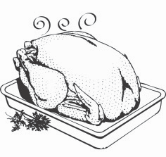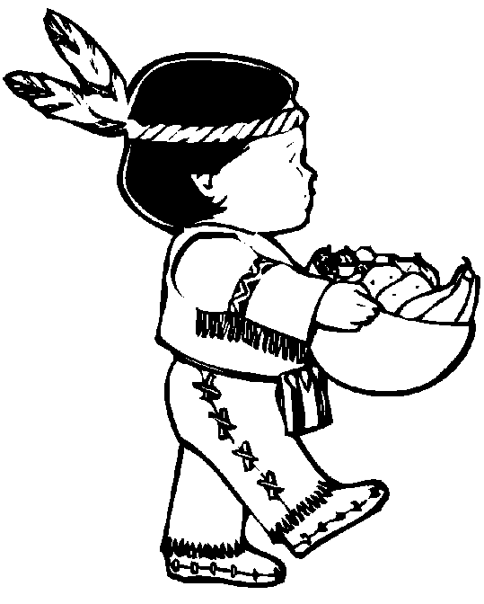
Show your thanks
- I will ________________________________________________________________
to make my parents happy and show my thanks.
- I will ________________________________________________________________
to make my teachers happy and show my thanks.
- I will ________________________________________________________________
to make my friends happy and show my thanks.

Be a global citizen
- 關懷別人 / 為別人著想 ____________ / _____________ about others
- 給予別人希望、耐心、微笑 giving others _________ , ____________ , __________
- 讓我們團結一起 Let’s all __________ __________.
- 留下一個印記在別人生命裡 _________ a _________ in other people’s ________

What can you do to help the earth and the people?
1.

2.

3.

4.

5.


