5 Hot Places
at Yuling Floral Expo
Enjoy amazing summer time in Yuling!!
Minnnan Old House & Museum
It is a 300-year-old Fukienese building. There is a square in the middle of the big house. Around the square are 24 rooms and two ponds. There is also a beautiful Chinese garden in back of the house. People can see some beautiful flowers, waters, bridges and Chinese plants in it.
EcoARK
The green building is made of water bottles. They use recycled water to cool down the building, so people don’t feel hot on the first floor, even in summer. There are also some interesting lessons about recycling. Take the MRT to Gym Station. Then go north for two blocks to Zhongshan Rd. and turn right. You’ll first see Minnan Old House and Museum. Then EcoARK is just next to it.
Yuling Story House
The English Tudor style house is now a small museum to show the history of Yuling and also has art activities for people. After visiting the museum, people can have a nice afternoon tea at the Story Tea House and enjoy the beautiful English garden. The museum is from 11 a.m. to 7 p.m., every Tuesday to Sunday.
Fine Arts Park
There are Floral Tunnel and Yuling Fine Art Museum in Fine Arts Park. Walking along Floral Tunnel, people can see different gardens from the United States, Thailand, Belau, Japan…… In the art museum, people can find a special Russian painting show. Parents can also take their children to Children’s Art Center to join some activities like painting or story telling.
Yuling Rose Garden
The garden is home to over 700 kinds of roses after seven years. Why seven years? It is hard to plant these many roses in Yuling because of its hot weather and the typhoons. Now people can enjoy the sweet smell and the beautiful flowers. Just get off at Gym Station and walk through Fine Arts Park to get there.

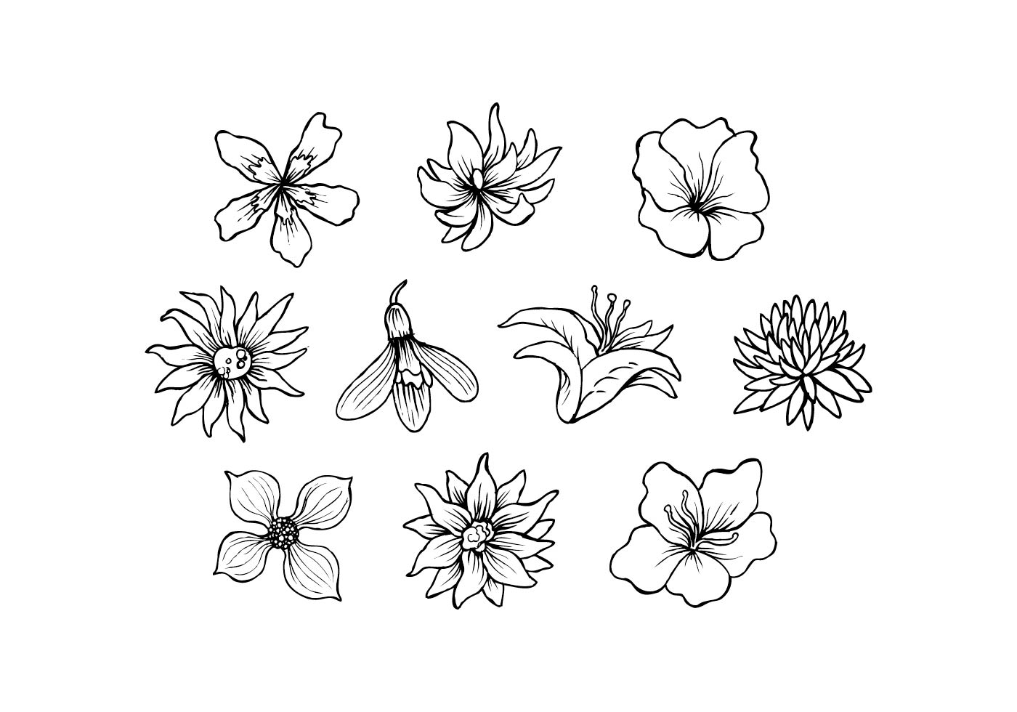
square 廣場 recycle 再利用 style 形式

( C )1. My husband and I plan to take our daughters to visit the Floral Expo this Saturday afternoon. The sisters enjoy listening to stories, the dad enjoys gardening, and I want to see some wonderful paintings. Where should we visit for our lovely Saturday afternoon?
- EcoARK. (B) Yuling Story House.
- Fine Art Park. (D) Yuling Rose Garden.

( D )2. Cindy and her classmates are going to do a report about how to help Mother Earth. They are trying to find out the place on the map at Gym Station.
Which can be the place on the map?
- A (B) B (C) C (D) D

( C )3. Which of the following is TRUE about the reading?
- EcoArk can stay cool because of the cool wind.
- The weather in Yuling is nice for roses to grow.
- People can see different building styles at Yuling Floral Expo.
- People can watch Chinese plants in the middle of Minnan Old House and Museum.

