The Four Seasons in Australia (Group1)

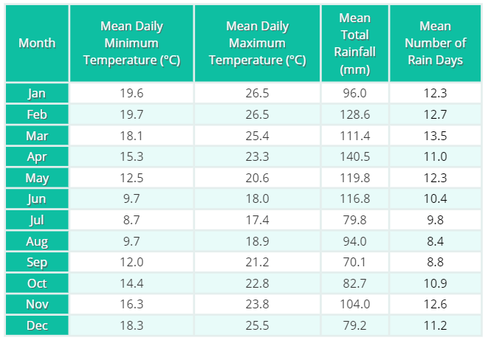

Spring comes in September and it ends in November. It is usually warm, so there are a lot of flowers. For people there, it is a good time to visit beautiful flower shows. I really love spring because it is the best season to enjoy delicious food and have a nice trip.

Let’s read with RIC:
- Retrieve (10mins) 2. Interpret (10mins) 3. Choice (10mins)
- Make the Google Slide according to your answers.
- Find out how to wear in spring in Australia and post it to the padlet.
- Find your puzzling(困惑的) part :
_________________________
- What months are spring months?
_______________________________
- How’s the weather in Australia in spring?
_______________________________
- What can we do in Australia in spring?
_______________________________
- Will it rain in Australia in spring?
______________

Plickers time！！

The Four Seasons in Australia (Group 2)
Summer comes in early December and it will last (持續)three months. The weather there is usually warm and dry in the west, but warm and wet in the east. In summer, it is really fun to have outdoor activities. People go swimming and celebrate Christmas at the beach. They really enjoy the Christmas party at the beach. My favorite outdoor activity is surfing.
the
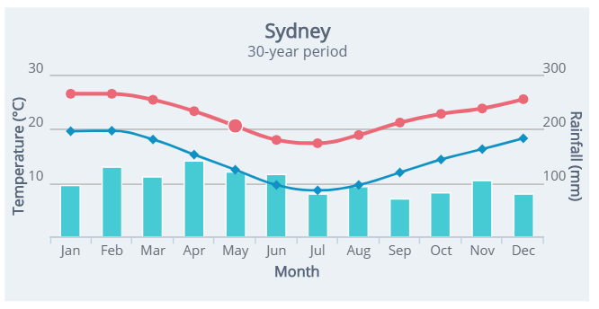

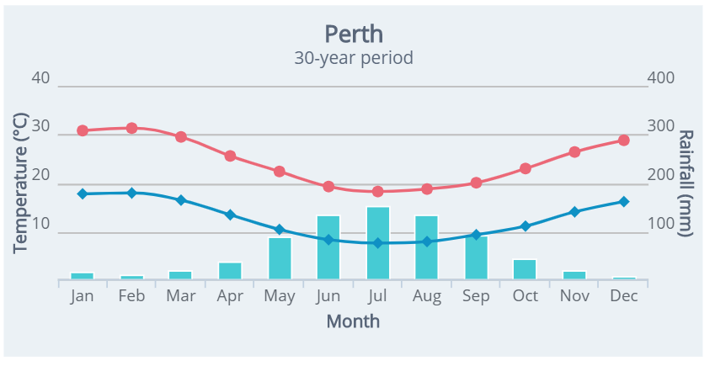
Let’s read with RIC:
- Retrieve
- What months are summer months? ________________________
- How’s the weather in Australia in summer? _____________________________
- What can people do in Australia in summer? __________________________
- Is Perth in the west Australia or east Australia?__________________________
(10 mins)

2.Interpret (10 mins) 3. Choice (10 mins)
- Make the Google Slide according to your answers.
- Find out how to wear in summer in Australia and post it to the padlet.
- Find your puzzling(困惑的) part :
_____________________________
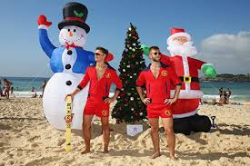
Plickers time！！

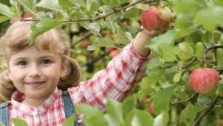
The Four Seasons in Australia (Group 3)

March, April, and May are the autumn months. It is usually cool in these three months and it rains a lot. For people there, autumn is a great season for picking grapes and apples. The best thing to enjoy those fresh fruit is to make juice. Come and visit this appealing (吸引人的) season.

Let’s read with RIC:
1.Retrieve (10 mins) 2.Interpret (10 mins) 3.Choice (10 mins)

Plickers time！！

- Make the Google Slide according to your answers.
- Find out how to wear in Australia in autumn and post it to the padlet.
- Find your puzzling(困惑的) part :
____________________________________

- What months are autumn months?
________________________
- How’s the weather in Australia in autumn?
________________________
- What can we do in Australia in autumn?
________________________
- What month do they have a lot of rain? ________________________

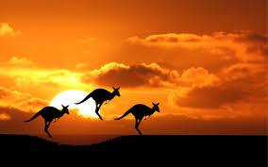
The Four Seasons in Australia (Group 4)

 | June | July | August | September | October | November | December
Temp(℃) | 9.7℃ / 18℃ | 8.7℃ / 17.4℃ | 9.7℃ / 18.9℃ | 12℃ / 21.2℃ | 14.4℃/ 22.8℃ | 16.3℃/ 23.8℃ | 18.3℃/ 25.5℃
Average Sunshine(1/hr) | 5.6 | 6.5 | 7.1 | 7.2 | 7.2 | 7.7 | 7.7
Let’s read with RIC:
Winter begins in June and ends in August. There is snow in some places, and some people like to go skiing. For them, winter is the season to have fun. There is little sunshine, so you don’t need to worry you will get dark.

1.Retrieve (10 mins) 2.Interpret (10 mins) 3.Choice (10 mins)

Plickers time！！

- What months are winter months?
________________________
- How’s the weather in Australia in winter? ________________________
- What can we do in Australia in winter?
_______________________________
- How’s the winter in Australia different from (不同於) Taiwan?
____________________________

- Make the Google Slide according to your answers.
- Find out how to wear in Australia in winter and post it to the padlet.
- Find your puzzling(困惑的) part :
_______________________________

