2018Tony英語U8延伸文章~Hailey Fort Name______
(任務:找出現在完成式、被動式、三大子句，名詞子句括號加粗，形容詞子句括號斜體加粗，副詞子句括號底線加粗，現在完成式現在完成進行式&被動式小括號加粗)
When Hailey Fort was just 5 years old, she asked her mother if they could buy a homeless man a sandwich. Within a year of giving lunch to a stranger in need, Hailey began growing vegetables to donate to the local food bank. Now, at age 9, helping the homeless has grown into a mission for Hailey and she's taken on a new project -- this year, the Mighty Girl from Bremerton, Washington is building 12 mobile sleeping shelters for homeless people in her community!
名詞子句______句、形容詞子句______句、副詞子句______句、現在完成____處、被動式_____處
“It just doesn't seem right that there are homeless people," she says. "I think everyone should have a place to live.” To Hailey, the logical solution was to find a way to provide shelter so she decided to construct mobile sleeping shelters. The shelters are 8 by 4 foot structures that include windows, a locking front door, and eco-friendly insulation made out of recycled jeans. Although adults help her use the large power saws, she does the rest of the construction herself, helped by phone consultations with her grandfather, who is a contractor. The shelter she’s building right now will go to her friend Edward, who has been homeless since he lost his job at a local supermarket. “He’s really nice,” she says. “I don't really want him to be rained on by all the bad weather we get here.”
名詞子句______句、形容詞子句______句、副詞子句______句、現在完成____處、被動式_____處
Hailey has received a $3000 grant from Together Rising and Monastery to help fund her first group of mobile shelters. Thanks to donations and a 50% discount being provided by the local Lowe’s Hardware store, she plans to build about a dozen shelters. She's also continued her gardening efforts and will make donations of fresh produce all summer. Last year, Hailey donated 128 pounds of food and hopes to donate 250 pounds this year. As she's become active on homeless issues, she's also learned about other needs faced by homeless people and aims to hand out 1,000 toiletry items, 500 menstrual products, and 100 coats this year.
名詞子句______句、形容詞子句______句、副詞子句______句、現在完成____處、被動式_____處
For now, Hailey spends her time moving between her garden and her first shelter, as well as spreading the word about her fundraising efforts. It will make for a busy summer, but Hailey knows that she has found her calling. When she’s asked what she’d like to be when she grows up, her immediate answer is a philanthropist: “someone who takes care of people.”
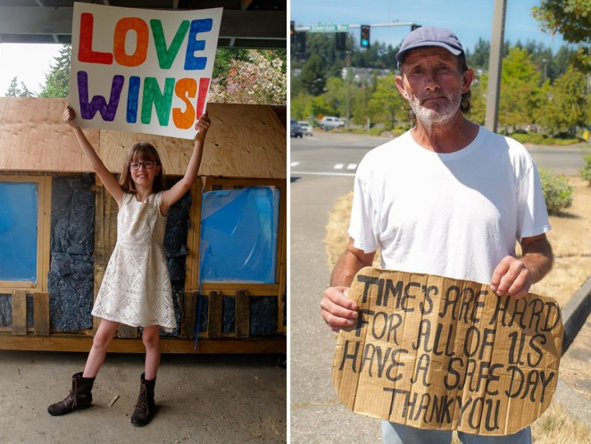
To support Hailey's fundraising campaign to cover the cost of additional shelters, visit http://bit.ly/1Q8raBf -- you can also follow her updates on Facebook at Hailey's Harvest.
名詞子句______句、形容詞子句______句、副詞子句______句、現在完成____處、被動式_____處

A 9-year-old girl is building shelters for the homeless because she thinks 'everyone should have a place to live'
https://www.independent.co.uk/news/world/americas/a-9-year-old-girl-is-building-shelters-for-the-homeless-because-she-thinks-everyone-should-have-a-10299386.html
Hailey Ford, a 9-year-old girl from Bremerton, Washington, is hard at work building 11 small homes for the homeless.
She has been putting in weeks of work on the shelters, drilling down bases, installing windows and cutting insulation.
"It just doesn't seem right that there are homeless people," Hailey told KING 5 News. "I think everyone should have a place to live."

I started putting together the frame for the floor today. By tomorrow I hope to have the pallets up for the walls. The containers behind me are my carrots. I planted 6 dozen carrots today.

Hailey has received a grant for the homes, which will be put in the town's permanent Tent City and be open to the homeless later this year.
名詞子句______句、形容詞子句______句、副詞子句______句、現在完成____處、被動式_____處
She got the idea after meeting a homeless man named Edward on the street while out shopping for groceries with her mother.
They gave the man a sandwich, but Hailey got to thinking about how she could do more and continue providing food to the needy, so she set up Hailey's Harvest, a garden with its own Facebook page, to grow vegetables.
"I said sure, thinking it would last a week. It’s been four years and she still delivers veggies to the homeless every week," her mom, Miranda, told nonprofit Together Rising.
名詞子句______句、形容詞子句______句、副詞子句______句、現在完成____處、被動式_____處
I got my pallets today from Lowe's. I set it up the way it will be put together. I didn't think it would be this big. I imagined it to be smaller. I am so happy with the size. I can't wait to get building.

One window got put in today. I didn't get as much done as I wanted today, but one wall is in and done.

A lot of progress has been made on Edward's sleeping shelter. Tonight the drip rail goes up on the roof. That will help keep everything dry.

Hailey soon branched out into building, and has been providing updates on her progress with the shelters, along with photos of herself hard at work.

"One window got put in today," she wrote in one post. "I didn't get as much done as I wanted today, but one wall is in and done."

Together Rising, which helped fund her project, said: "We can't think of a better example than our Hailey, she's proof that no person - or act of kindness - is too small to change the world."
名詞子句______句、形容詞子句______句、副詞子句______句、現在完成____處、被動式_____處

Meet Hailey, The 9-Year-Old Who Grows Food And Builds Shelters For The Homeless
https://pulptastic.com/meet-hailey-9-year-old-grows-food-builds-shelters-homeless/
When Hailey Ford met Edward, a homeless man in her hometown of Bremerton, Washington, she and her mother bought him a sandwich.
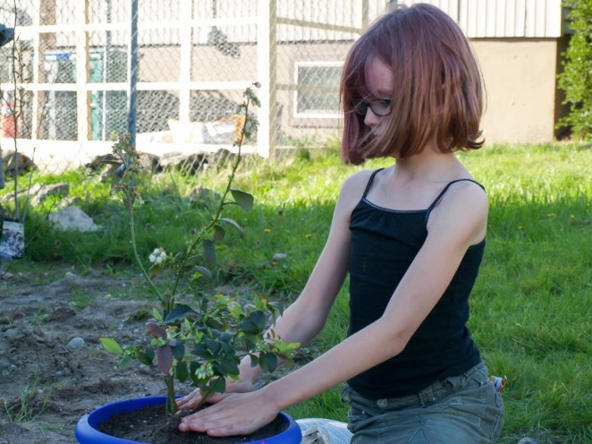
8While that would have been the last of it for most people, it simply wasn’t enough for the 9-year-old, who felt that surely there was a way to keep providing food for those in need. So she started Hailey’s Harvest, a garden that was able to donate 128 pounds’ worth of produce to the local food bank last year.

名詞子句______句、形容詞子句______句、副詞子句______句、現在完成____處、被動式_____處
But it still wasn’t enough for young Hailey. Soon after, she came up with the idea to build small, mobile shelters for the homeless people in her community.

“It just doesn’t seem right that there are homeless people,” she said. “I think everyone should have a place to live.”

The homes that Hailey had in mind are simple. They would feature solar panels, and use recycled denim as insulation.

With the help of her mother Miranda, Hailey was awarded a $3,000 grant from Together Rising. A local Lowes store also pledged to give Hailey a 50% discount on building materials.
With this funding, Hailey is all set to build 11 homes for a Tent City soon to open in Bremerton later this year.

Currently, Hailey is about halfway finished on the first home, which will go to Edward, the man who started her on her journey.

Not only that, Hailey also hopes to increase her garden’s yield this year, so she can donate at least 250 pounds of food.

The young activist even plans to distribute toiletries, feminine products, books, and coats, too.

“We can’t think of a better example than our Hailey – she’s proof that no person – or act of kindness – is too small to change the world,” Together Rising founder Glennon Doyle Melton said.
名詞子句______句、形容詞子句______句、副詞子句______句、現在完成____處、被動式_____處

Hailey's Harvest~One girl making a difference
By Jodi Ubelhor-Strauch on April 8, 2016
Hailey Fort of Bremerton has been caring for the homeless population of Kitsap County for more than four years. She brings them food, toiletries and warm coats, and she's even working on providing shelter to people who don't have a place to stay. In fact, during the past year, she's raised thousands of dollars to further her cause. Hailey's is a terrific tale indeed - especially when you consider that she is just 10 years old.

Hailey, whose father is first ETC Quentin Fort assigned to the USS Michigan Gold, learned about the plight of the homeless in our area when she was 6 years old.
"I was out with my mom and saw this man on the side of the road," she recalled. "I asked her what he was doing there, and she told me he was homeless."

Her mother, Miranda Fort, explained that "homeless" meant that the man had nowhere to live and probably didn't have enough to eat. That day, Hailey decided to help, so she and her mom bought that homeless man lunch. Little did Miranda know, but that sandwich was just the beginning.
名詞子句______句、形容詞子句______句、副詞子句______句、現在完成____處、被動式_____處

Hailey's next step was to plant a garden. She wanted to grow vegetables so she could give healthy food to homeless people. Miranda helped in the beginning, but these days, Hailey plants, tends and harvests her produce, including hundreds of pounds of tomatoes, broccoli and more each year, all on her own.

Hailey guesses that she spends about an hour each day tending her garden and another hour or two delivering the fruits of her labor to her homeless friends each week during the season. Her mom estimates that Hailey has donated close to 400 pounds of produce from her garden.

But Hailey's passion doesn't end with her green thumb. In addition to handing out toiletries and providing warm coats to school children, she is also building homes.
名詞子句______句、形容詞子句______句、副詞子句______句、現在完成____處、被動式_____處
When Hailey first decided to build homes for homeless people, Miranda decided they needed help. With plans designed by her grandfather, a contractor, and a $3,000 grant provided by Together Rising, Hailey has completed the first of what she hopes will be many small shelters for the homeless.

Hailey's first shelter is a small wooden house that provides about 32 square feet of living space, enough for a single person to lie down comfortably. The shelter is fully insulated and includes a window for ventilation and a locking door for security. Hailey says she's learned a lot about construction since the project began and does almost all the work by herself, though Mom jumps in to help out when it comes to cutting.
名詞子句______句、形容詞子句______句、副詞子句______句、現在完成____處、被動式_____處
Initially, Hailey planned to give the shelter to her friend, Edward. They chose paint colors together and discussed where the shelter would be placed, but those plans didn't quite work out.
Hailey smiled as she shared an update on her friend's situation. "He moved back home with his mom in Colorado," she said. "He's not homeless anymore!"

Plans are currently in the works to donate Hailey's shelter to an organization that provides sanctuary for victims of domestic violence, and plans for the next shelter are already in place.

Hailey's efforts haven't gone unnoticed. With the help of her parents, she runs a website and Facebook page with more than 42,000 fans for what she now calls "Hailey's Harvest."

Hailey's story has also been picked up by local Washington ABC and NBC news affiliates, magazines like Military Kids Life and Popular Science for Kids, and on the Internet, including features on Bored Panda, A Mighty Girl, and the Huffington Post.
名詞子句______句、形容詞子句______句、副詞子句______句、現在完成____處、被動式_____處
Recently, Hailey was awarded the Charlotte Bacon Act of Kindness Award from Newtown Kindness. The award came with a beautiful trophy as well as a cash prize, which Hailey, of course, promptly donated to North Kitsap Fishline's Birthday Fairy Program, which provides birthday gifts to underprivileged children.

In light of the cost of their daughter's big dreams, Hailey's parents started a crowdfunding campaign through GoFundMe to help pay for building materials and gardening supplies. Initially, they hoped to raise $500. Now, 10 months later, Hailey's Harvest has raised more than $55,000 and counting. Hailey plans to use the money to continue building shelters and provide for the needs of the homeless.
Even with all her success, Hailey has even bigger dreams.

"Well, I want to try and make a place where people can come and sleep in for a couple nights like the Salvation Army ... only bigger!"

And with all this spunky 4th grader has accomplished in her first 10 years, she has a pretty good chance of succeeding.
名詞子句______句、形容詞子句______句、副詞子句______句、現在完成____處、被動式_____處
http://www.northwestmilitary.com/military-life/military-life/2016/04/haileys-harvest/

QUESTION DISCUSSION問題探討 Name__________
第一階段問題，共6題，每組抽1題，將心得寫在黑板上
Group | Questions
1 | - If you were Hailey Fort, would you help the homeless people? Why or why not?
2 | - If you were Hailey Fort, what kind of difficulties would you face?
3 | - If you were Hailey Fort, how would you convince your parents to support you?
4 | - If you were Hailey Fort, how would you face the difficulties and overcome them?
5 | - If you were Hailey Fort, how would you keep helping the people in need all the time?
6 | - If you were Hailey Fort, what else can you do to help the homeless people?

第二階段問題，共19題，每組抽2題，將心得寫在海報上
- What goes through your mind when you hear the word ‘homeless’?
- Do you ever give money to homeless people? How do you feel?
- Is homelessness a problem in your country? Why or why not?
- What does your government do for the homeless?
- What does homelessness say about a society?
- Why do you think people become homeless?
- What do you think when you walk past homeless people?
- How difficult do you think it is for homeless people to get back into employment, get a house, etc?
- If you were homeless, where and how would you live?
- What do you think it would be like to suddenly become homeless?
- Are there homeless children in your country? If yes, how do you feel?
- Why does the government allow homelessness?
- Why do many people look down on the homeless?
- What can you do to help the homeless?
- If you were homeless, what would you do all day?
- Would you give a homeless person a shower and a bed for the night in your home? Why or why not?
- Do homeless people lose their civil or human rights in your country? If yes, how do you feel?
- Do you think homelessness will ever disappear, even in rich countries?
- What questions would you ask a homeless person?
世界咖啡館討論法The World Café
