Elememts of the Story
附件八
B組
Class No Name

請用單字或片語回答下列問題
- Setting (Tell when and where)
- Characters (Who is in the story?)
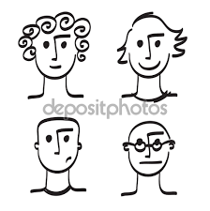
- Oh no! (What’s the problem in the story?)
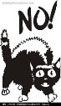
- Order of the events事件 (Tell the story in order次序)
3
2
1

- Problem solved解決 (How is the problem solved or fixed修正?)

I can ...
retell the story!

