Elements of the Story
A組
附件七
Class No Name

Please answer the questions with keywords or phrases
- Setting (Tell when and where)
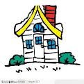
- Characters (Who is in the story?)
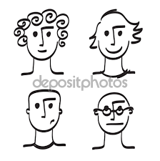
- Oh no! (What’s the problem in the story?)
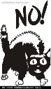
- Order of the events (Tell the story in order)
3
2
1

- Problem solved (How is the problem solved or fixed?)
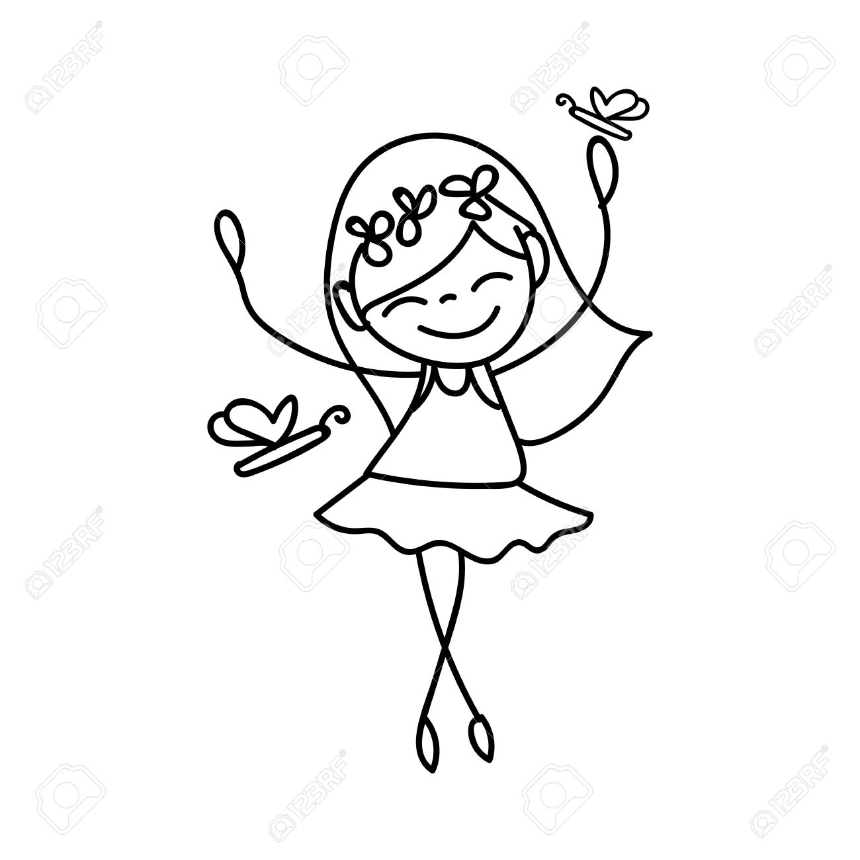
I can rewrite the story!
________________________________________________________

