These years churches are in a calamitous state. To start with, the number of church-goers is dropping sharply (see Figure 1). Many say they do not belong to any church, and those who do go less often than they used to. Going to church appears less and less on people’s to-do list. Another worrying fact is that fewer and fewer young people go to church, which leads to an older church (see Figure 2).
And there is also the problem with money. Keeping a church door open is not cheap. Fewer people going to church means little money coming in. This makes it harder to keep a church open.
When the time comes for a church to close, there is little to do but to sell it. Churches that were lucky enough to find a buyer were put to other uses. Some were changed into restaurants or school gyms, and some even became nightclubs, for example. Churches that had little luck were knocked down in the end.
Just like a store that keeps losing business needs to think of ways to save itself, it is perhaps time for the church to try to win people’s hearts back and play an important part in people’s lives again. This is not something that one can simply pray to get an answer to.
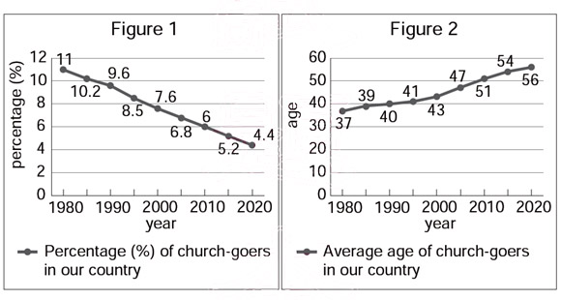
figure | 圖
average | 平均

37. | What does it mean when someone is in a calamitous state?  (A) They have serious trouble.  (B) They try to change themselves.  (C) They are looking for a second chance.  (D) They lost interest in the outside world.
38. | What can we learn about the church-goers from the report?  (A) Between 1980 and 2005, few church-goers were younger than 50.  (B) In 2010, only 6% of church-goers were younger than 50 years old.  (C) In 2020, the percentage (%) of church-goers drops to lower than half that in 1980.  (D) Between 1980 and 2020, the rising number of old church-goers has led to an old church.
39. | What is talked about in the report?  (A) Where the church’s money goes.  (B) How people decide to join a church.  (C) What happens to churches that are closed.  (D) Why people have stopped going to church.
40. | Below are four findings from other reports. Which does NOT agree with the idea of the report?  (A) “Reports show over 90% of church-goers go to church because their fathers do. In the last 20 years, 49% of men under 30 have left the church. That means there’s a 90% chance that their children won’t go to church. This is hard for the church to take in.”  (B) “Between 2003 and 2010, over 1,000 new churches were built in the country. This may sound like good news. During the same years, however, more than 2,000 were closed.”  (C) “In the report, 33% of the people that were interviewed say they never go to church and another 33% say they used to. Only 15% go to church at least once a month.”  (D) “Of the 15 countries in the report, the percentage (%) of church-goers in some countries, like Denmark, is lower than 10%; in others, like Poland, the percentage is higher than 70%.”

- Step 1:Prediction(預測)
- 從圖(一)可看出從1980到2015,上教堂的人口越來越少,這對教堂而言是好現象還是壞現象?所以此篇的主題可能為何? The number of church-goers is dropping sharply from 1980 to 2015 (see Figure 1), what might be the reading about? Is it a good state or a bad state for churches?
_________________________________________________________________
- 從圖(二)得知,上教堂的平均年齡越來越高,所以此篇可能談及上教堂人口中的甚麼部分? The average age of church-goers is getting higer from 1980 to 2015(see Figure 2)? What might be talked about in the reading?
- 上教堂人口中,大多數是老人。
- 越來越多的老人上教堂。
- 越來越多的年輕人上教堂。
- 上教堂人口中,大多數是年輕人。
- Step 2: Skimming (略讀)
快速閱讀文本並找出文本提到最多的議題或事物是什麼？
Look through the article quickly. What is this article mainly about? (這個步驟
reconfirm 前一步驟 確認 prediction的正確性)
- Step 3: Scanning (掃讀): 在此過程中判斷此文的結構為因果的探索(Cause & Effect),或者是正反的辯證(Contrast or Comparision), 或是事實、細節羅列(Facts and Details)。
- 為什麼上教堂人口變少? Why is the number of church-goers is dropping sharply?
__________________________________________________________________________________________________________________________________________________________________________
- 上教堂人口變少產生甚麼結果?What are the problems (effects) that these facts lead to ?
_____________________________________________________________________________________
_____________________________________________________________________________________
- 解決方法為何?請找出並羅列細節 。
How to deal with all the problems? Look for the details and write them down.
__________________________________________________________________________________________________________________________________________________________________________
VI. 題中題出題之方向常用事物異同之比較。Comparision (sameness((similarity))
and difference)
40. Below are four findings from other reports. Which does NOT agree with the idea of the report?
(A)“Reports show over 90% of church-goers go to church because their fathers do. In the last 20 years, 49% of men under 30 have left the church. That means there’s a 90% chance that their children won’t go to church. This is hard for the church to take in.”
此答案與本文主旨相似為何?_______________________________________________________
(B)“Between 2003 and 2010, over 1,000 new churches were built in the country. This may sound like good news. During the same years, however, more than 2,000 were closed.”
此答案與本文主旨相似為何?_______________________________________________________
(C)“In the report, 33% of the people that were interviewed say they never go to church and another 33% say they used to. Only 15% go to church at least once a month.”
此答案與本文主旨相似為何?_______________________________________________________
(D)“Of the 15 countries in the report, the percentage (%) of church-goers in some countries, like Denmark, is lower than 10%; in others, like Poland, the percentage is higher than 70%.”
此答案與本文主旨相似為何?_______________________________________________________

