Class: _______ No. _______ Name: ________________________
Whose thoughts are these?
Read these sentences. Can you tell whose thoughts they are?
Copy them in the bubbles next to each person.
_________________________

_________________________

- I am a boy, and I really want a doll.
- Boys shouldn’t play with dolls.
- Taking care of a doll will make me happy.
- Boys can cradle a doll, just like a father hugging his baby.
- Boys should be good at basketball.
- Playing with dolls will not make boys sissy.
William
_________________________

_________________________

_________________________

______________________

______________________

_________________________

_________________________

_________________________

William’s grandmother
_________________________

_________________________

_________________________

_________________________

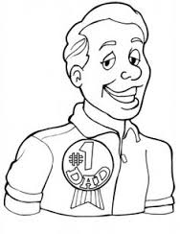William’s father

