Class & No.:___________________ Name: __________________________________
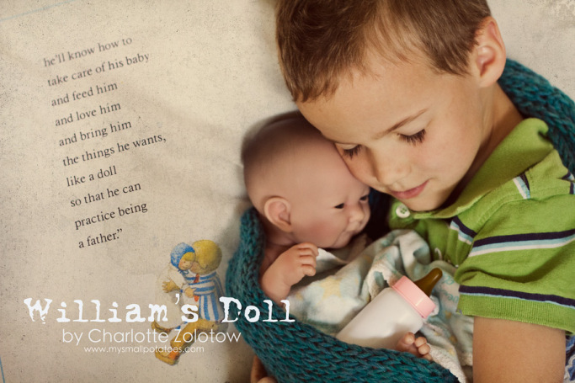
All about William
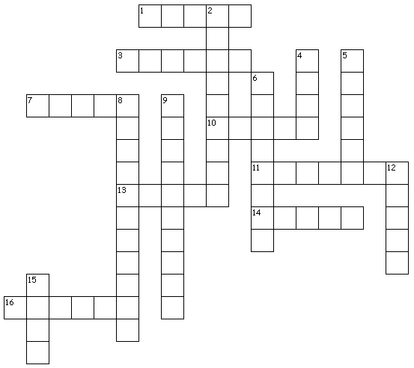

Across
1. William’s father is _____ because he doesn’t think William needs a doll.
3. William’s doll will wear a white dress and a _____.
7. William wants to push his doll in the ______ in the park.
10. William wants to kiss his doll goodnight after he pulls down the _____.
11. William is good at making ______ and bridges for his trains.
13. William’s grandmother buys him a doll with a long white ______.
14. William’s brother thinks he’s a _____ because he likes dolls.
16. William wants to hug his doll and give it a _____ of milk.
Down
2. A doll with curly _____ is what William wants.
4. With his new doll, William will know how to _____ care of his baby.
5. William wants to _____ the doll in his arms.
6. With his new doll, William will ______ being a father.
8. William tells his ______ that he really wants a doll.
9. William’s father gives him a smooth and round ______.
12. The boy next door calls William a _____ boy because he likes dolls.
15. William wants a _____ very much.

This word bank can help you.

take | upset | practice | tunnels
grandmother | dress | basketball | bonnet
shade | sissy | eyelashes | creep
swing | cradle | bottle | doll

take | upset | practice | tunnels
grandmother | dress | shade | bonnet
basketball | sissy | swing | creep
eyelashes | cradle | bottle | doll

