B Survey: Who plays with what Names: ___________
__________
__________
After reading the story, please sort the items again.
Work with your friends by using the sentences as:
* Who will play with ….? * I don’t know. What do you think?
* I think it can be for…. * I think so.
* I am not sure if (boys/girls) like it. * I agree.
* I think only (boys/girls) like it. * I think both boys and girls would like it.
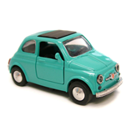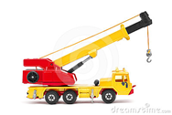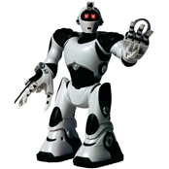
car crane(起重機) robot(機器人)
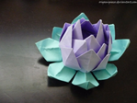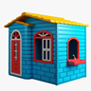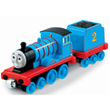
origami(摺紙) toy house train beading(穿珠子)
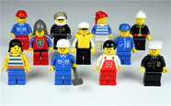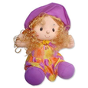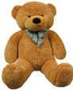
Lego (樂高) doll stuffed animals(絨毛玩具)
 | For boys | For girls
car
toy house
robot
origami
train
beading
crane
Lego
doll
stuffed animals

