Useful Websites 1—1020627 Edited by Emily
Item | Title | Website | webpage | Introduction
 | A to Z Teacher Stuff | http://atozteacherstuff.com/ | 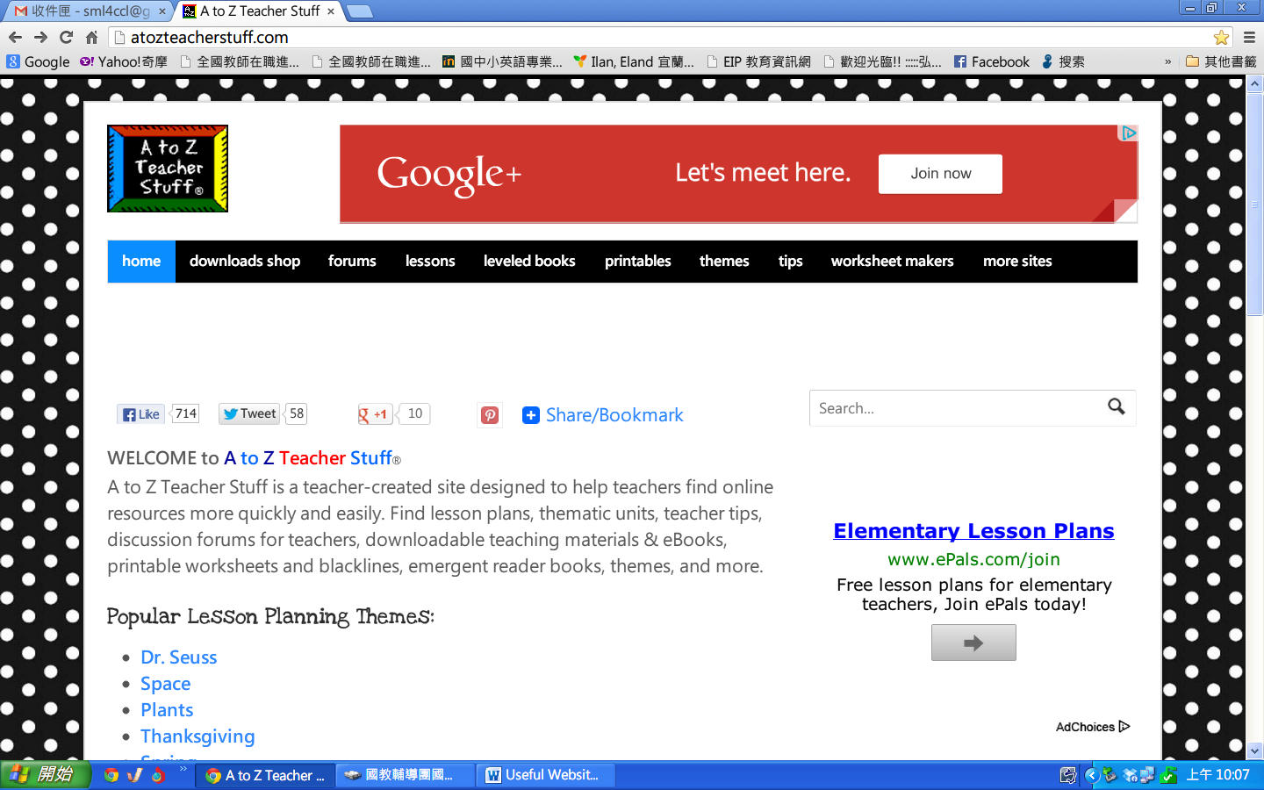 | lesson plans, thematic units, teacher tips, discussion forums for teachers, downloadable teaching materials & eBooks, printable worksheets and blacklines, emergent reader books, themes, and more.
 | kidsinco online scholarly source | http://www.kidsinco.com/complete-list-of-playscripts/ | 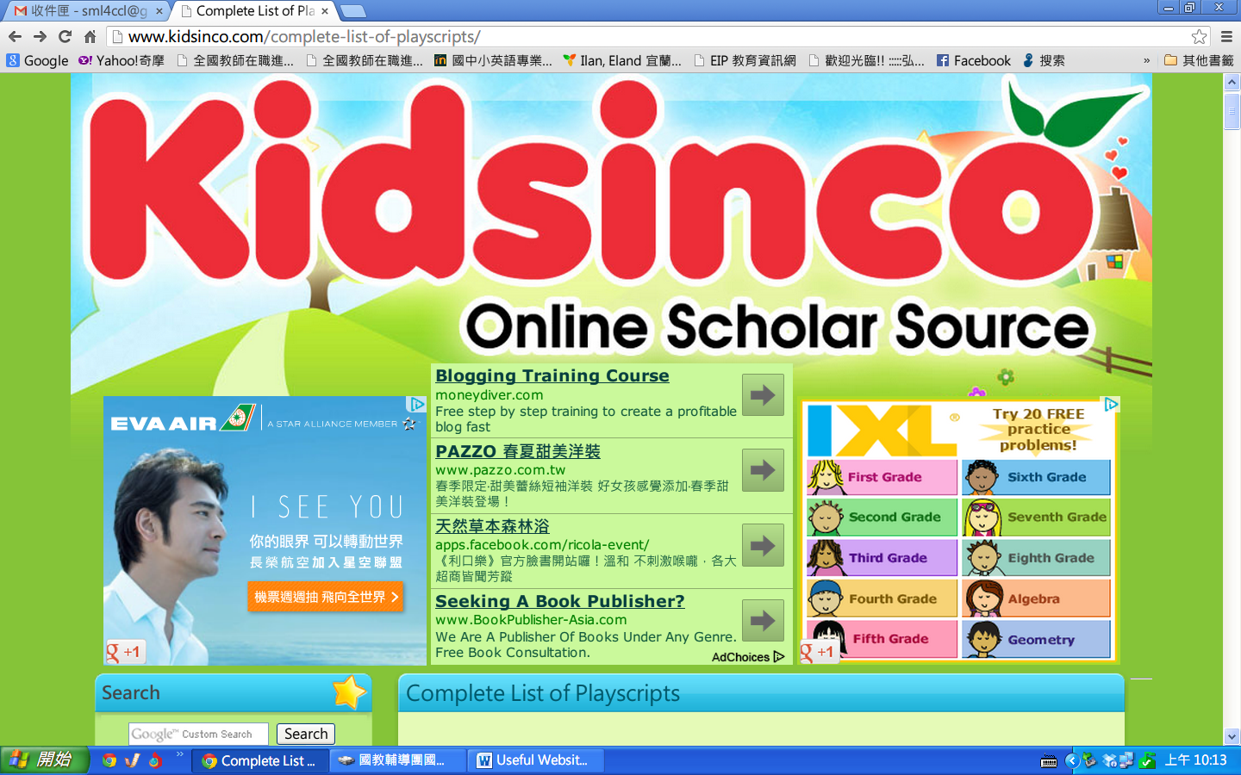 | Fairy stories, scripts
 | e4kids | http://web.pts.org.tw/php/html/e4kids/week/main_week.php | 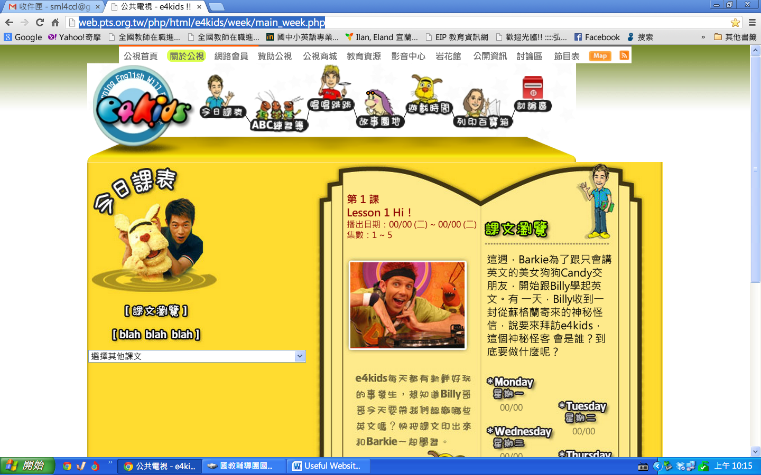 | Songs, chant, MTV
 | BBC education-wordblender game | http://www.bbc.co.uk/schools/wordsandpictures/clusters/blender/ | 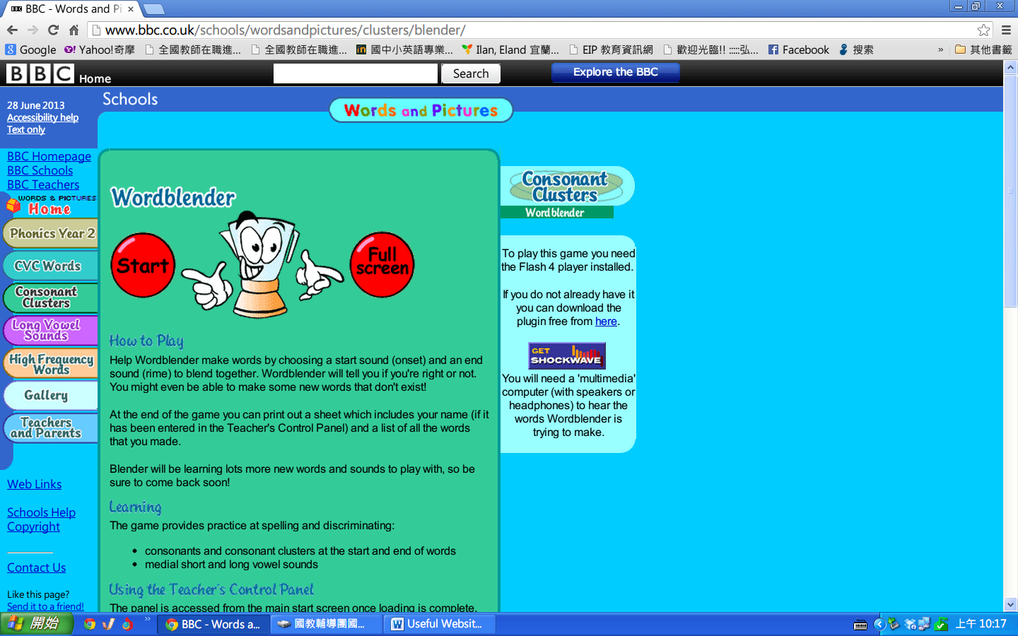 | Consonants, vowels, phonics
 | BBC education-bitesize literacy | http://www.bbc.co.uk/bitesize/ | 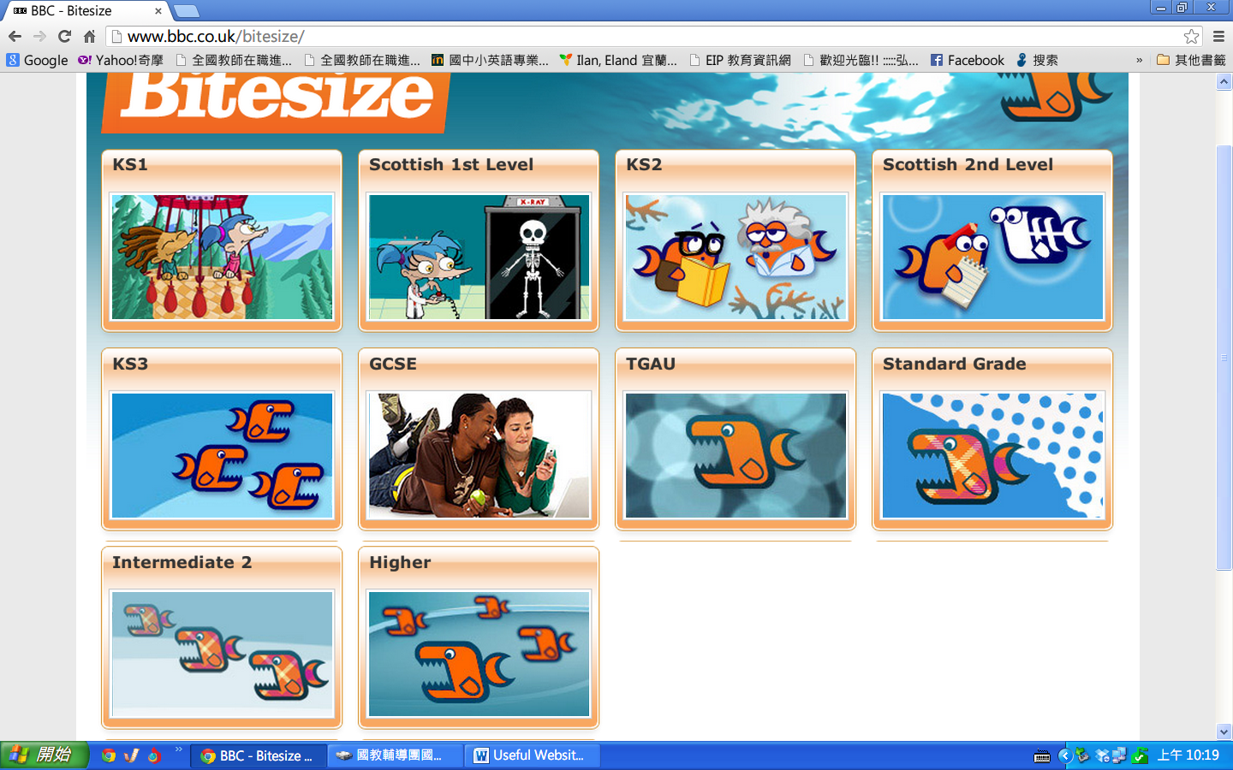 | Rhymes, chants, pronouns, and etc.
 | Online Etymology Dictionary | http://www.etymonline.com/ | 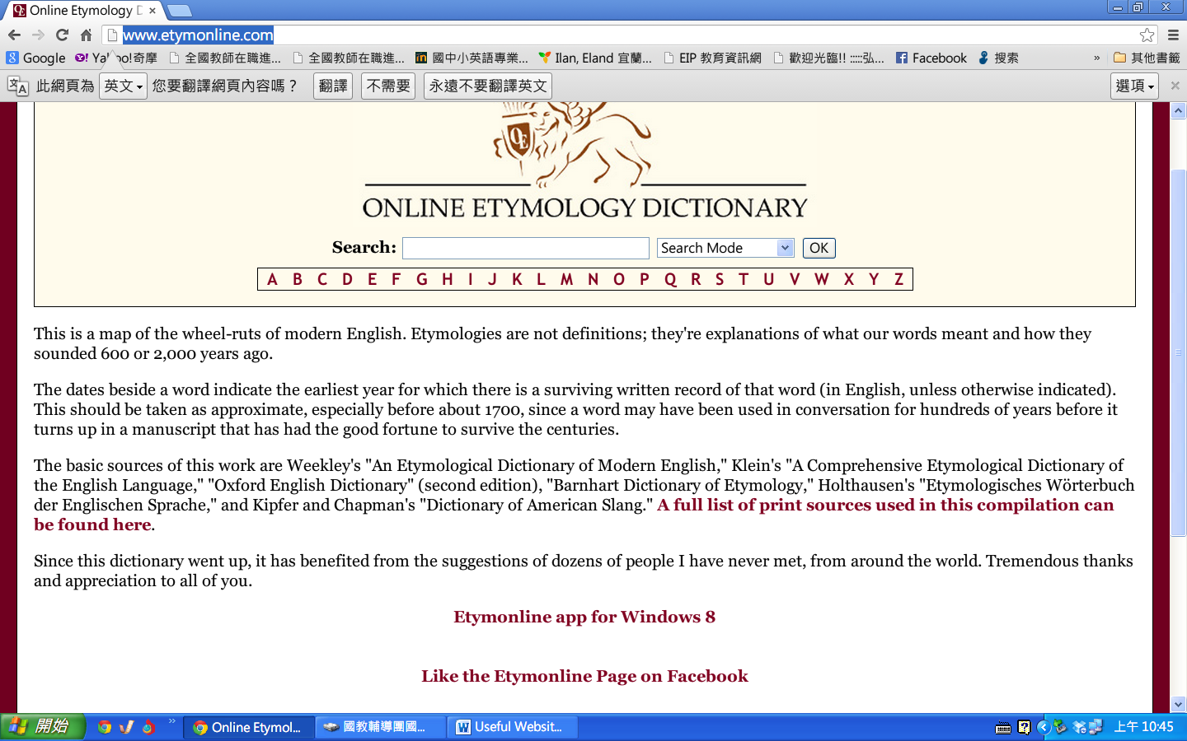 | Word origin
 | 123listenign | http://www.123listening.com/ | 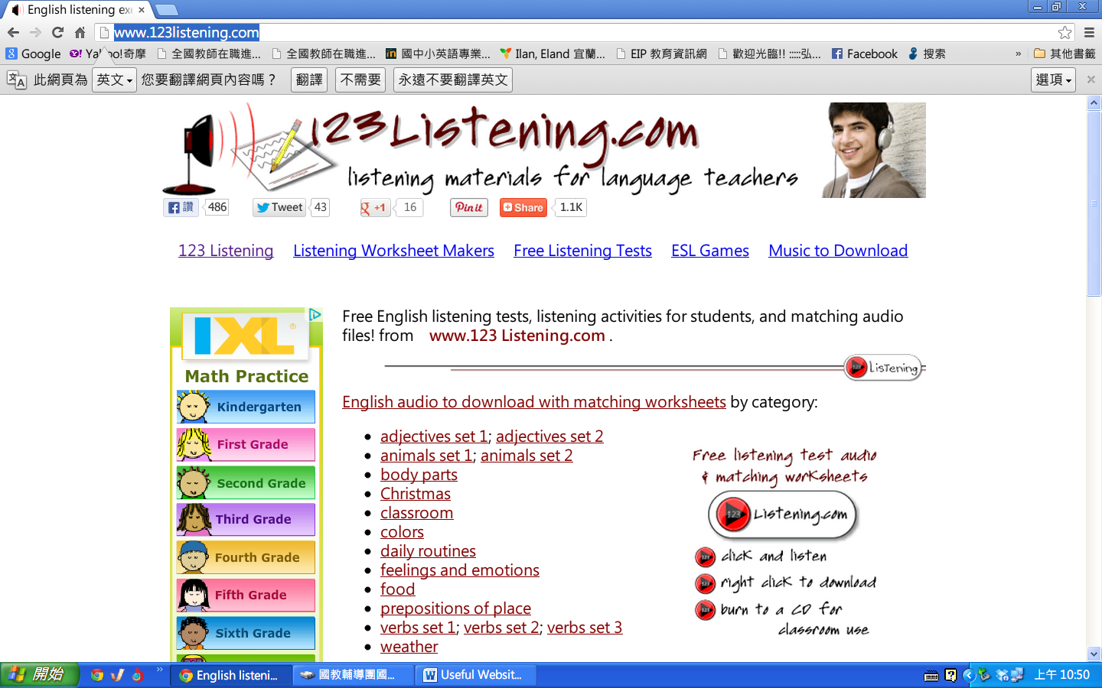 | Listening practice
 | lyrics training | http://www.lyricstraining.com/ | 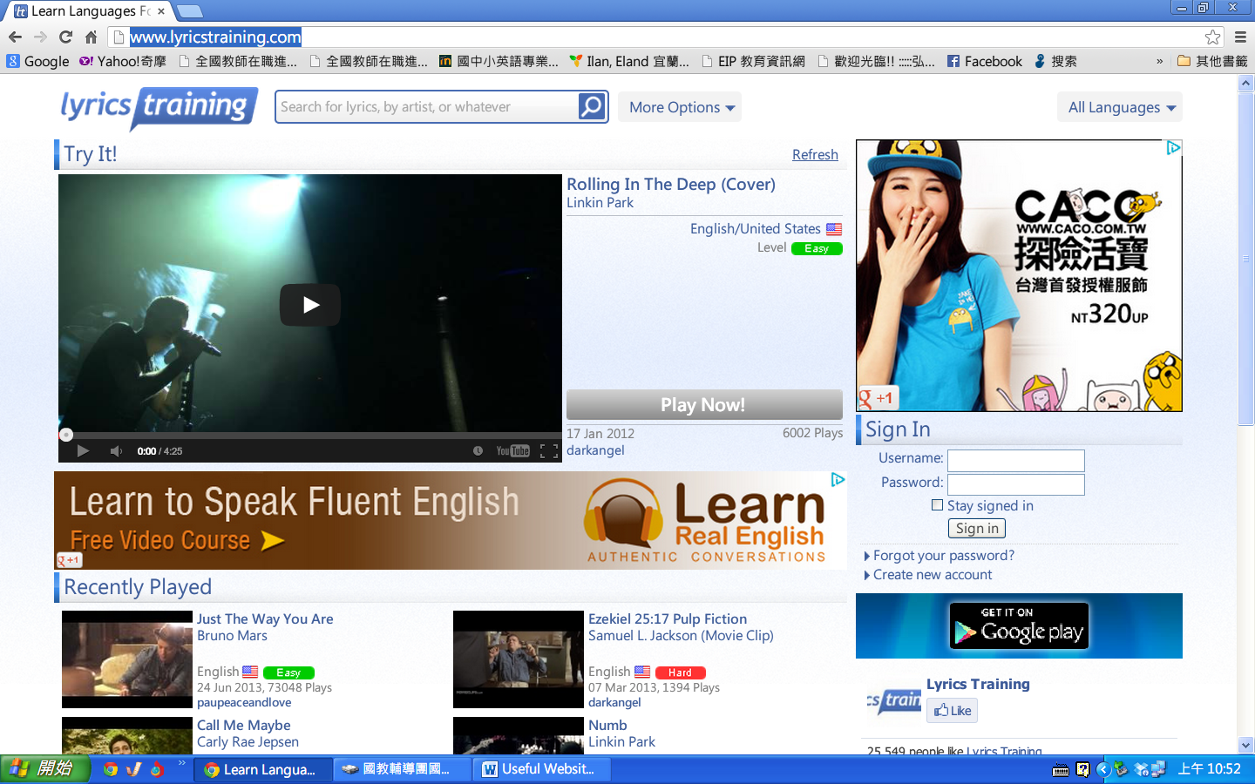 | Lyrics practice

